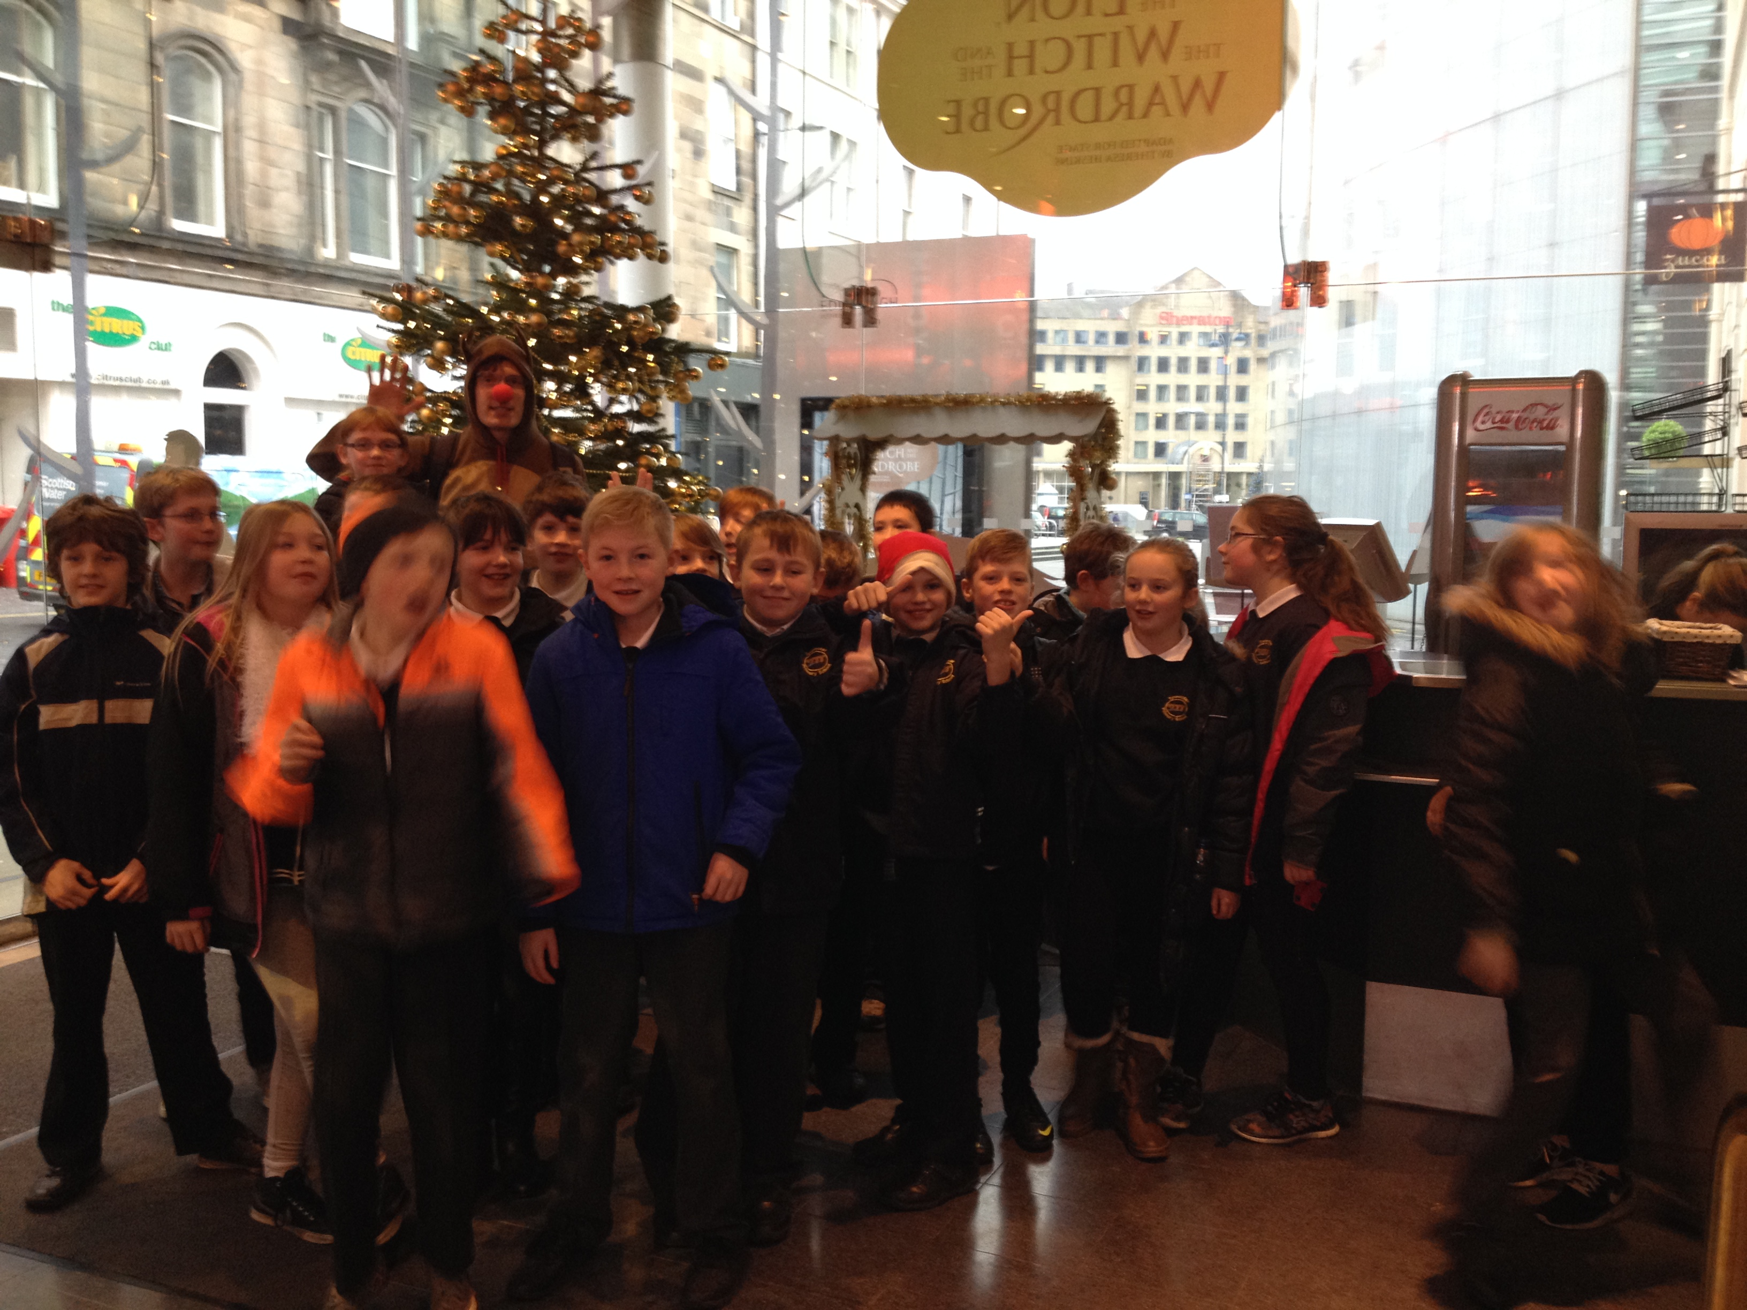 |  | Skiing!  We have enjoyed our epic trip to Midlothian Ski Centre. #LOL  We have learned to snow plough. We also learned how to fall! We learned to use the tow and had loads of fun. |  | 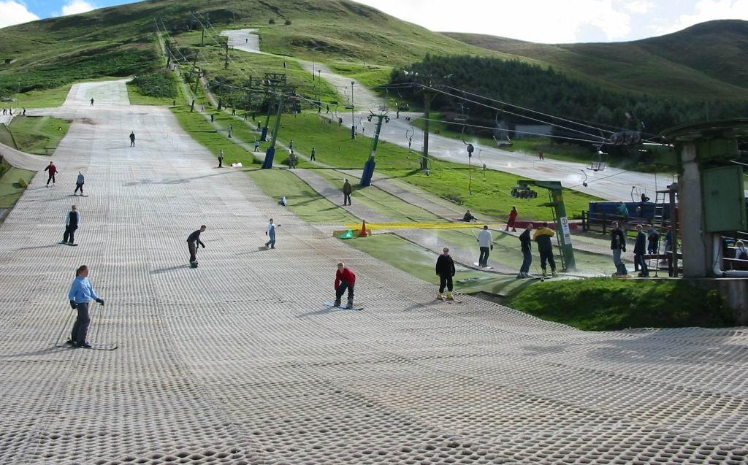
WWI  We were told to research something about ww1. It was a big success and now we know more about ww1. There was a famous football match, trenches, and trench foot. |  | 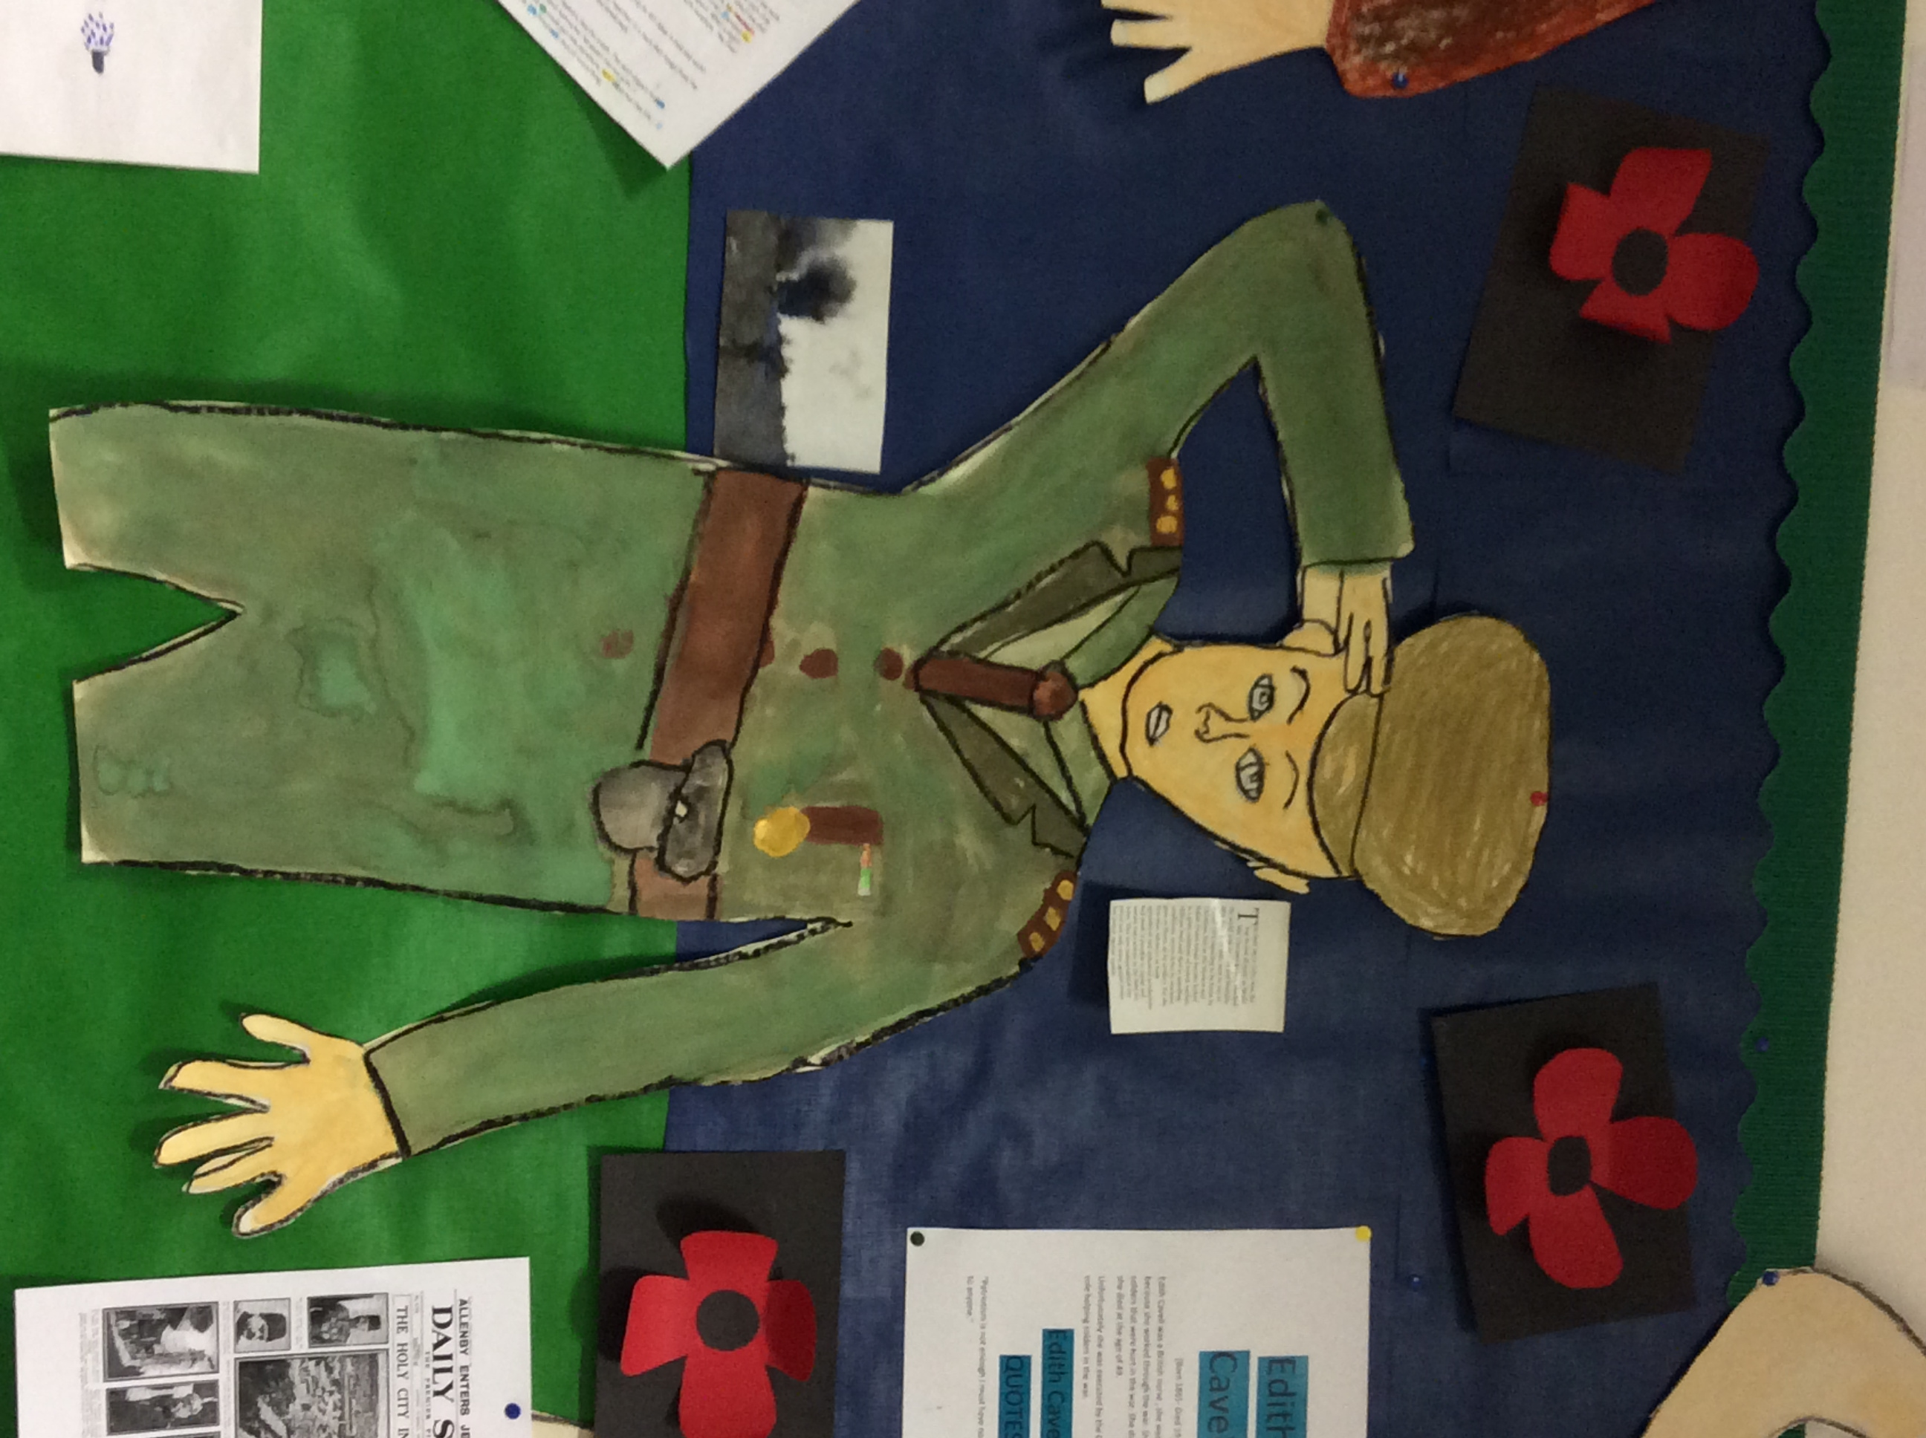  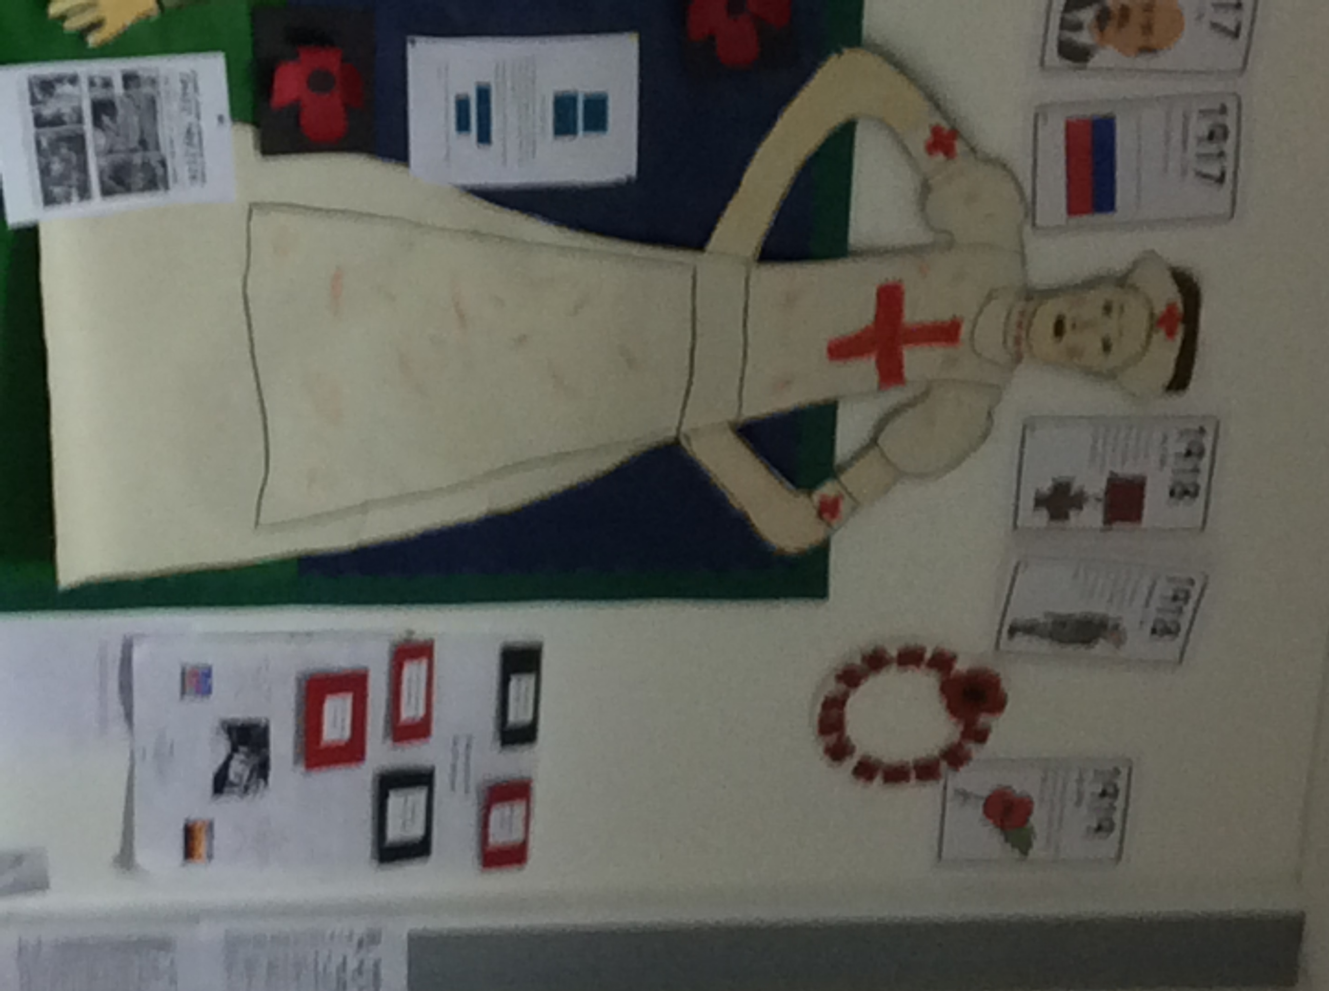 |  | Mindsets  We have been learning about fixed and growth mindsets. We have been learning about getting into the learning pit to face lots of questions and challenges!
Drama work shop  We had a drama work shop about The Lion The Witch And The Wardrobe. It was fun we got to act out the script and have fun with our voice in voice exercises. The photo above is at the theatre. |  | WWI  We have learned about how it actually began. We have enjoyed listening to Private Peaceful, which allows us to understand the time.  We have also been learning about what life was like in the trenches. |  | 

