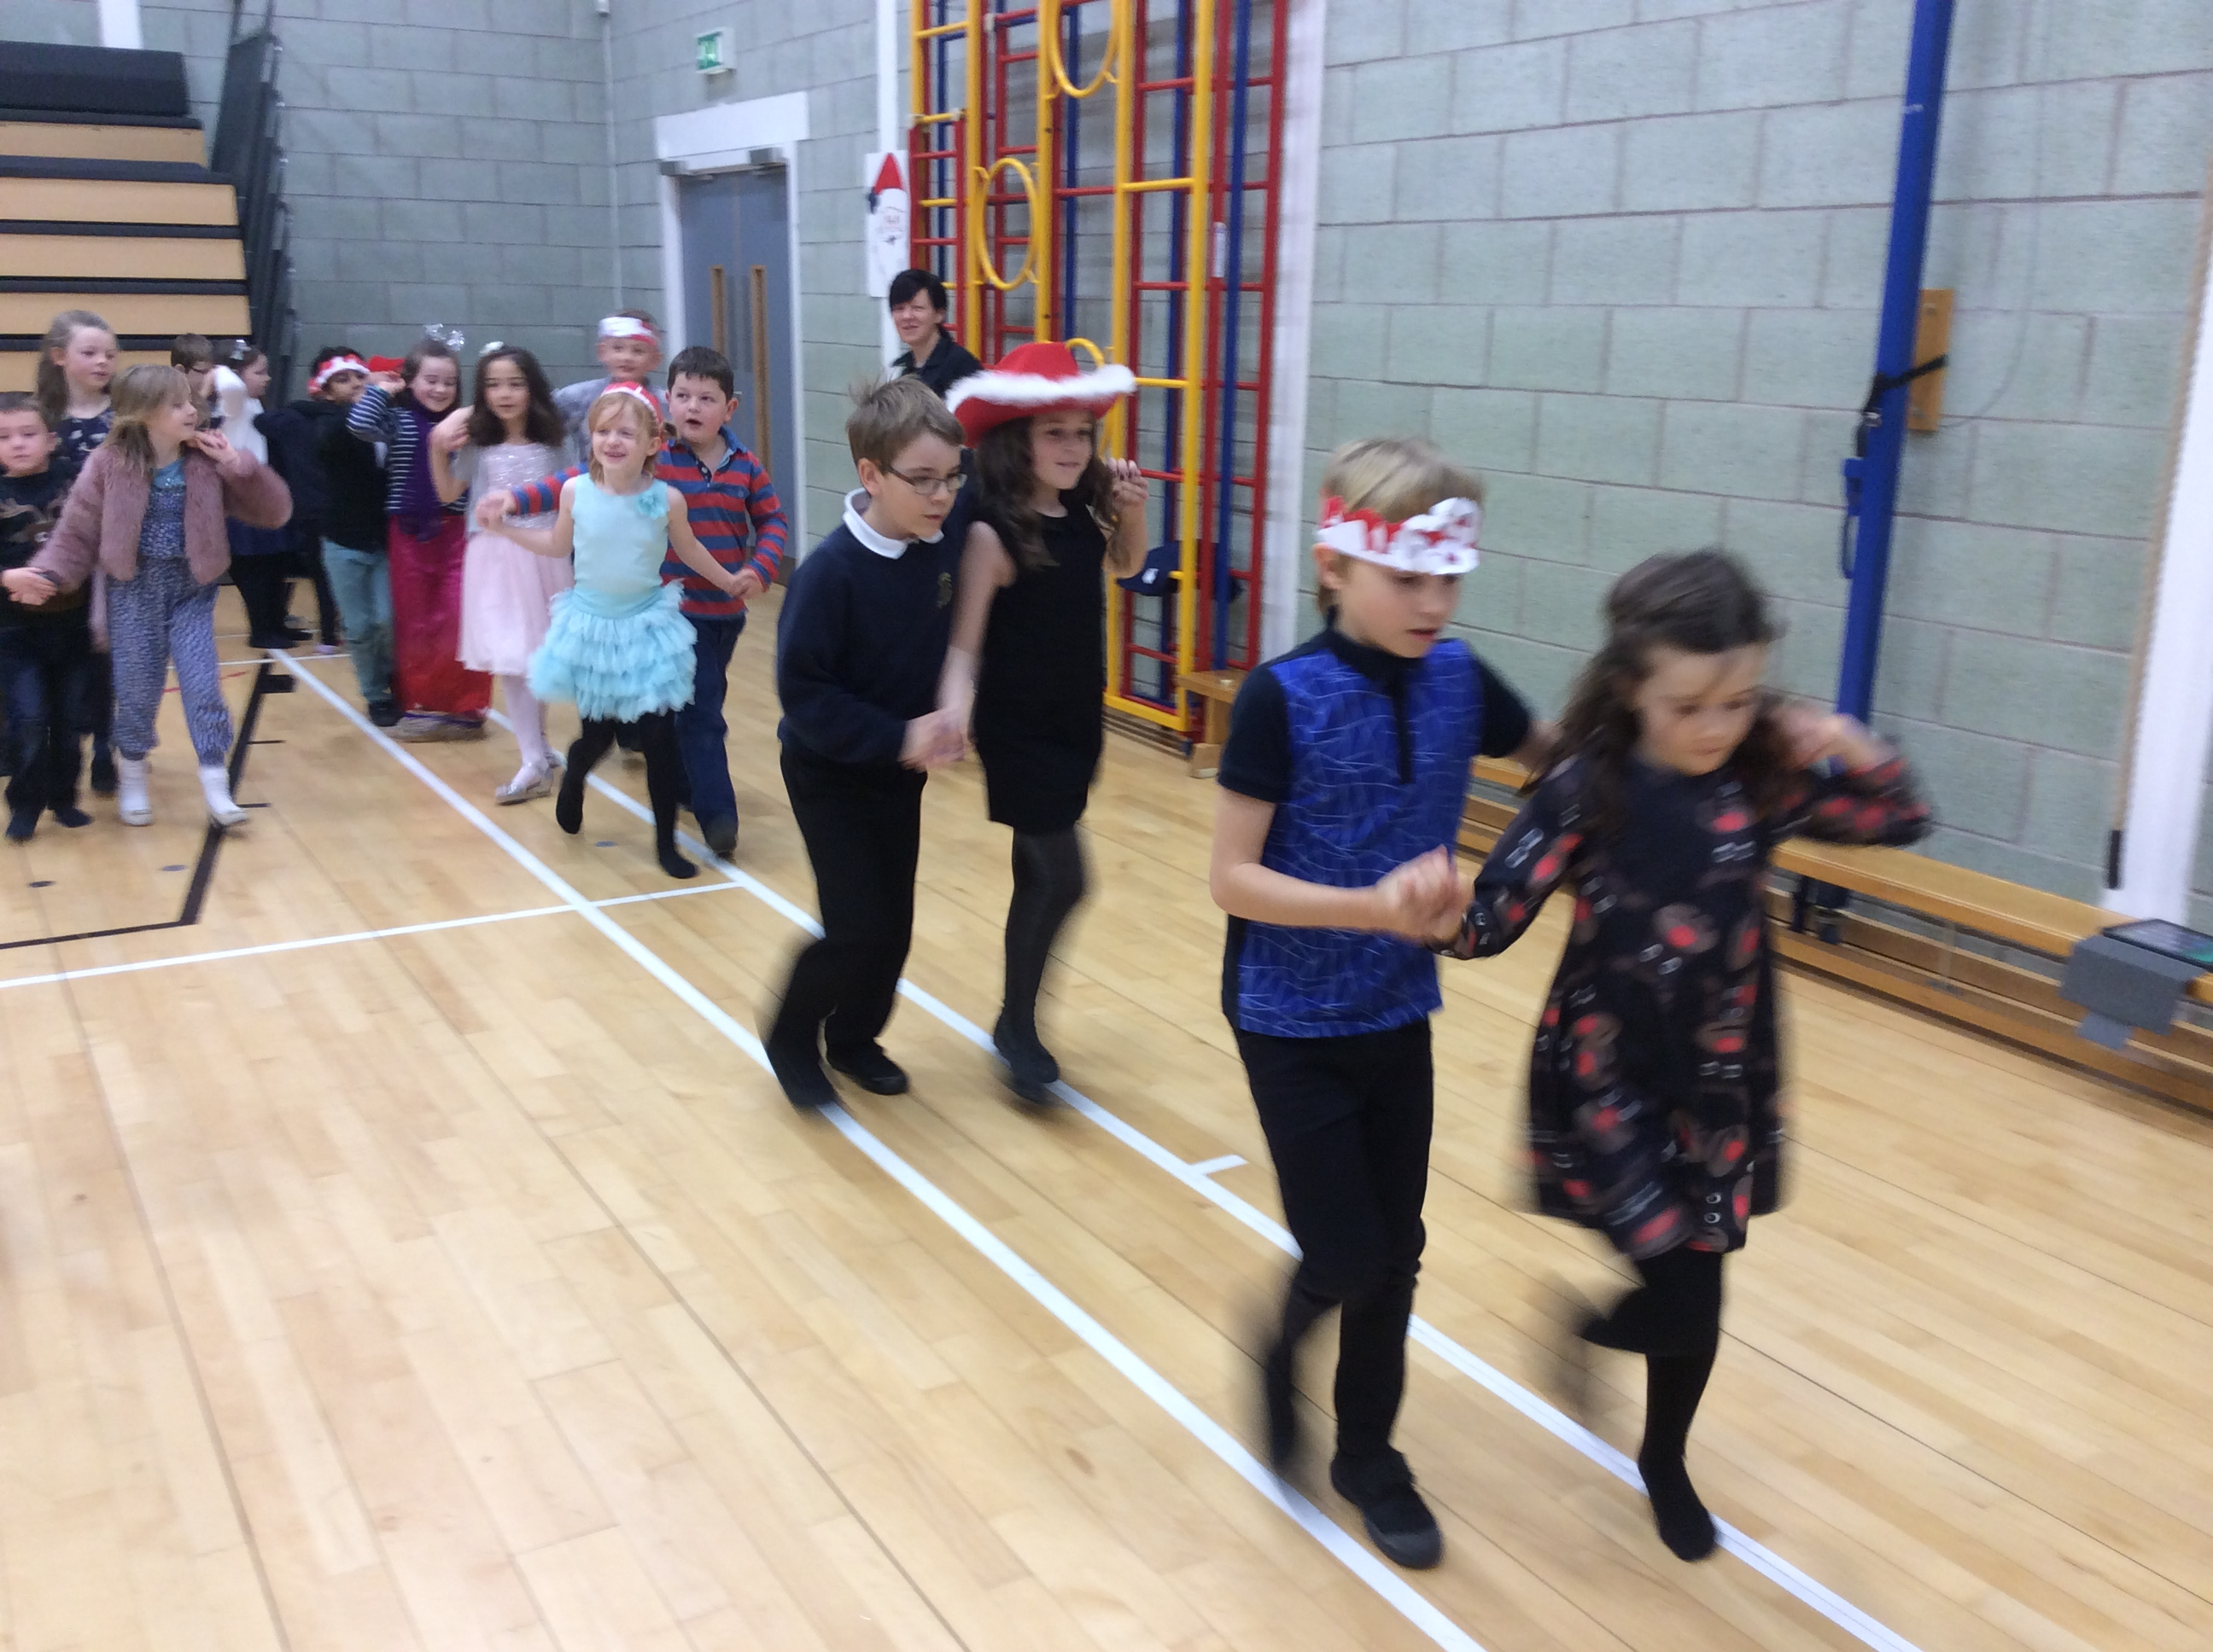 |  | Christmas  This term was packed full of fun Christmas activities. We absolutely loved performing in our school Nativity. We hope you enjoyed it too! |  | 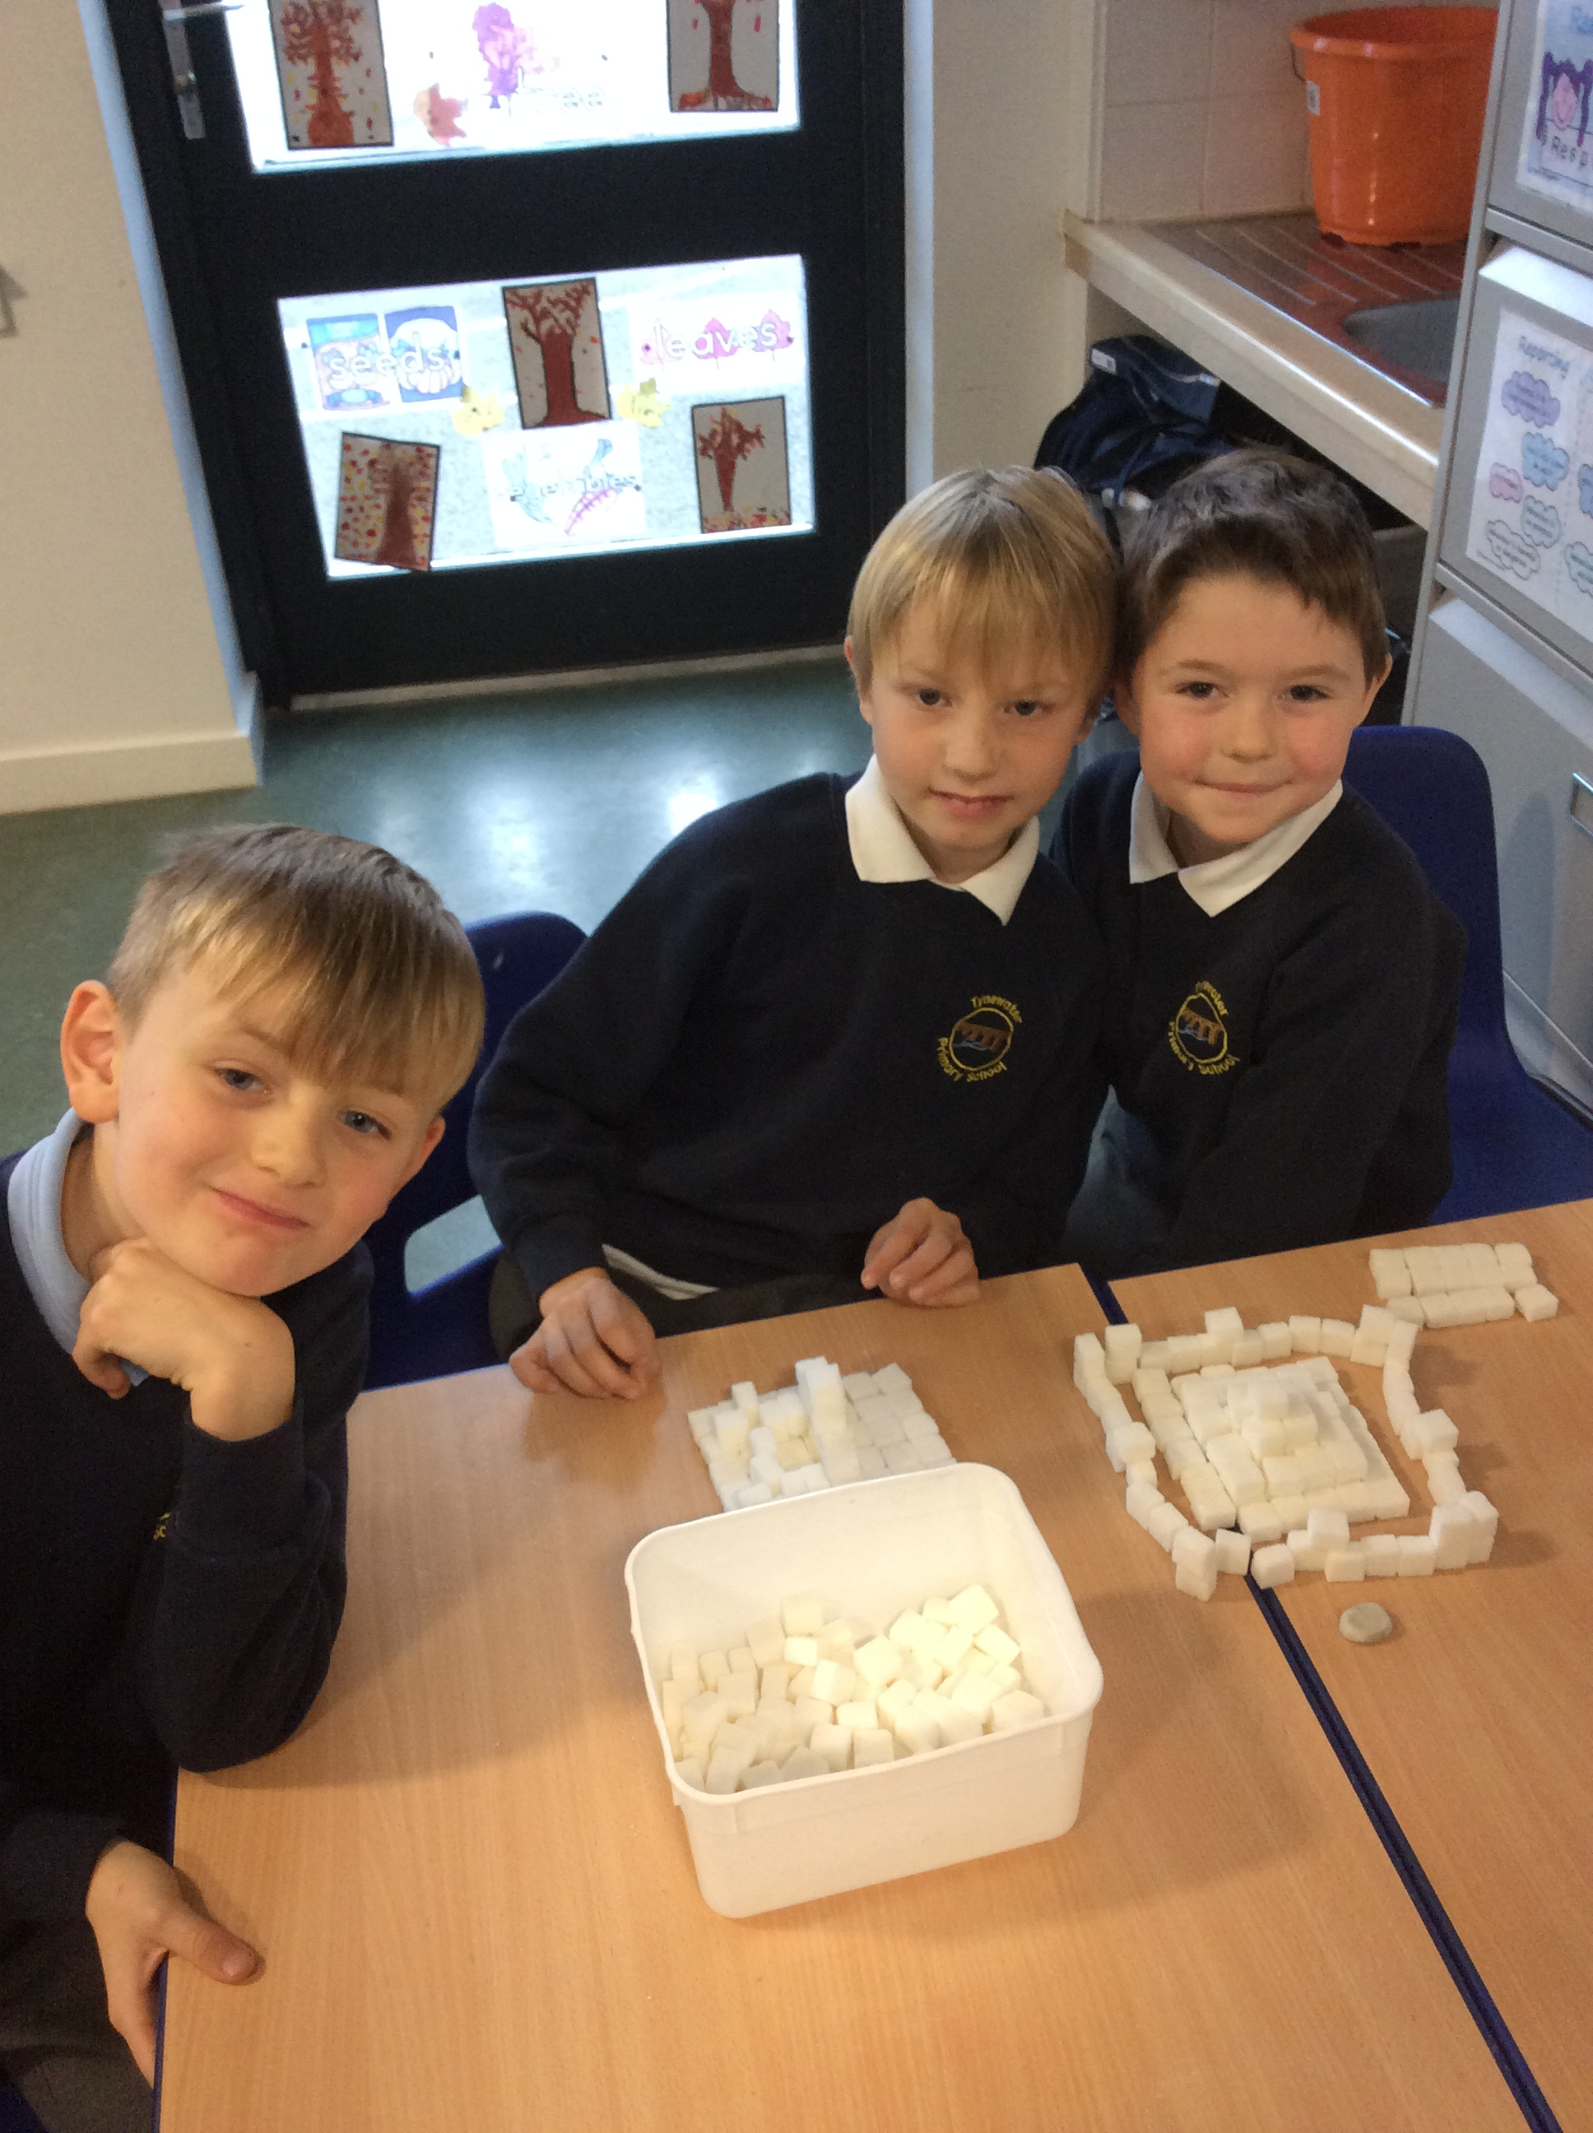  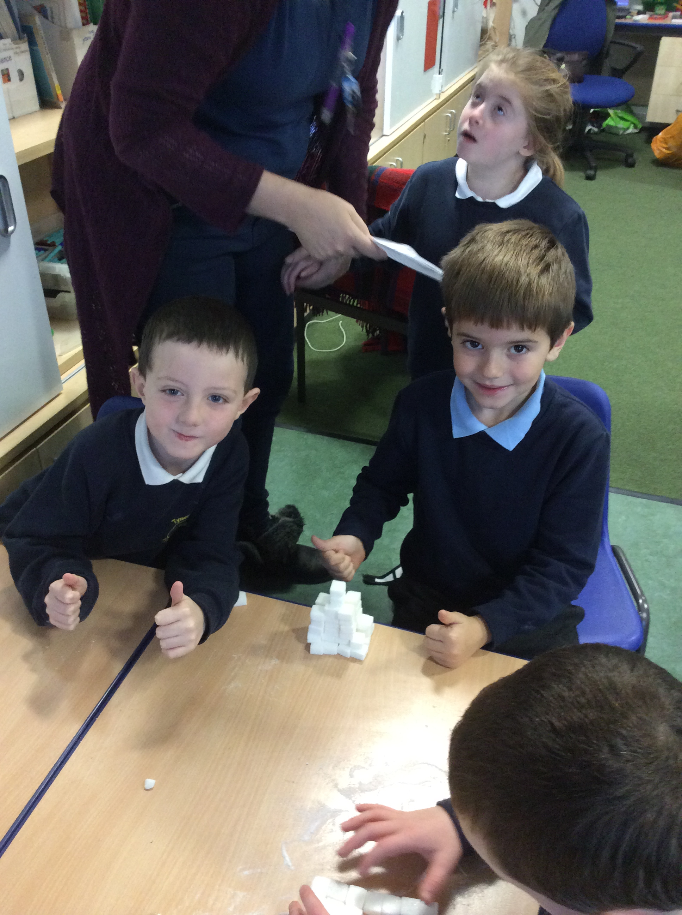
Christmas party  We absolutely loved sharing our Christmas party with the P4’s. We learned three new Scottish dances in P.E. and it was great to perform these on the day. |  | 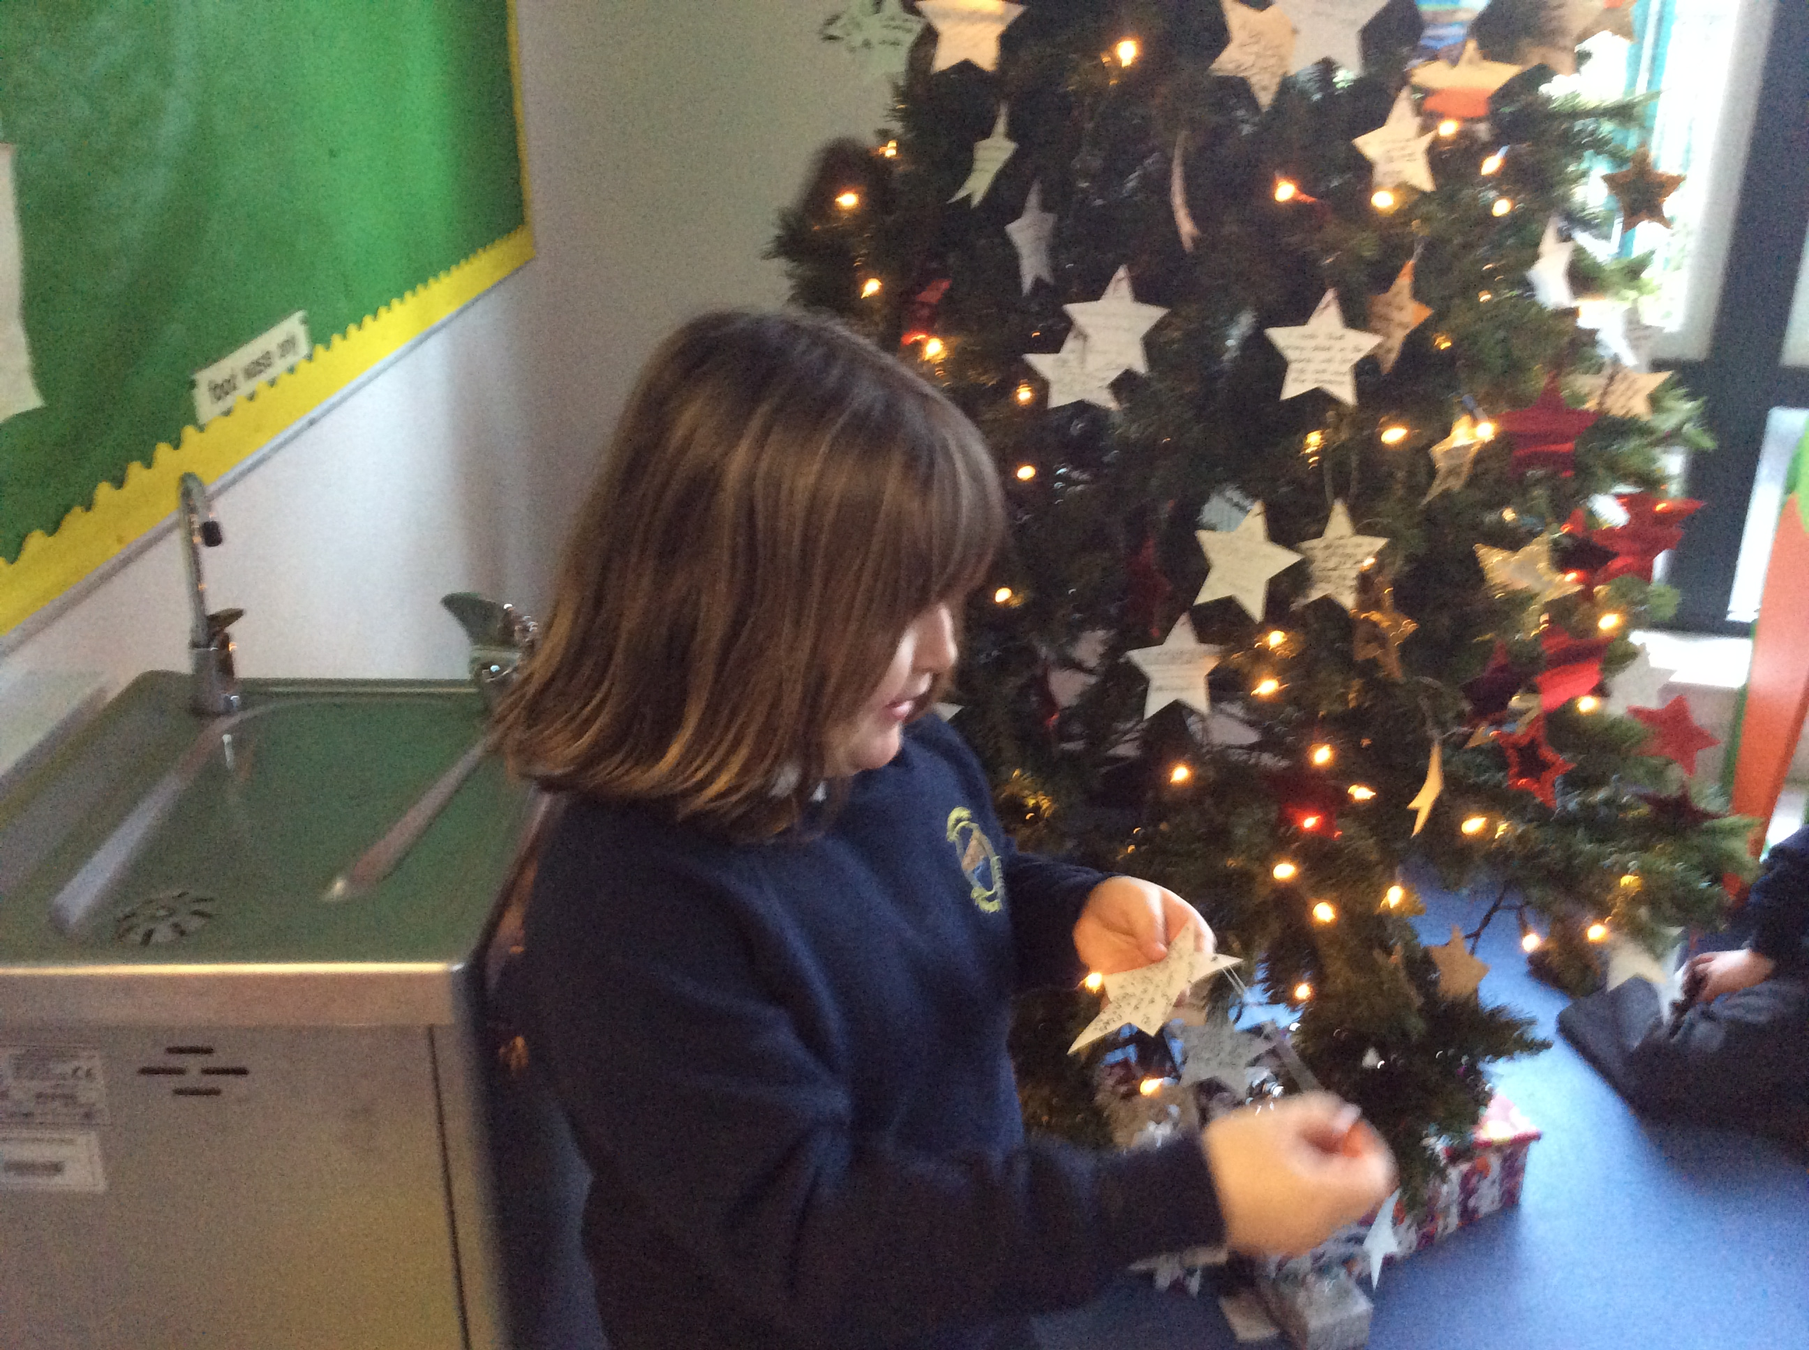 |  | Ancient Egypt  We enjoyed designing and building our own pyramids using sugar cubes. We also enjoyed having a competition to make the best mummy. It was quite tricky to wrap somebody up using toilet paper!
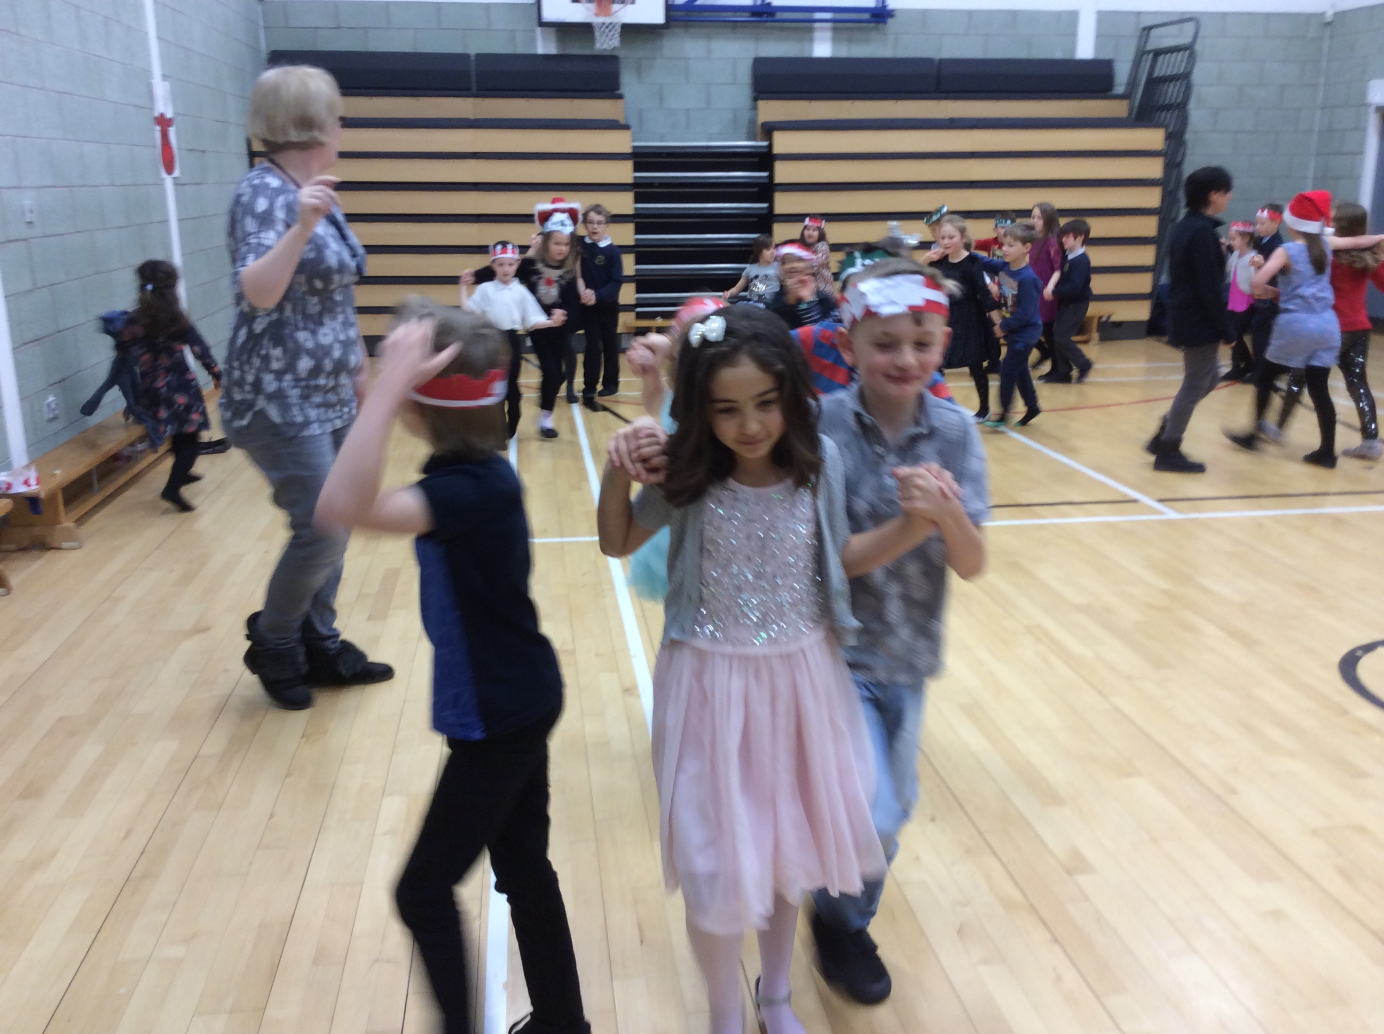 |  | One of our favourite Christmas activities was writing a wish for the new year and sharing it with the rest of the class. We really enjoyed putting our wishes on the tree. |  | 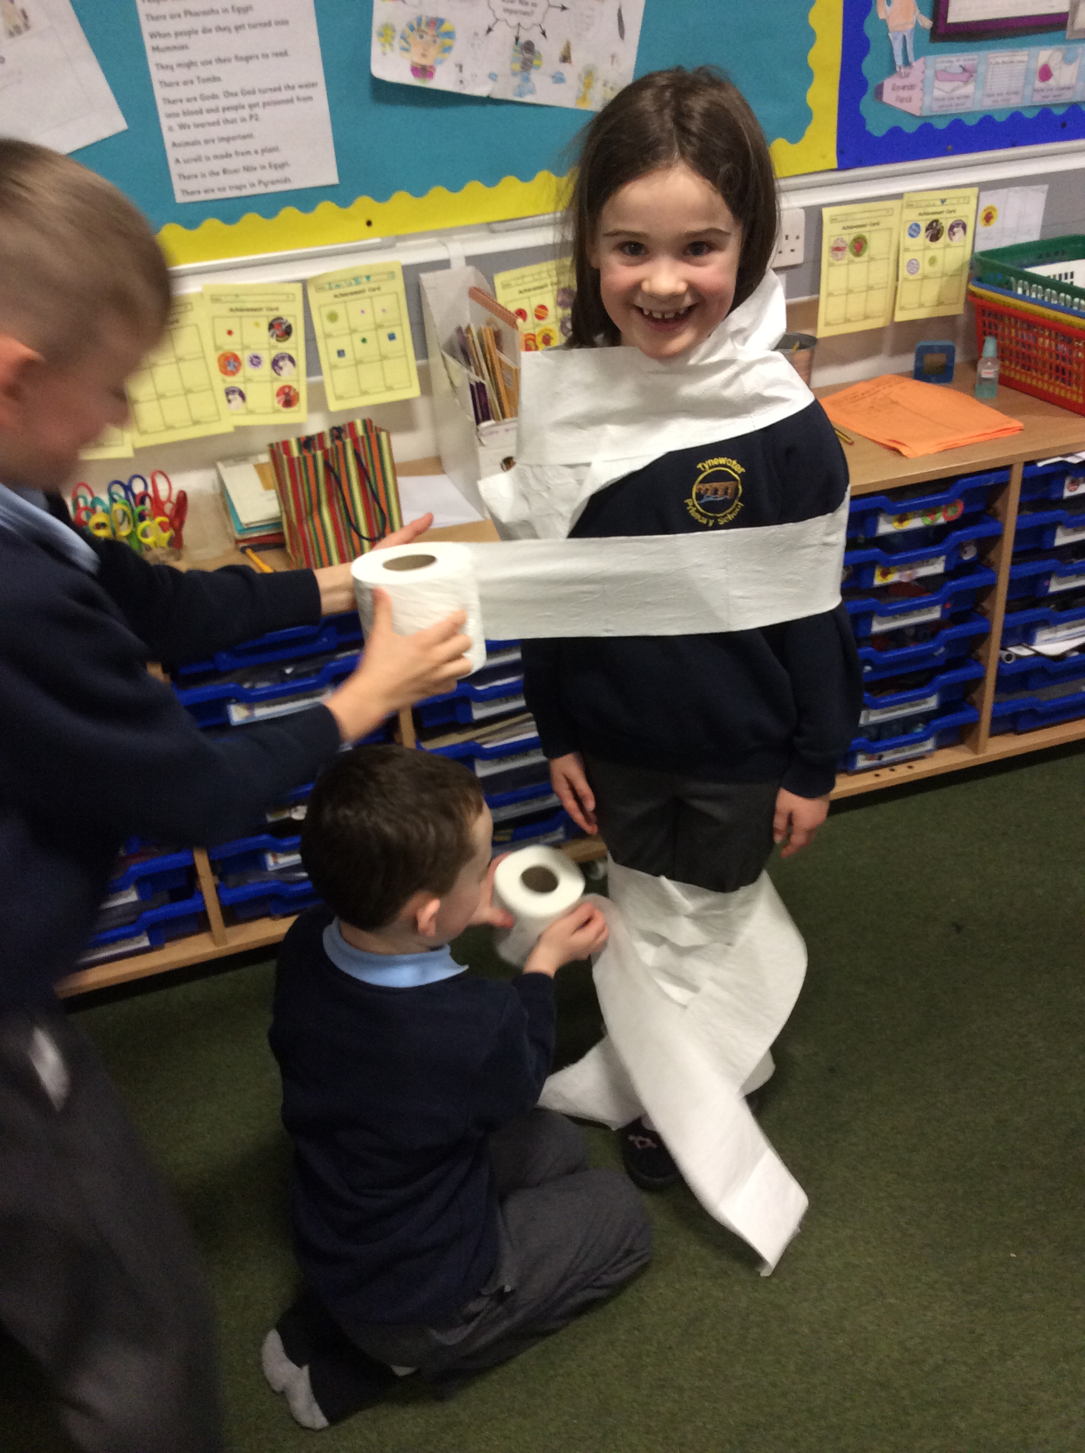  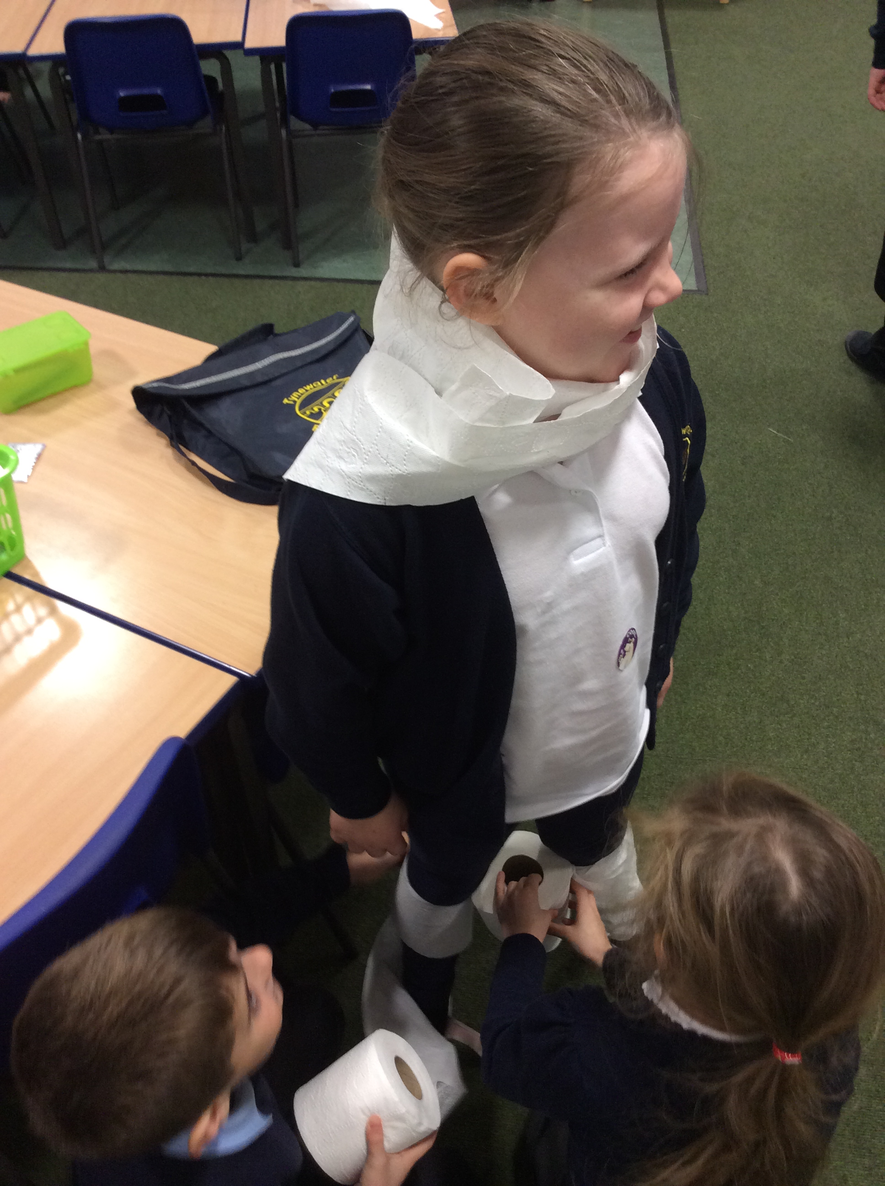  Text or photograph

