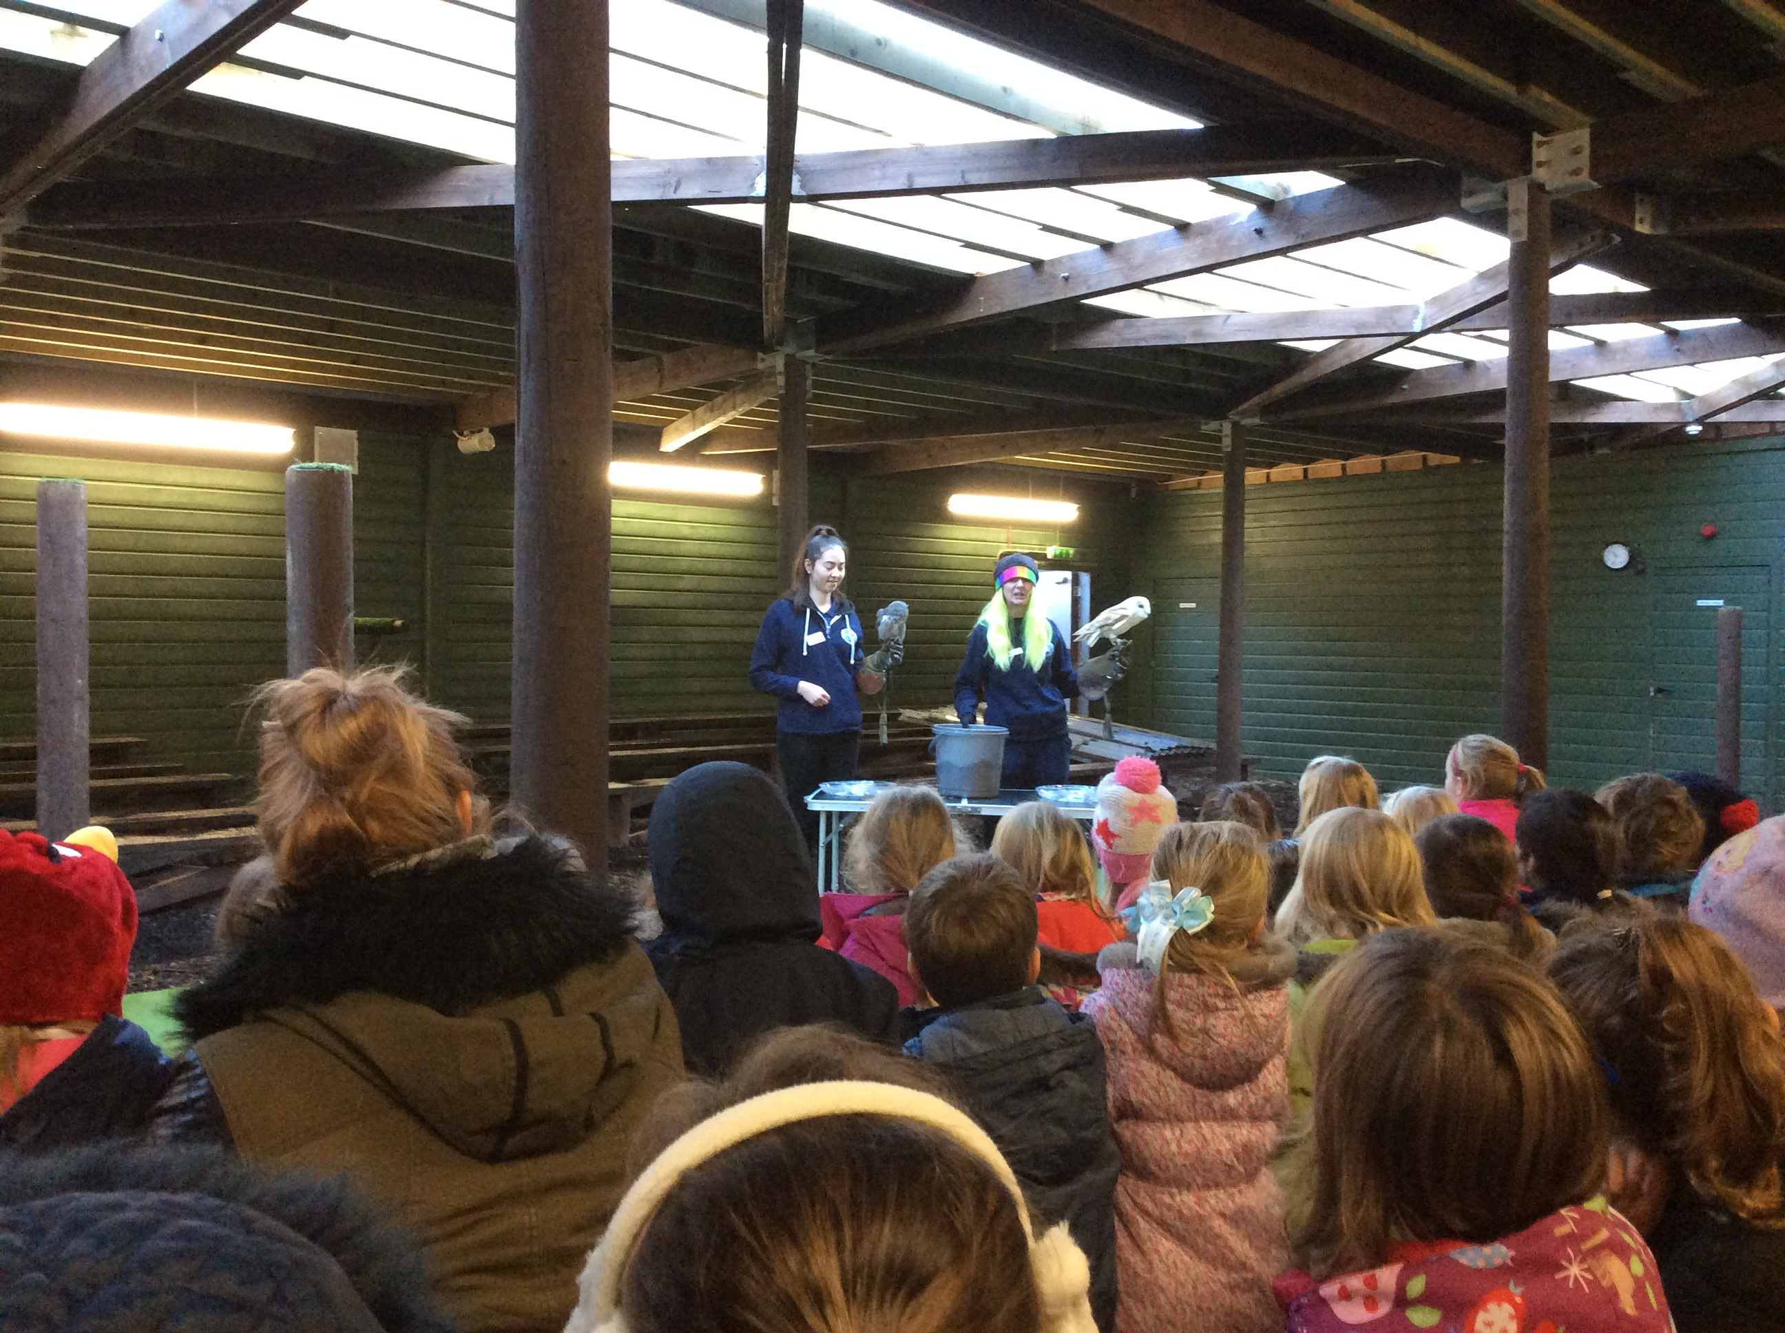 |  | We had a fantastic time dressing in our pyjamas for ‘Children in Need’ day and we were really surprised when Pudsey arrived at Tynewater and came into each class to visit us. |  | 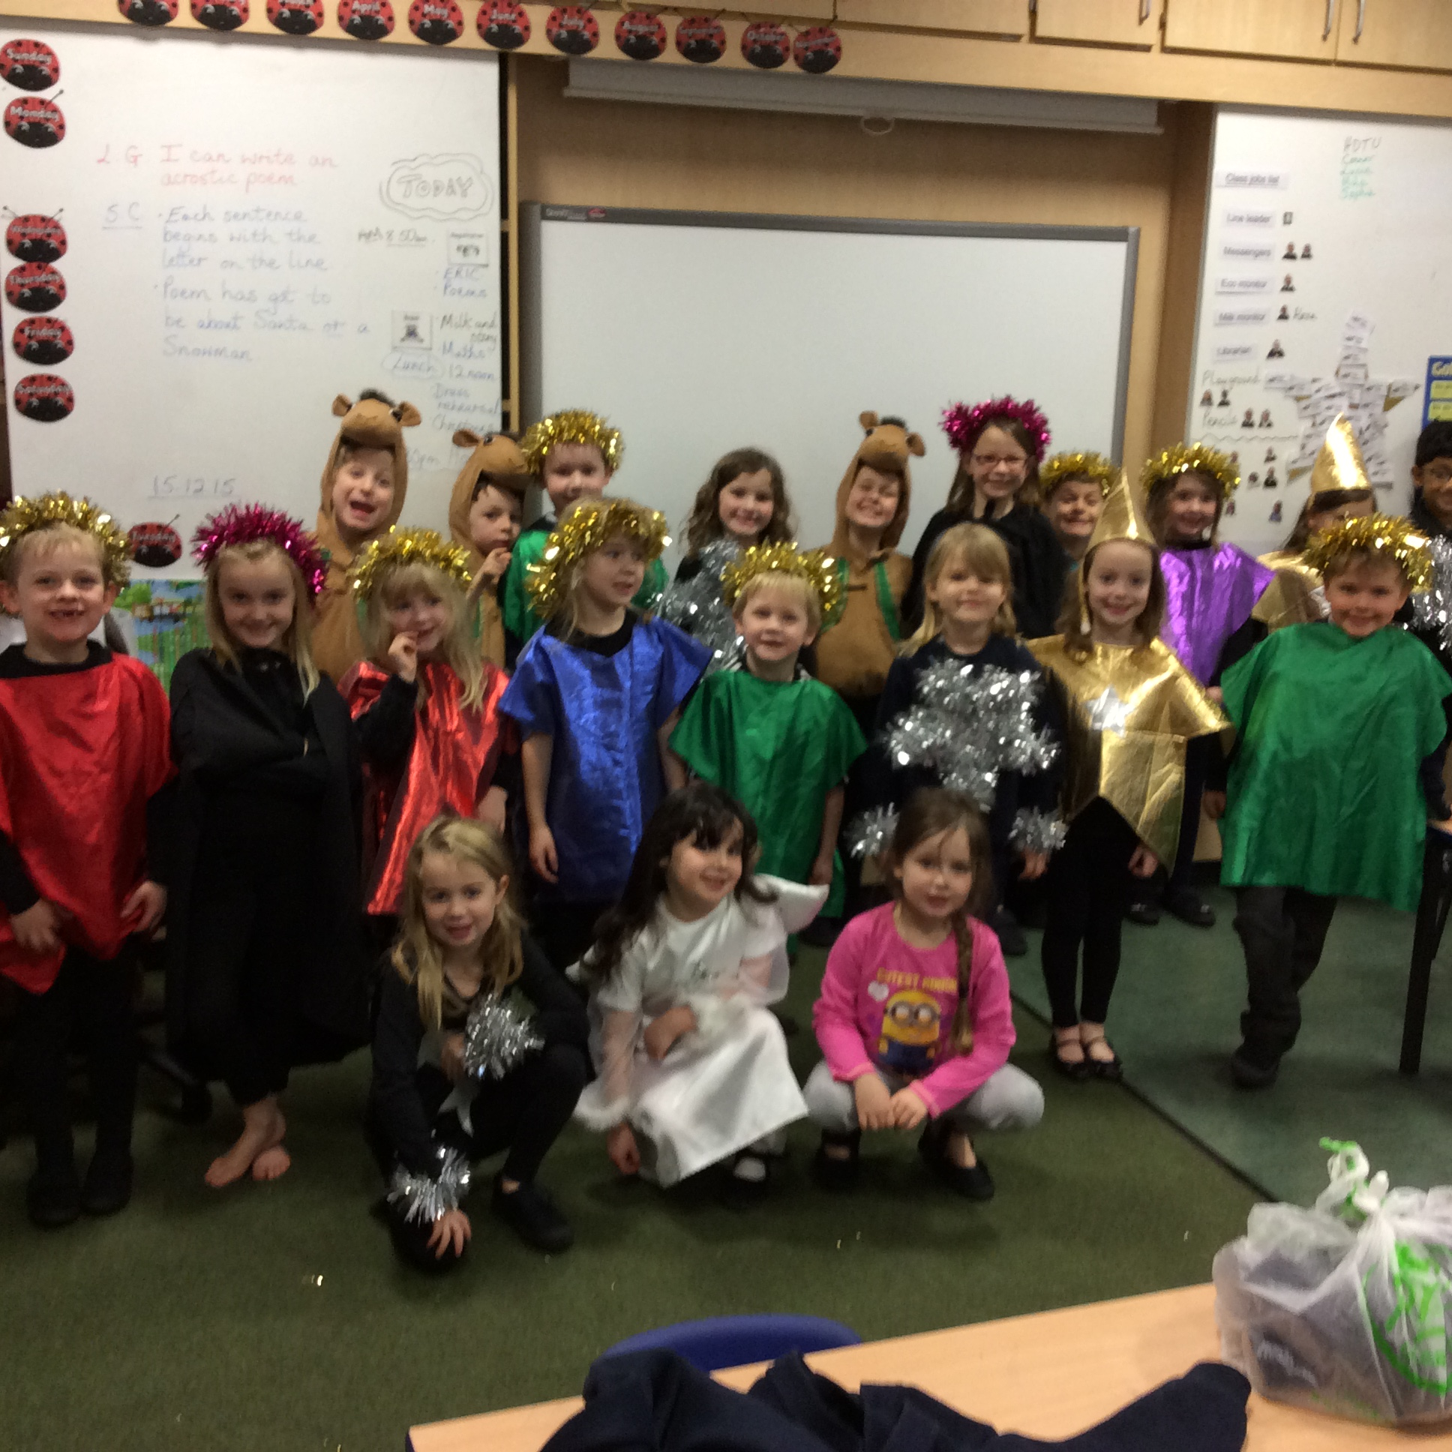
Primary one and two had a wonderful day at the Owl Centre discovering lots of things about different owls. The barn owl flew silently above our heads and we couldn’t hear her at all! |  | 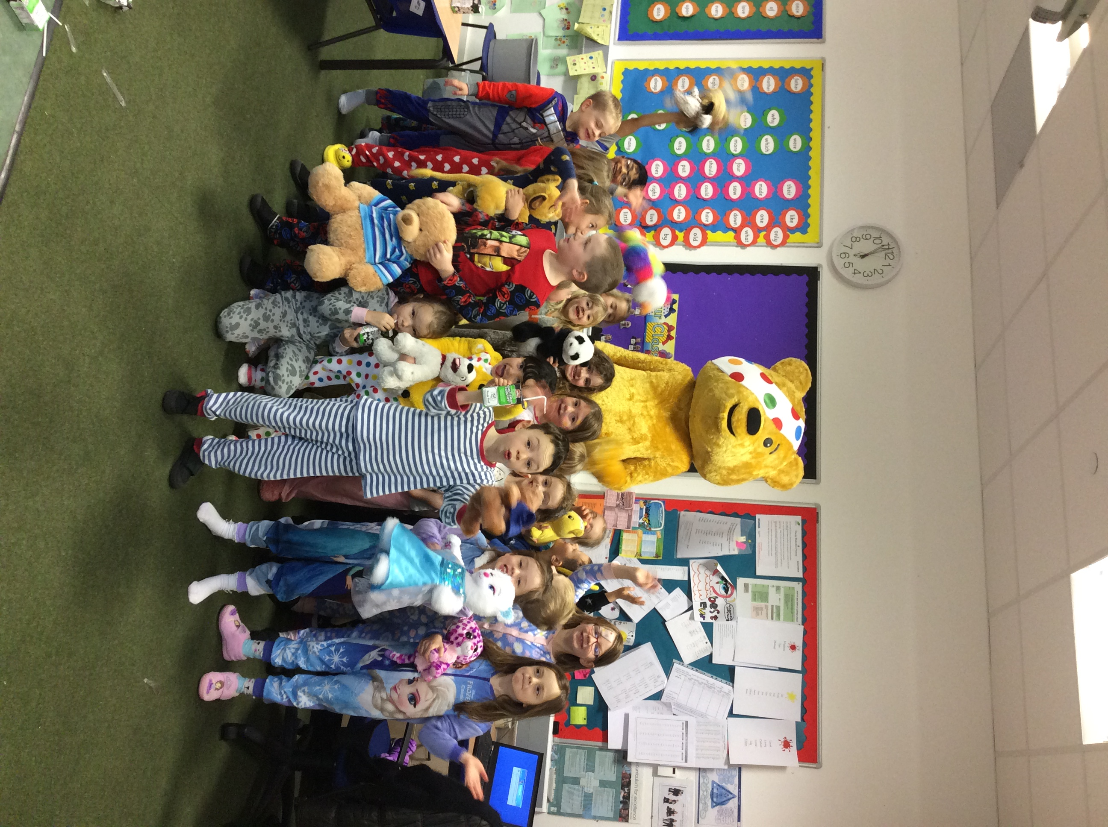 |  | We worked really hard learning all the songs and words for the Nativity but we enjoyed dressing up as stars, camels, angels and choir members. We think the mums and dads liked seeing us too.
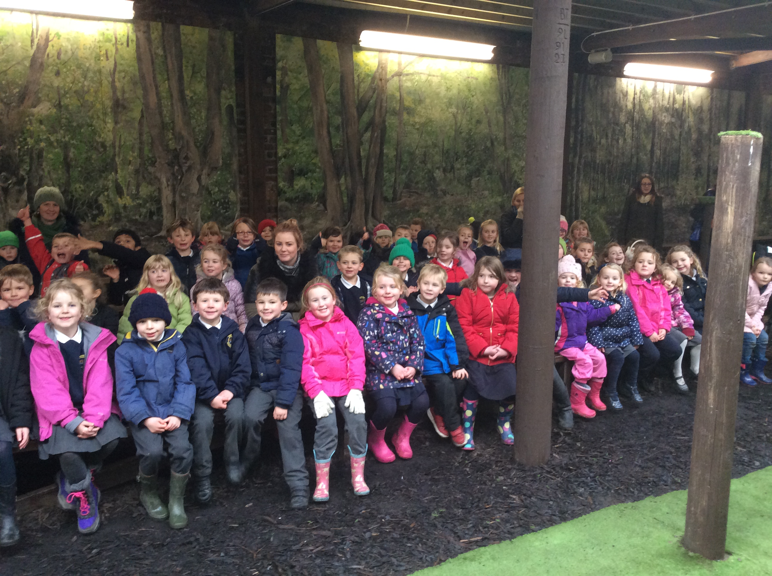 |  | Before our Nativity presentation, we had fun making our Christmas hats and then Santa came to our party and gave us all gifts. Everyone (except the teachers) was on the good list, so we all got one. |  | 

