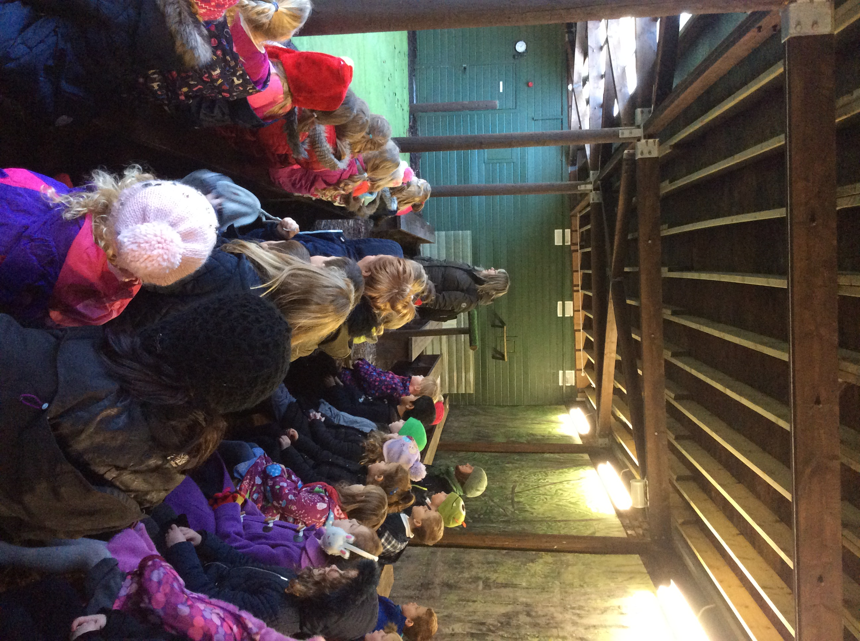 |  | Christmas Nativity  We worked hard to learn the songs and rehearse our parts for our Christmas Nativity, Sparkle. We hope that you enjoyed watching it as much as we enjoyed performing it for you. |  | 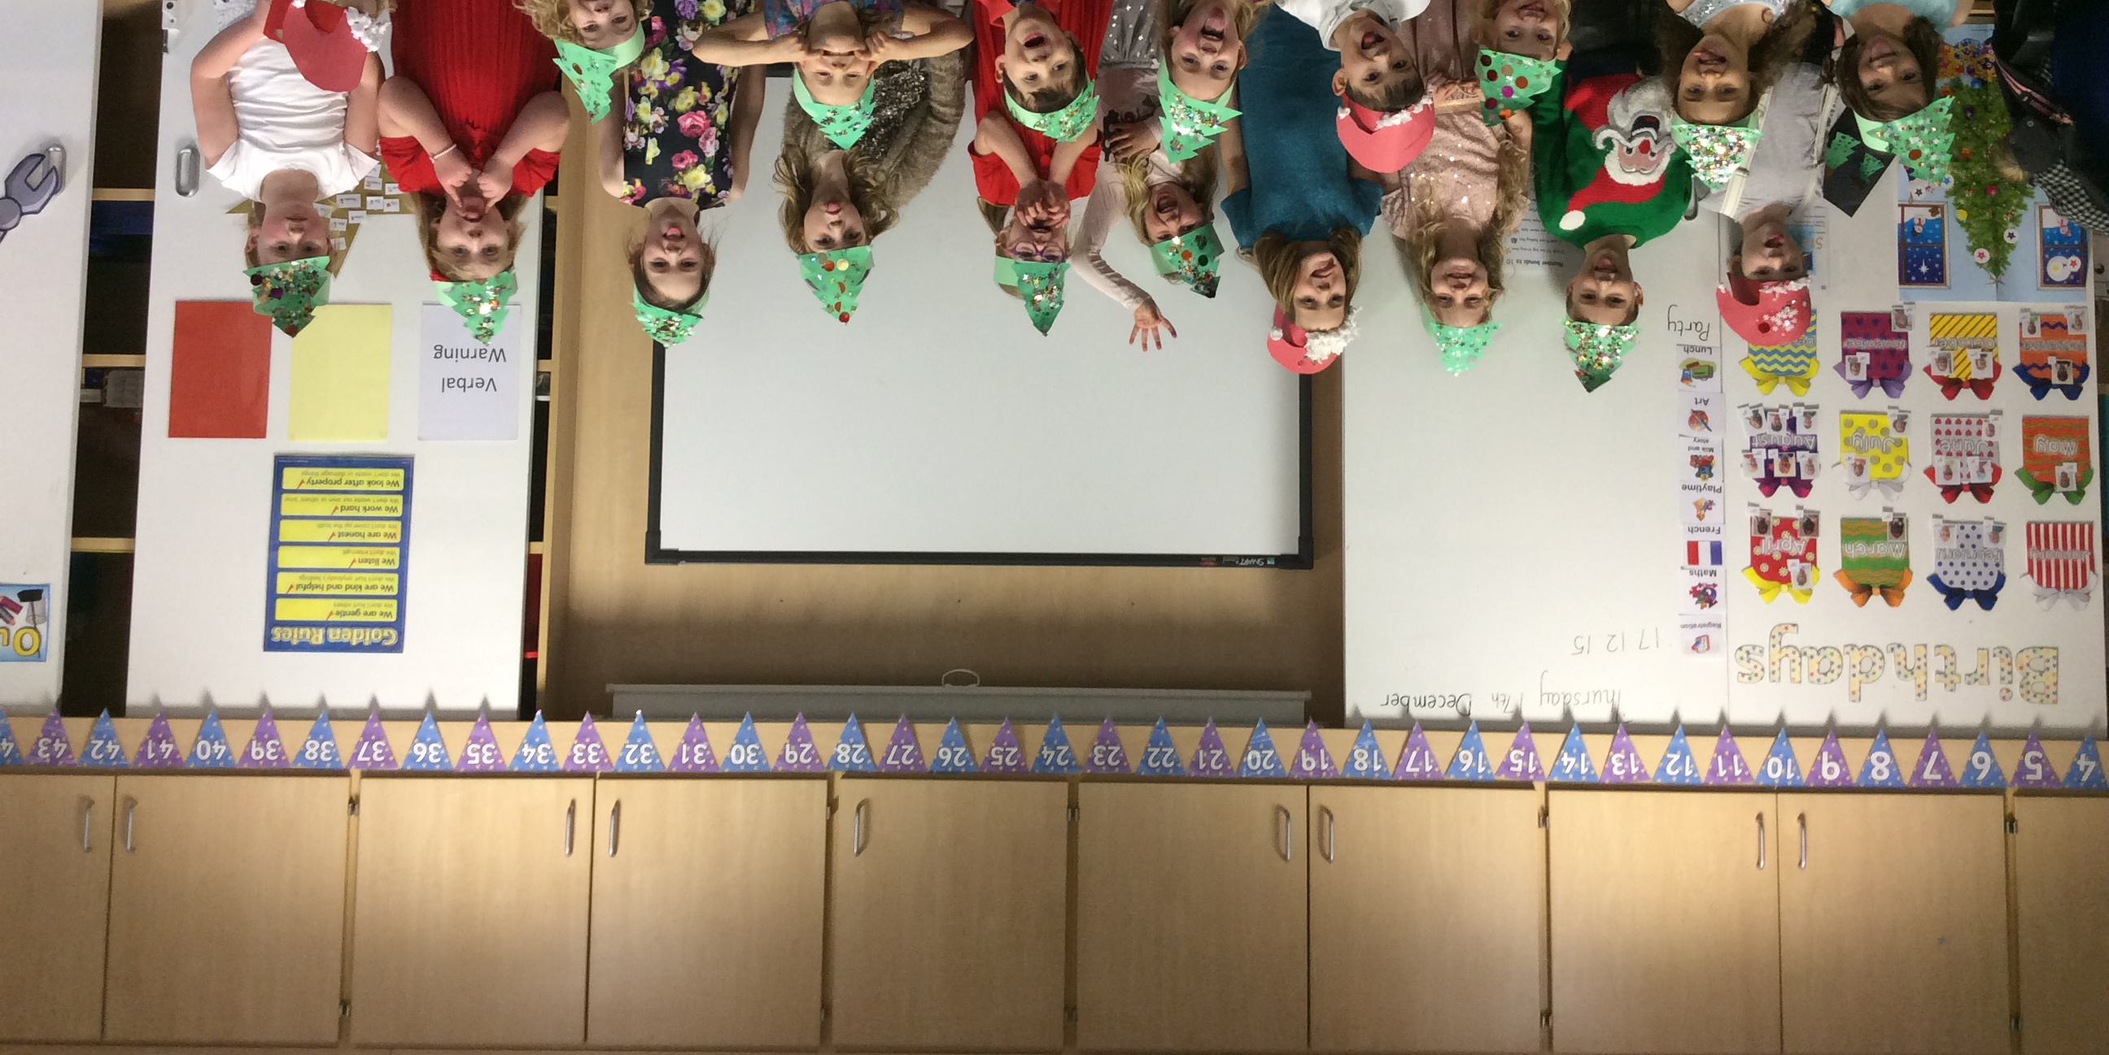
Owl Centre  We had lots of fun at the owl centre and met lots of different owl species. We learned what owls like to eat, how they find their food and where they live. |  | 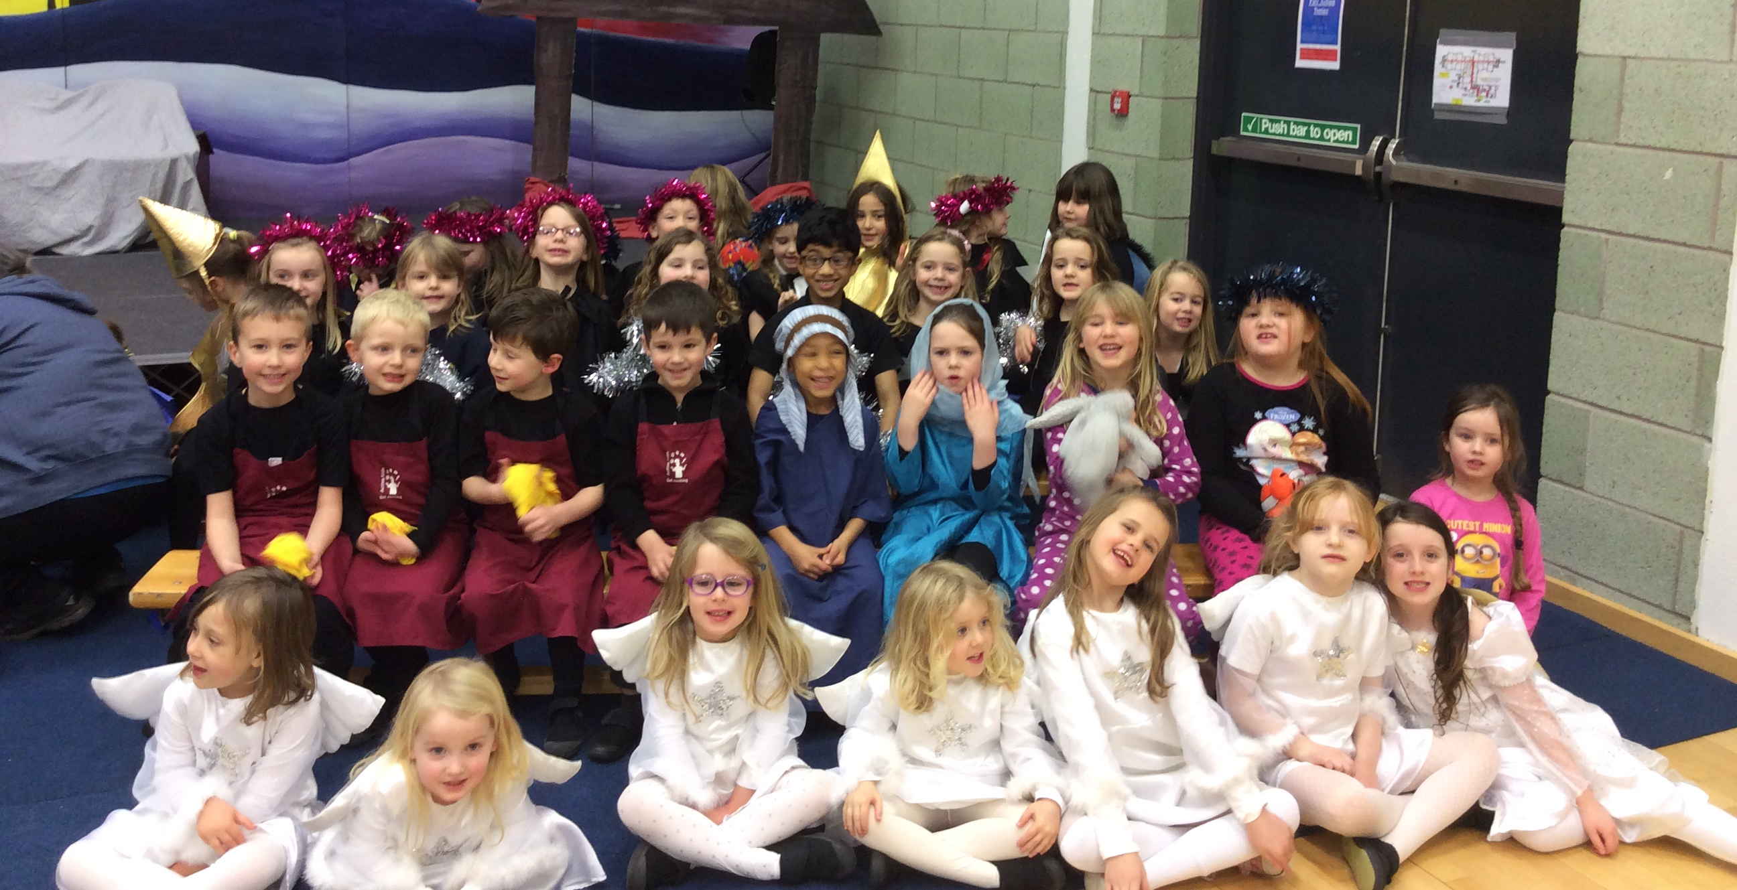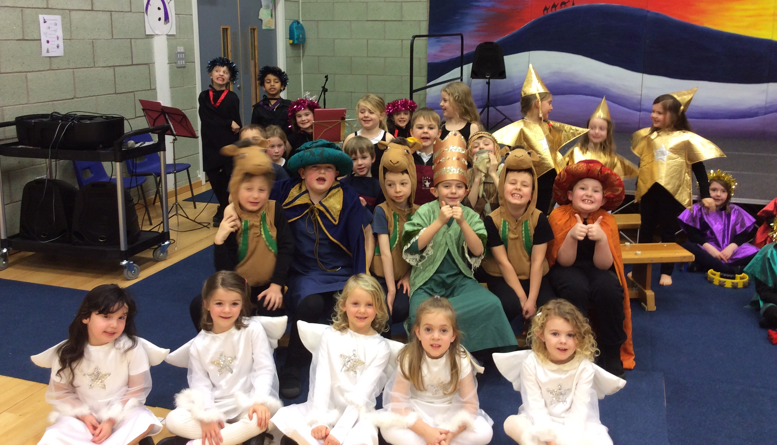 |  | Christmas Lunch  We made santa and Christmas tree hats for our Christmas lunch. We drew round and cut out the different shapes and then decorated our hats with glitter and cotton wool.
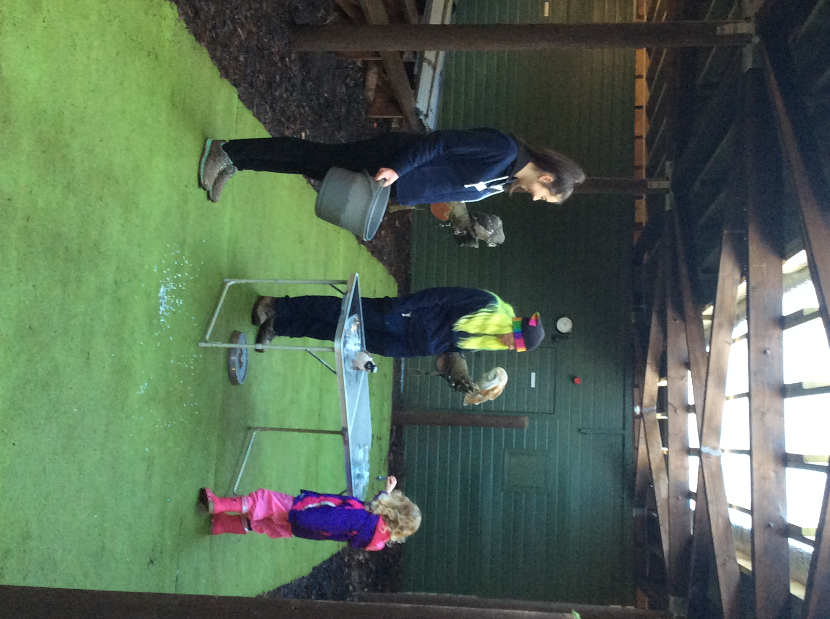 |  | Christmas Party  We dressed up in our best party clothes for our Christmas party. I think that we must have been good as Santa came and brought us all a present. |  | 

