Primary 7 LONDON trip!  On the way down to London we stopped off at Berwick Upon Tweed, Newcastle, York, Darlington and London. It was not bumpy and the journey was fun! It took 4 hours 21 minutes. Matteo |  | 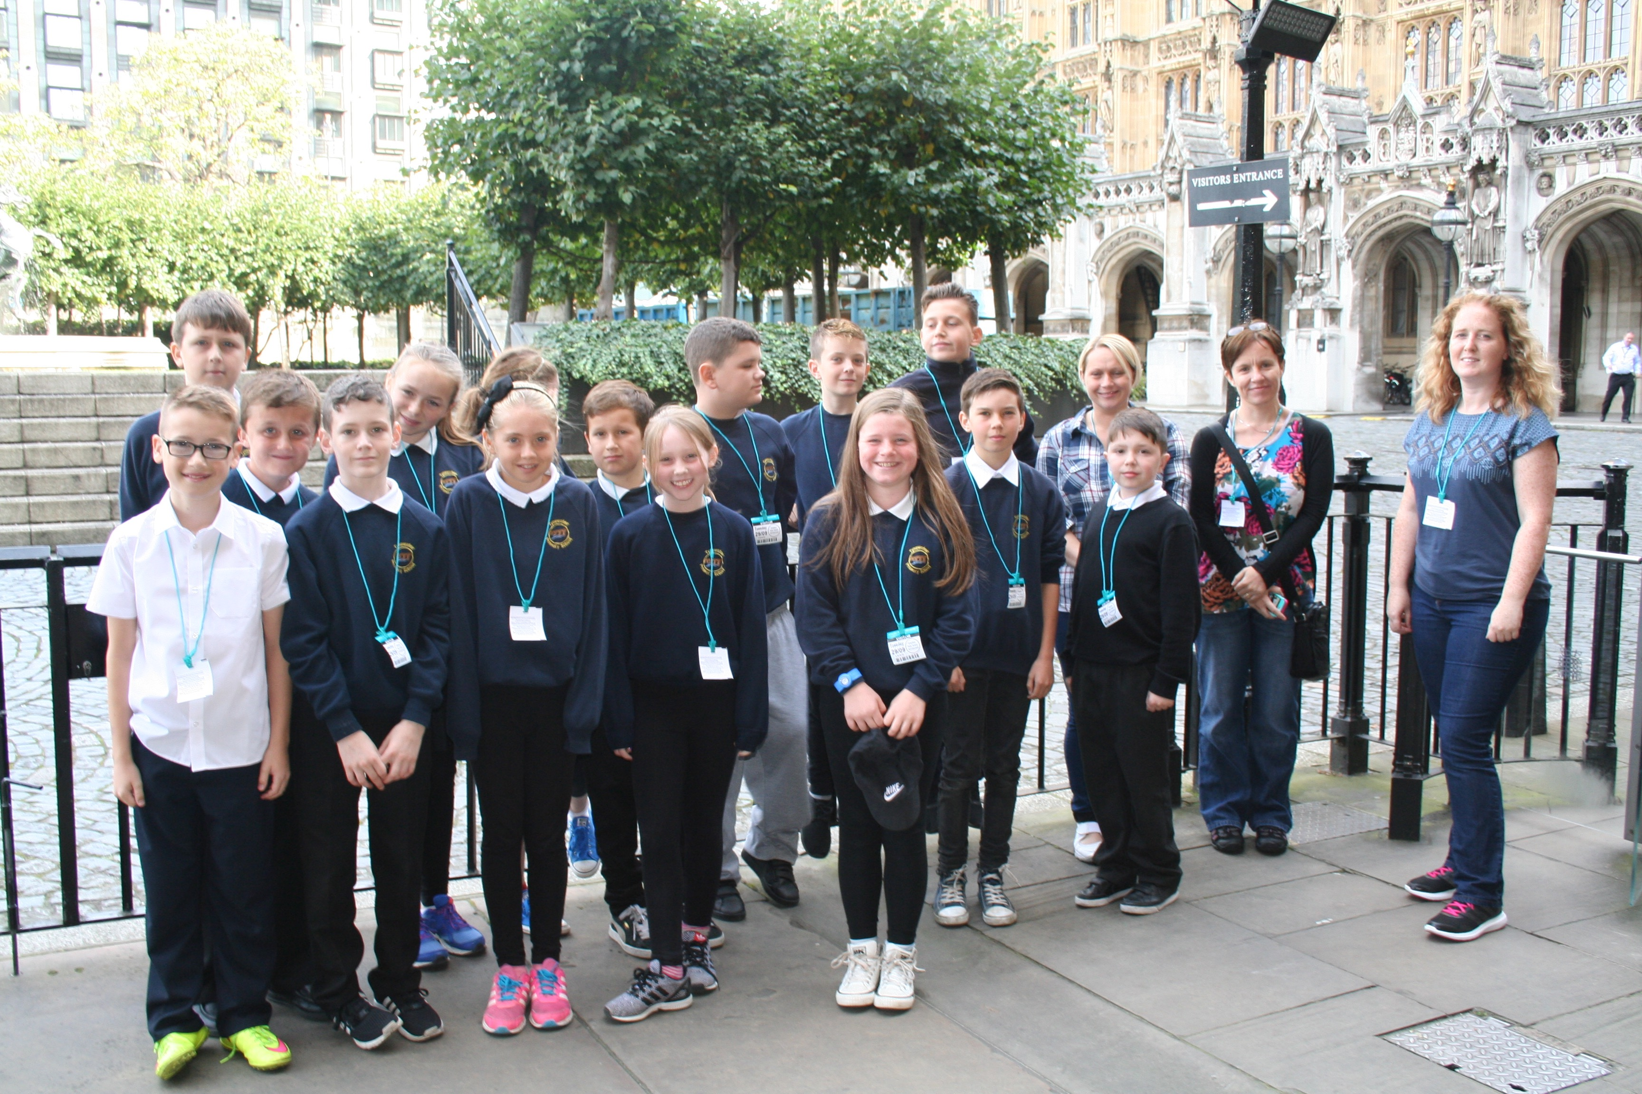 |  | Westminster Parliament: The Parliament was much bigger than I thought. It looked a bit like a massive castle. They have LOTS of different rooms for all the people who work there. We had a workshop and learnt a lot. Kerr
Hostel  The hostel was not as I expected. It was more like a hotel! There were more schools visiting, not just us. The beds were triple bunk beds. They were very comfortable. Erin |  | The Museum of London  It was massive and very interesting. We learnt a lot about Medieval London. There was lots of information about Bronze and Iron aged London too. The gift shop was great too. Luke. |  |   The BBC: The BBC had a lot of rooms; over 1000 people work there. We got to visit the One Show studio and sat on their couch! Matteo and Lucy got to read the news and Erin did the weather. Scott had a floating head! Eilidh
The breakfast was amazing! Matteo  The Tube: The tube was really noisy, and bumpy and could be a bit scary. You could see the wires alongside the track. The people on the tube were a bit rude. James |  | 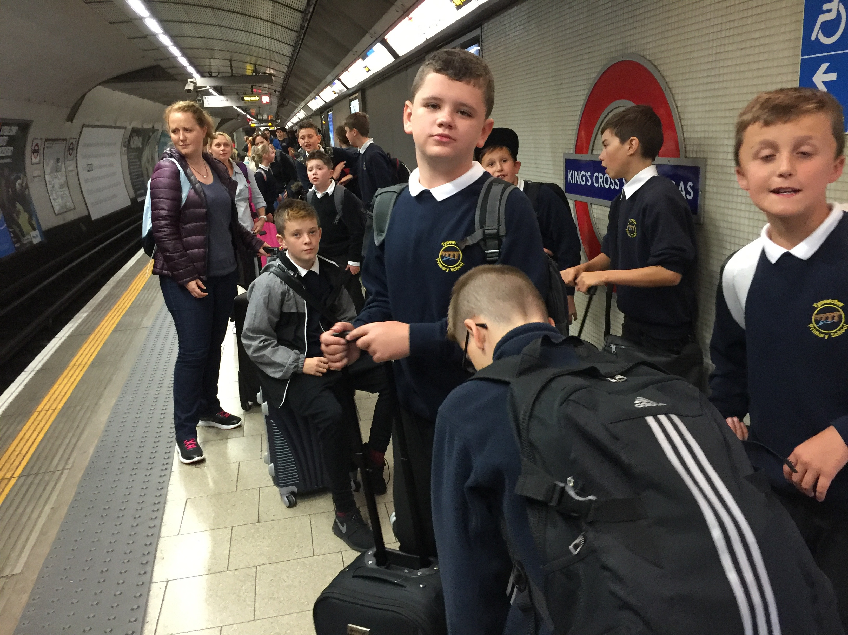
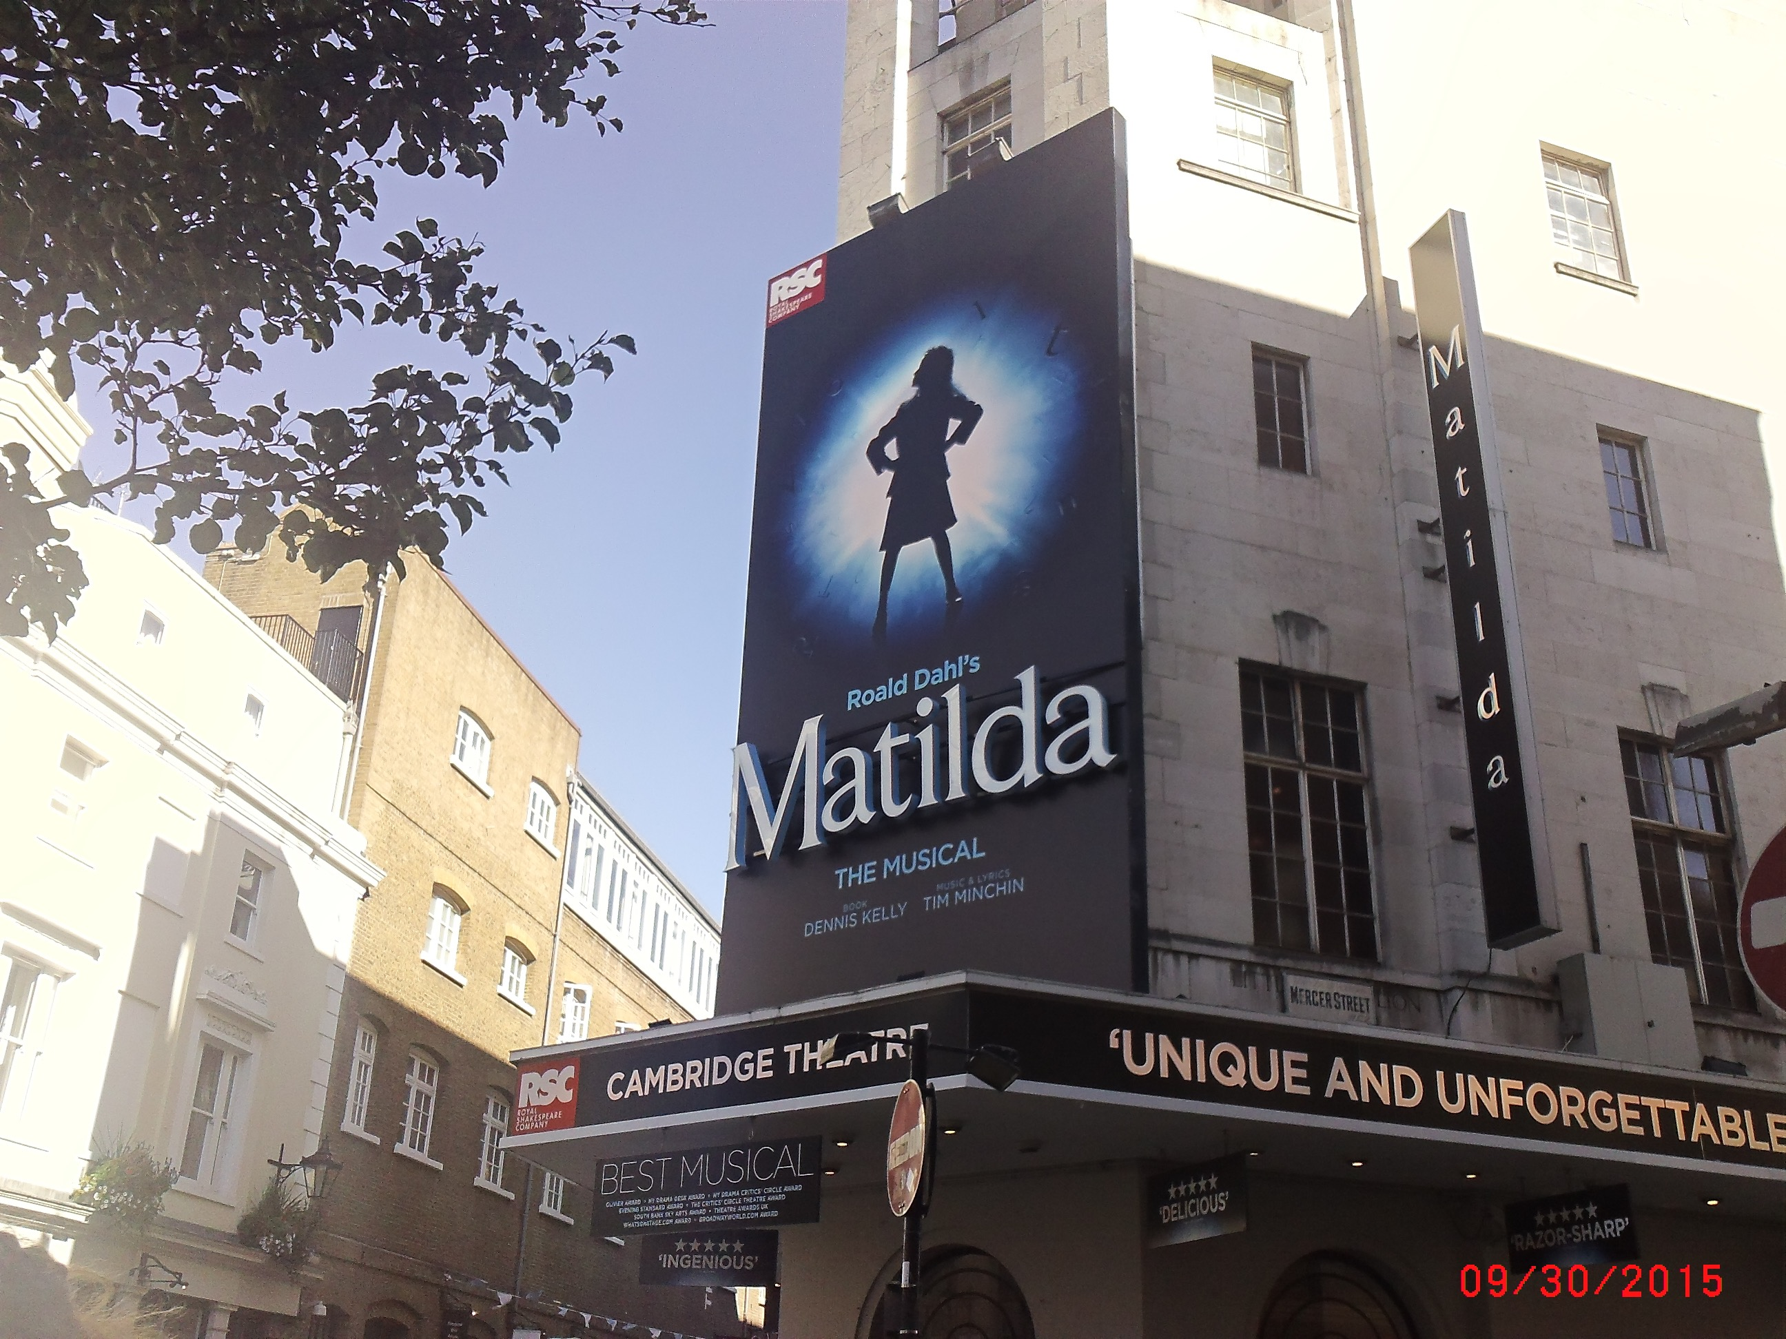 |  | Matilda: The actors were brilliant. Lizzie Wells played Matilda. It made us feel bad because they were able to remember all their lines and moves and we can hardly remember our assembly words! Kerr |  | When 15 of the P7s went to London Keiron and I stayed behind and made a big display about growth and fixed mindsets to show what a difference your mind set can make to your learning. By Katie
London Eye: The London Eye was very high. It was higher than I thought. The pods are also bigger than they look outside. It is extended now over the water. It took 31 minutes to go all the way around. I liked seeing Buckingham Palace. Samuel.  River Thames Boat: On the river Thames boat ride we got to see a lot of the famous buildings in London. We saw our hostel and it was one of my best experiences in London. We waved to people on the bridges! Matthew |  | 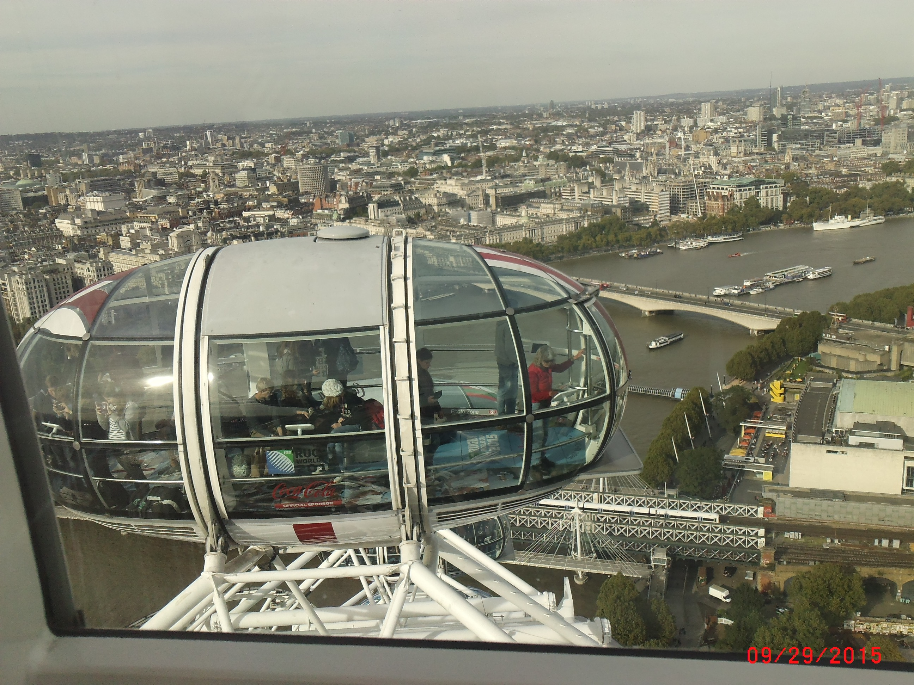 |  | Mind sets  Growth mind sets are when you are always open to learn new things. But if you have a fixed mind then you never try to learn anything new. By Katie
 |  | 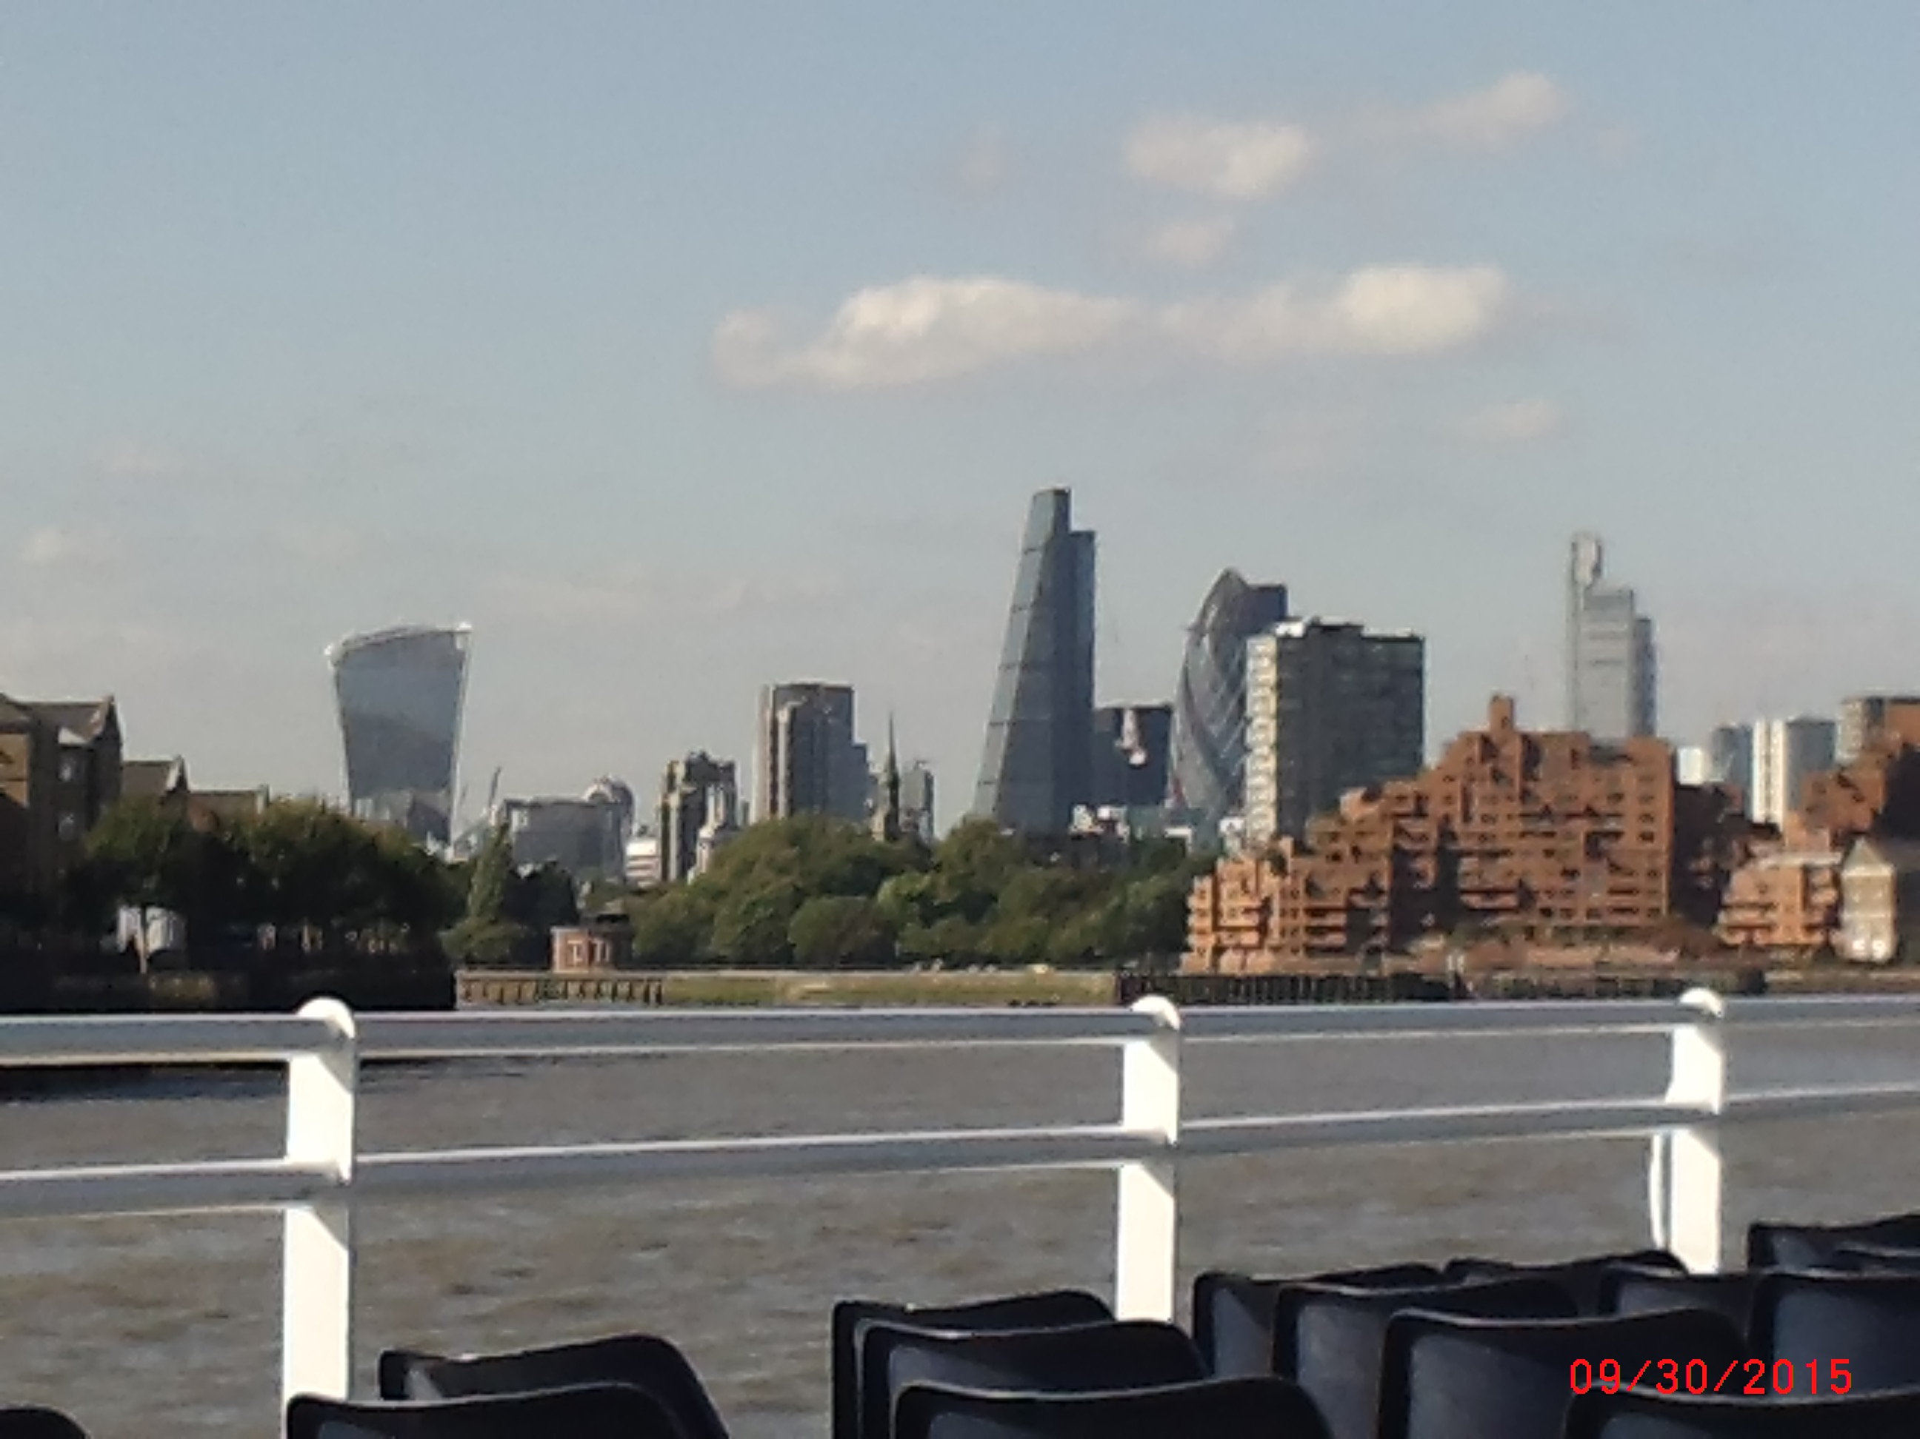 |  | 

