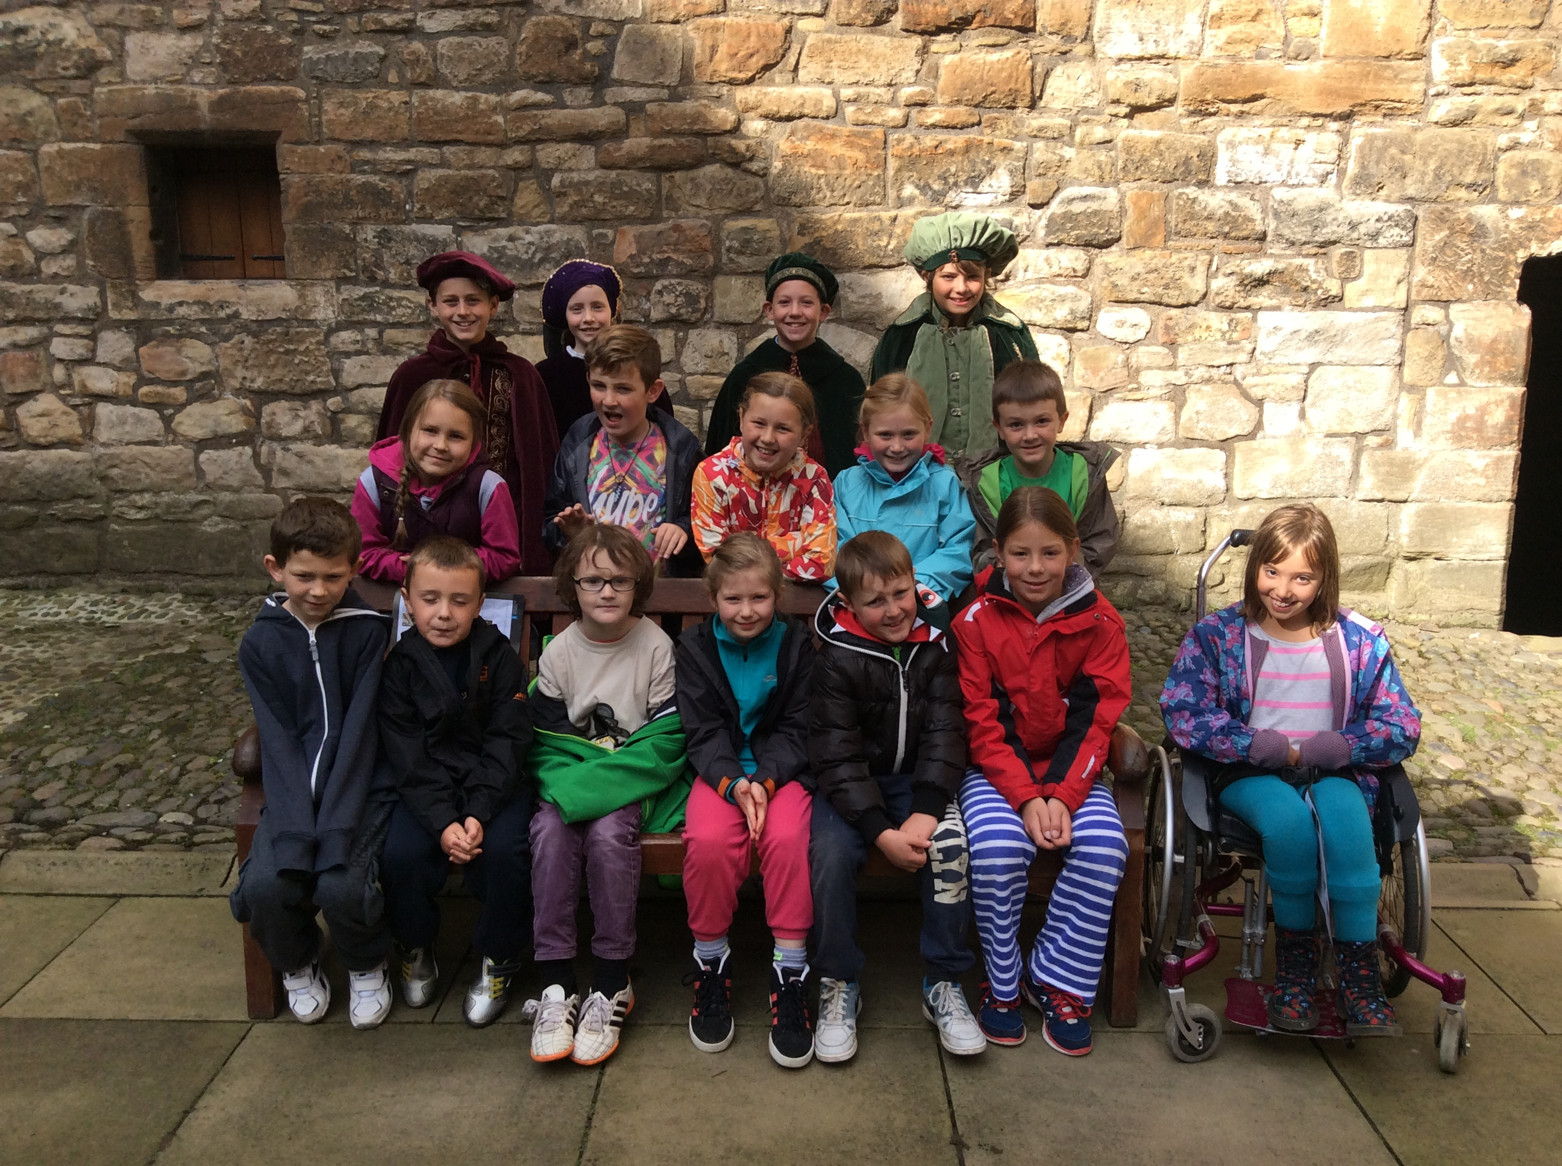 |  | We participated in a football taster session this term. We had so much fun and all improved our dribbling, passing and shooting. It’s fantastic to hear that four of the girls went along to the trials and now play for Dalkeith Miners. |  | 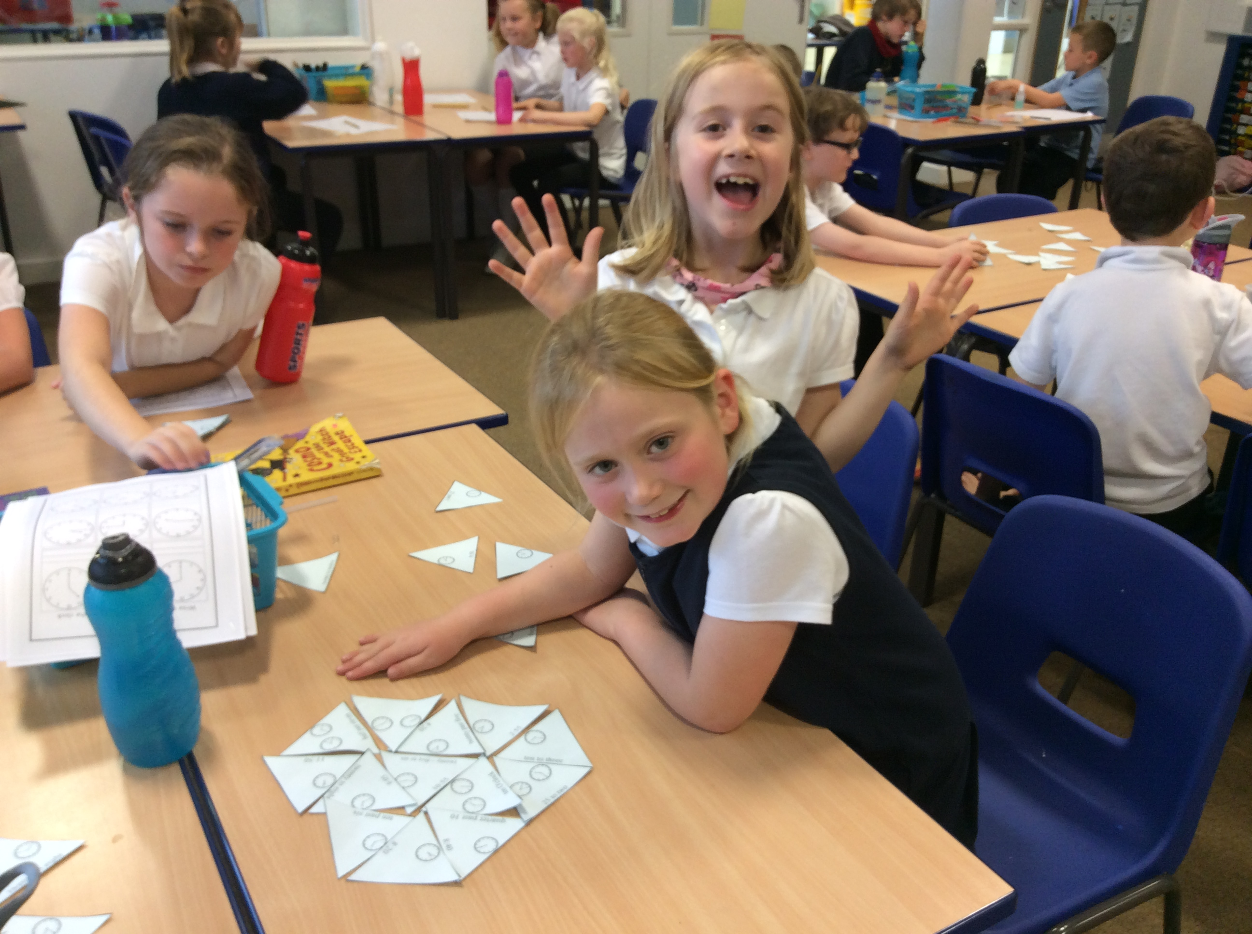
At the beginning of term Primary 4 took part in their first residential trip to Low Port. We learned a lot about ourselves and each other and tried lots of new things. We particularly enjoyed the tour of the palace. |  | 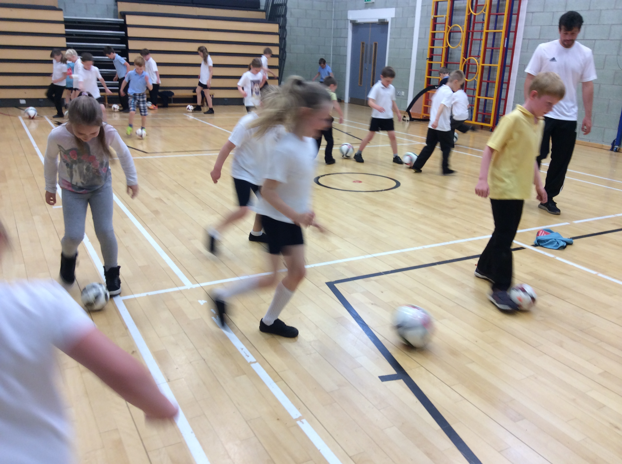 |  | P4 have been learning to tell the time. We have been playing lots of active maths games and putting our knowledge into practice. We have also been improving our mental maths so we can beat our Big Maths scores each week.
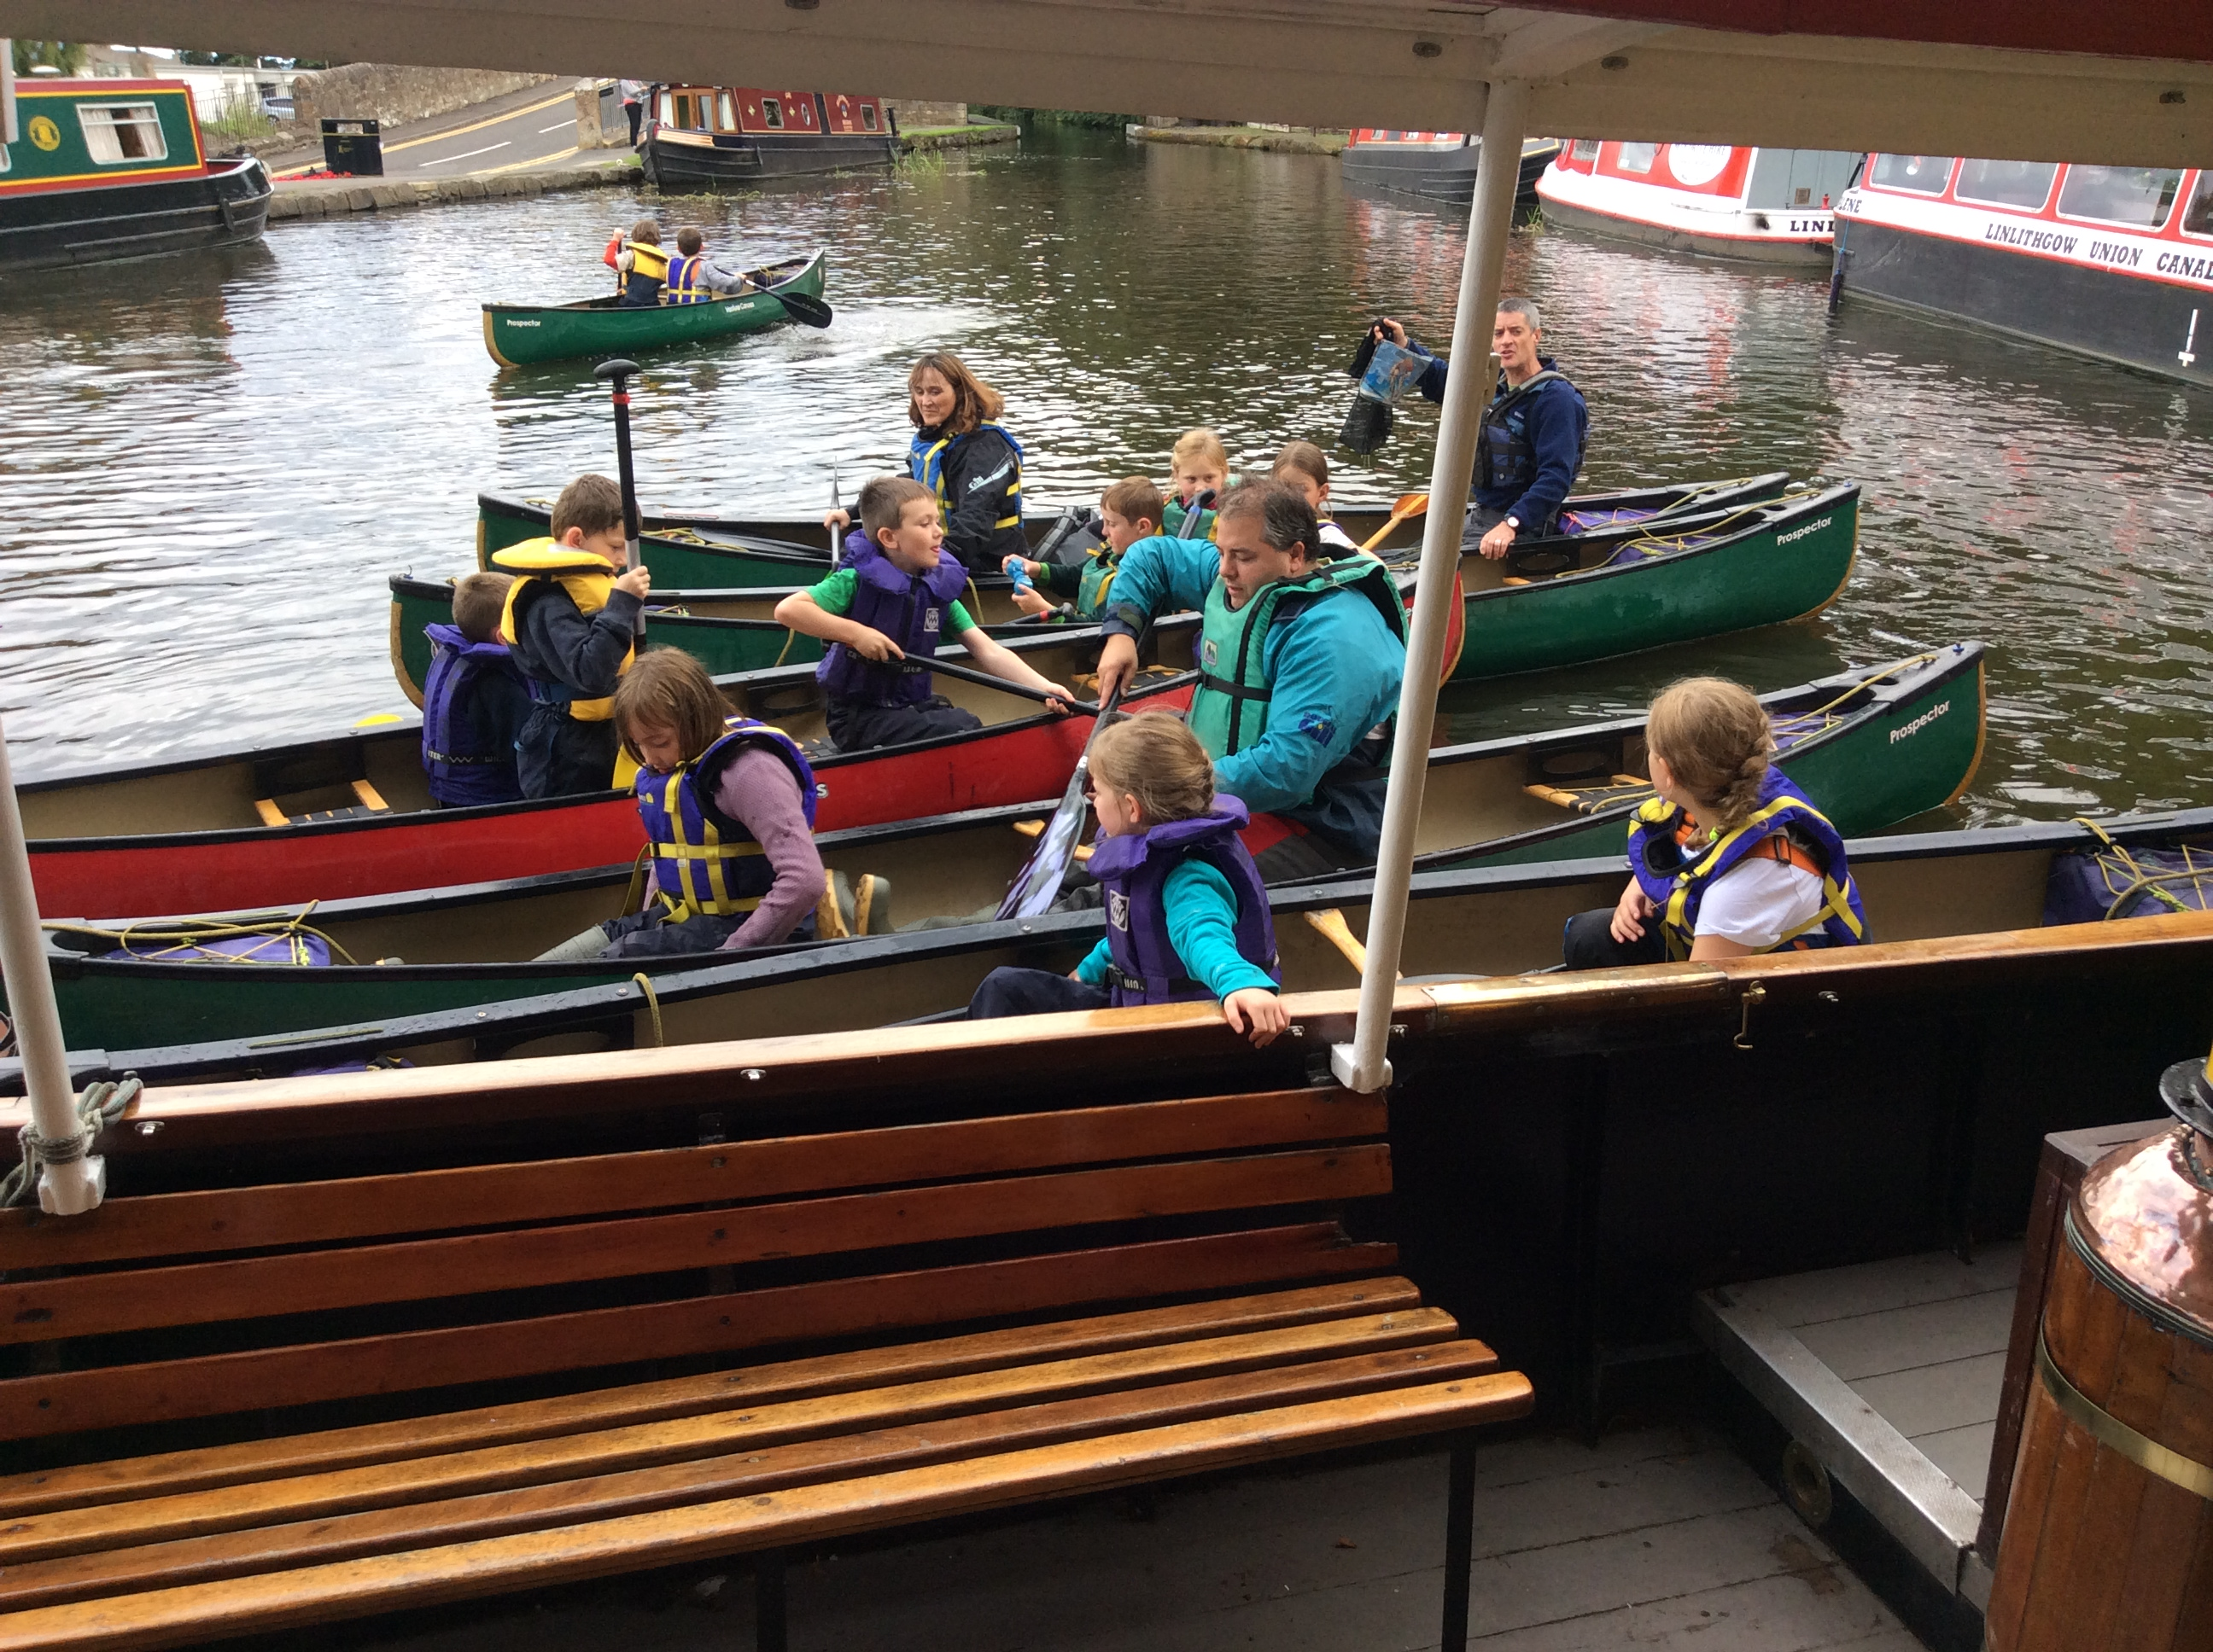 |  | Miss Blyth and Miss McDonald told us all about their visit to the Cousland Smiddy. We watched a video of a blacksmith at work and also tried fresh, organic produce from the allotment. We hope to visit the Smiddy later in the year. |  | 

