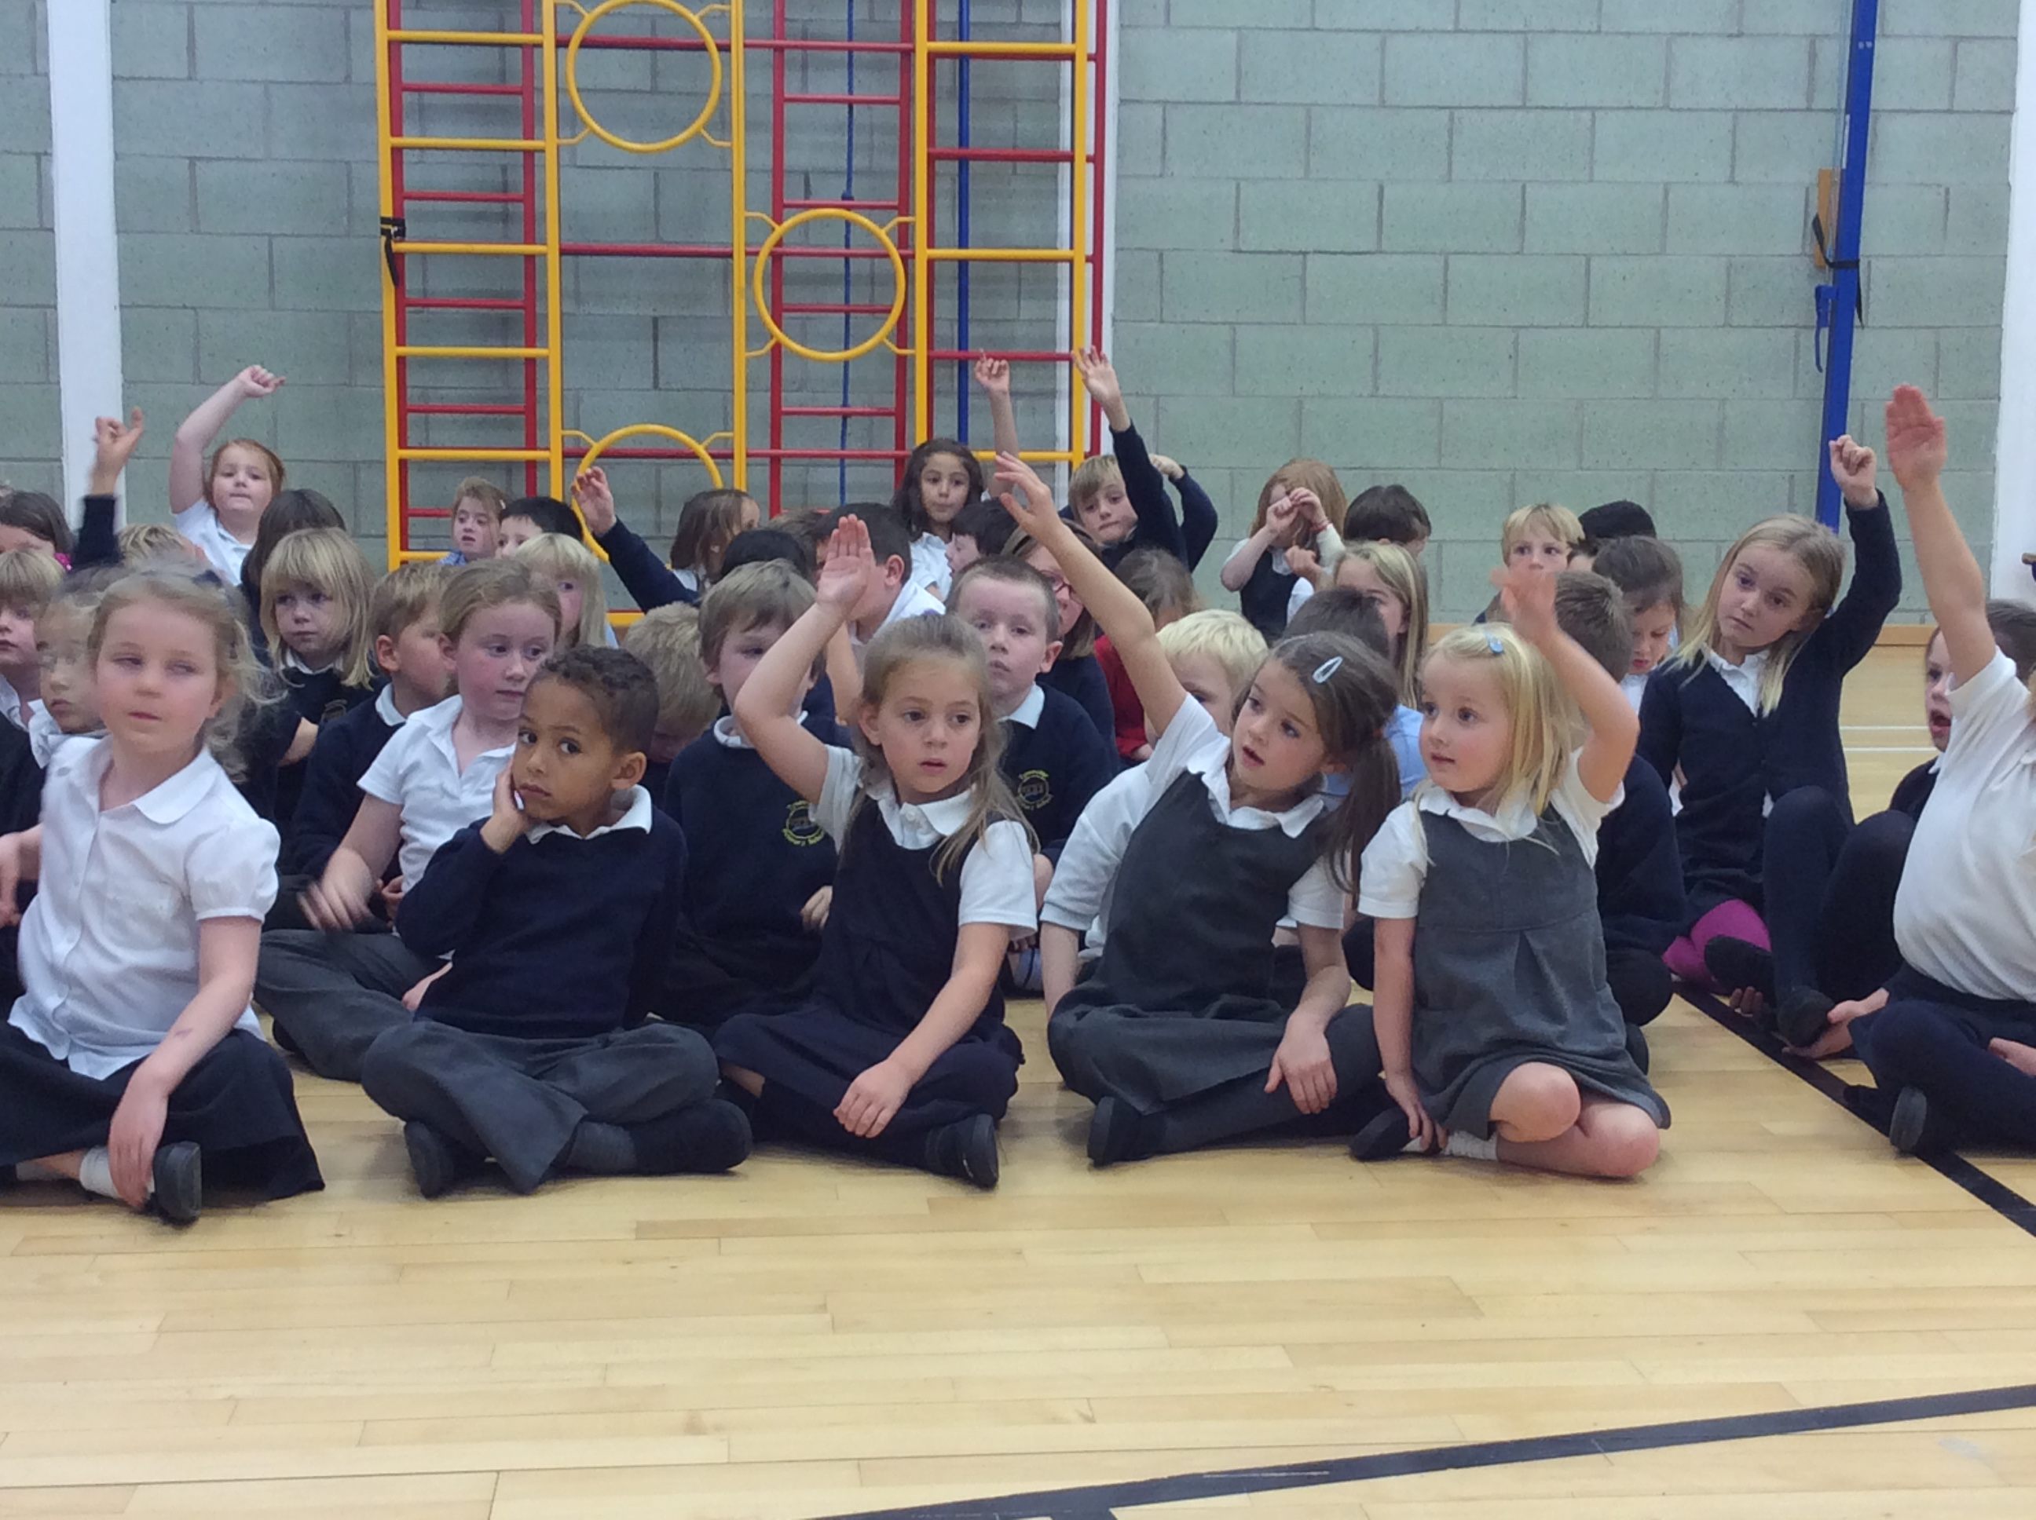 |  | We have been learning all about 2D and 3D shapes. We went on a shape hunt in the playground and spotted lots of different shapes. |  | 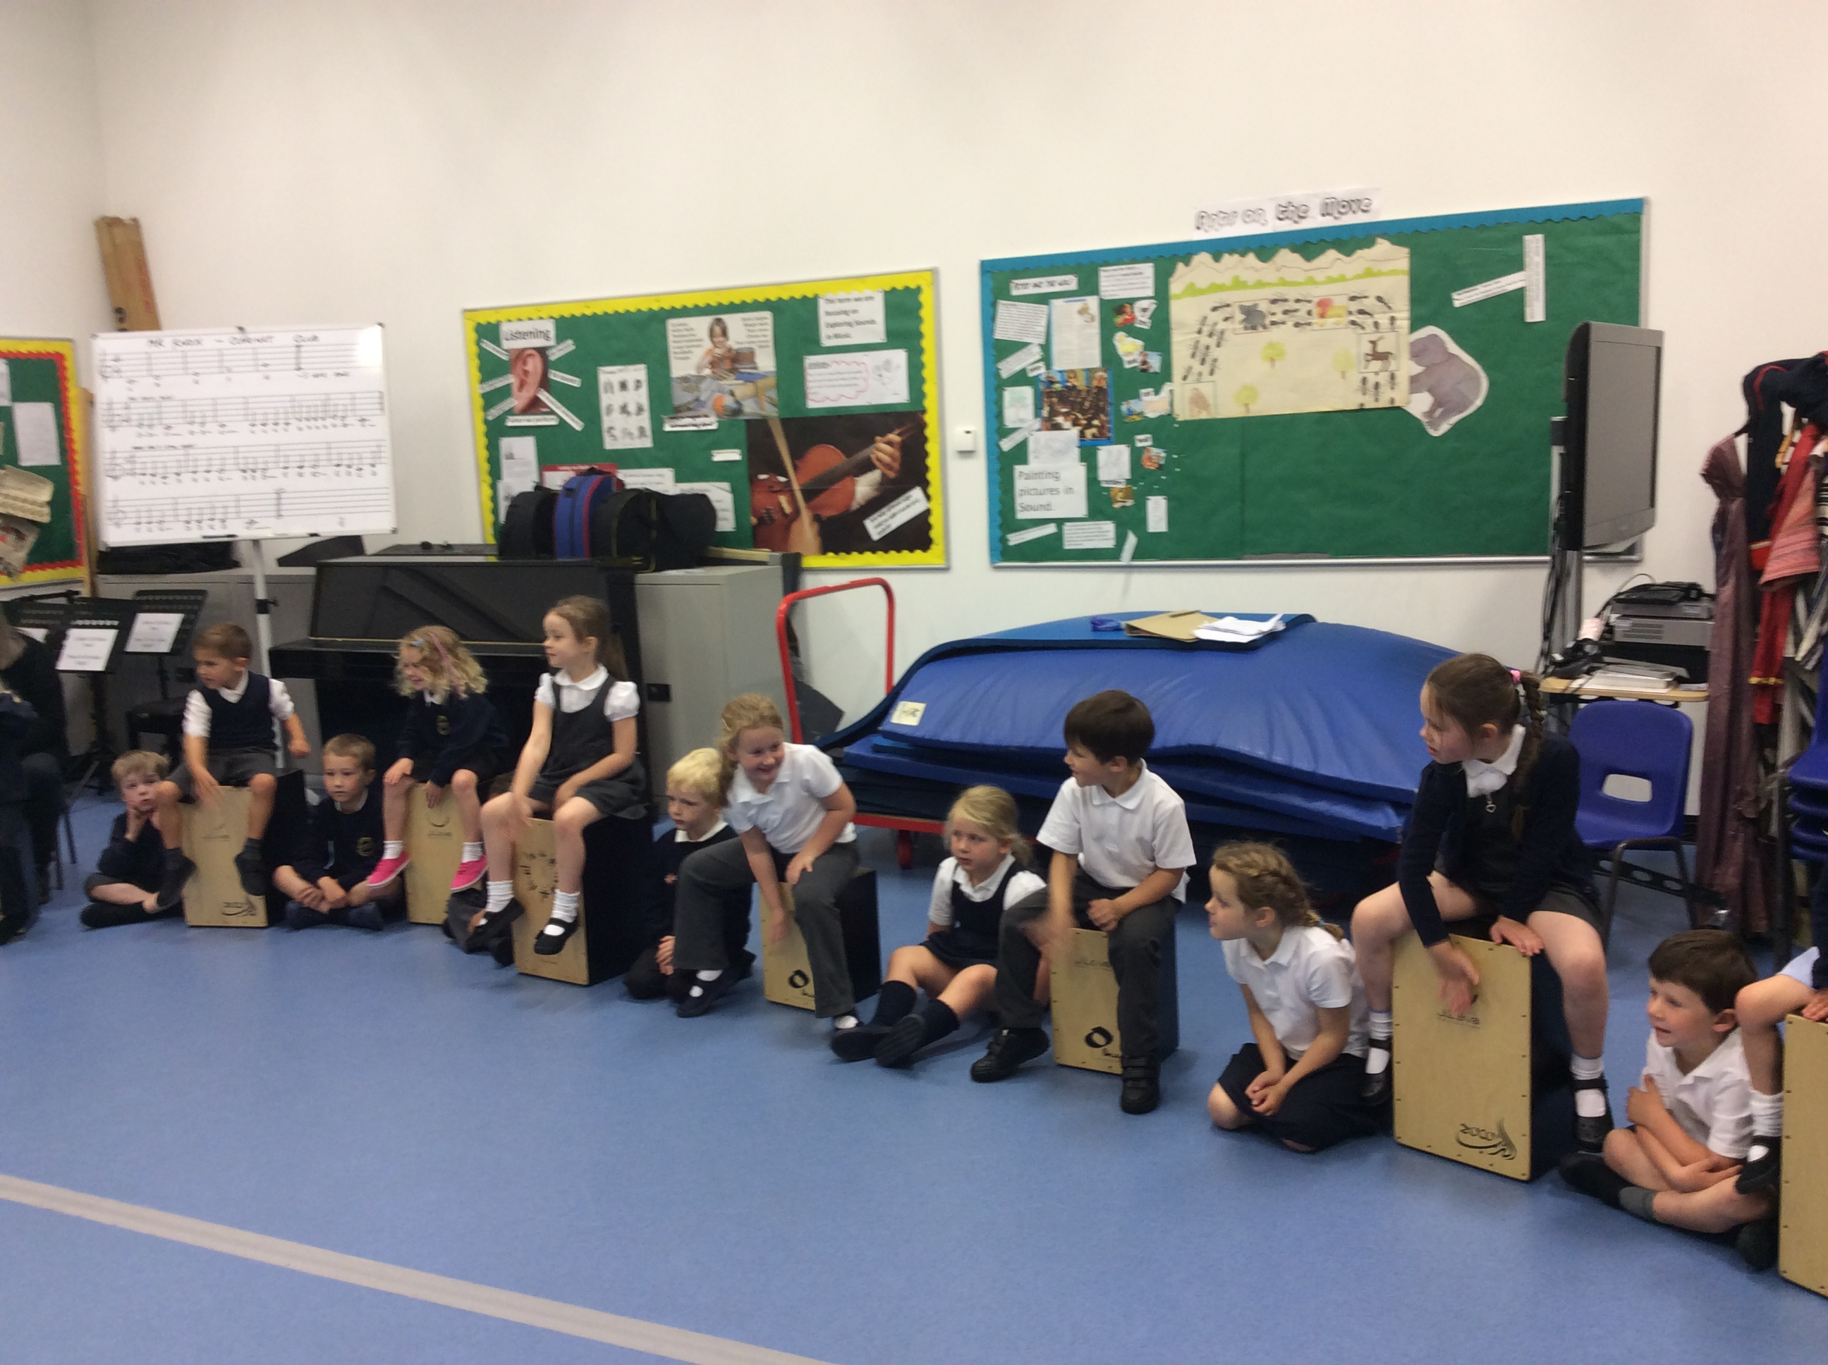
We have been working with P1/2 and P3 and sharing learning superhero stories as we discover what makes a good learner. We have then been making our learning superheroes in class. We put a marble in the class pots every time we show that we are a good learner. |  | 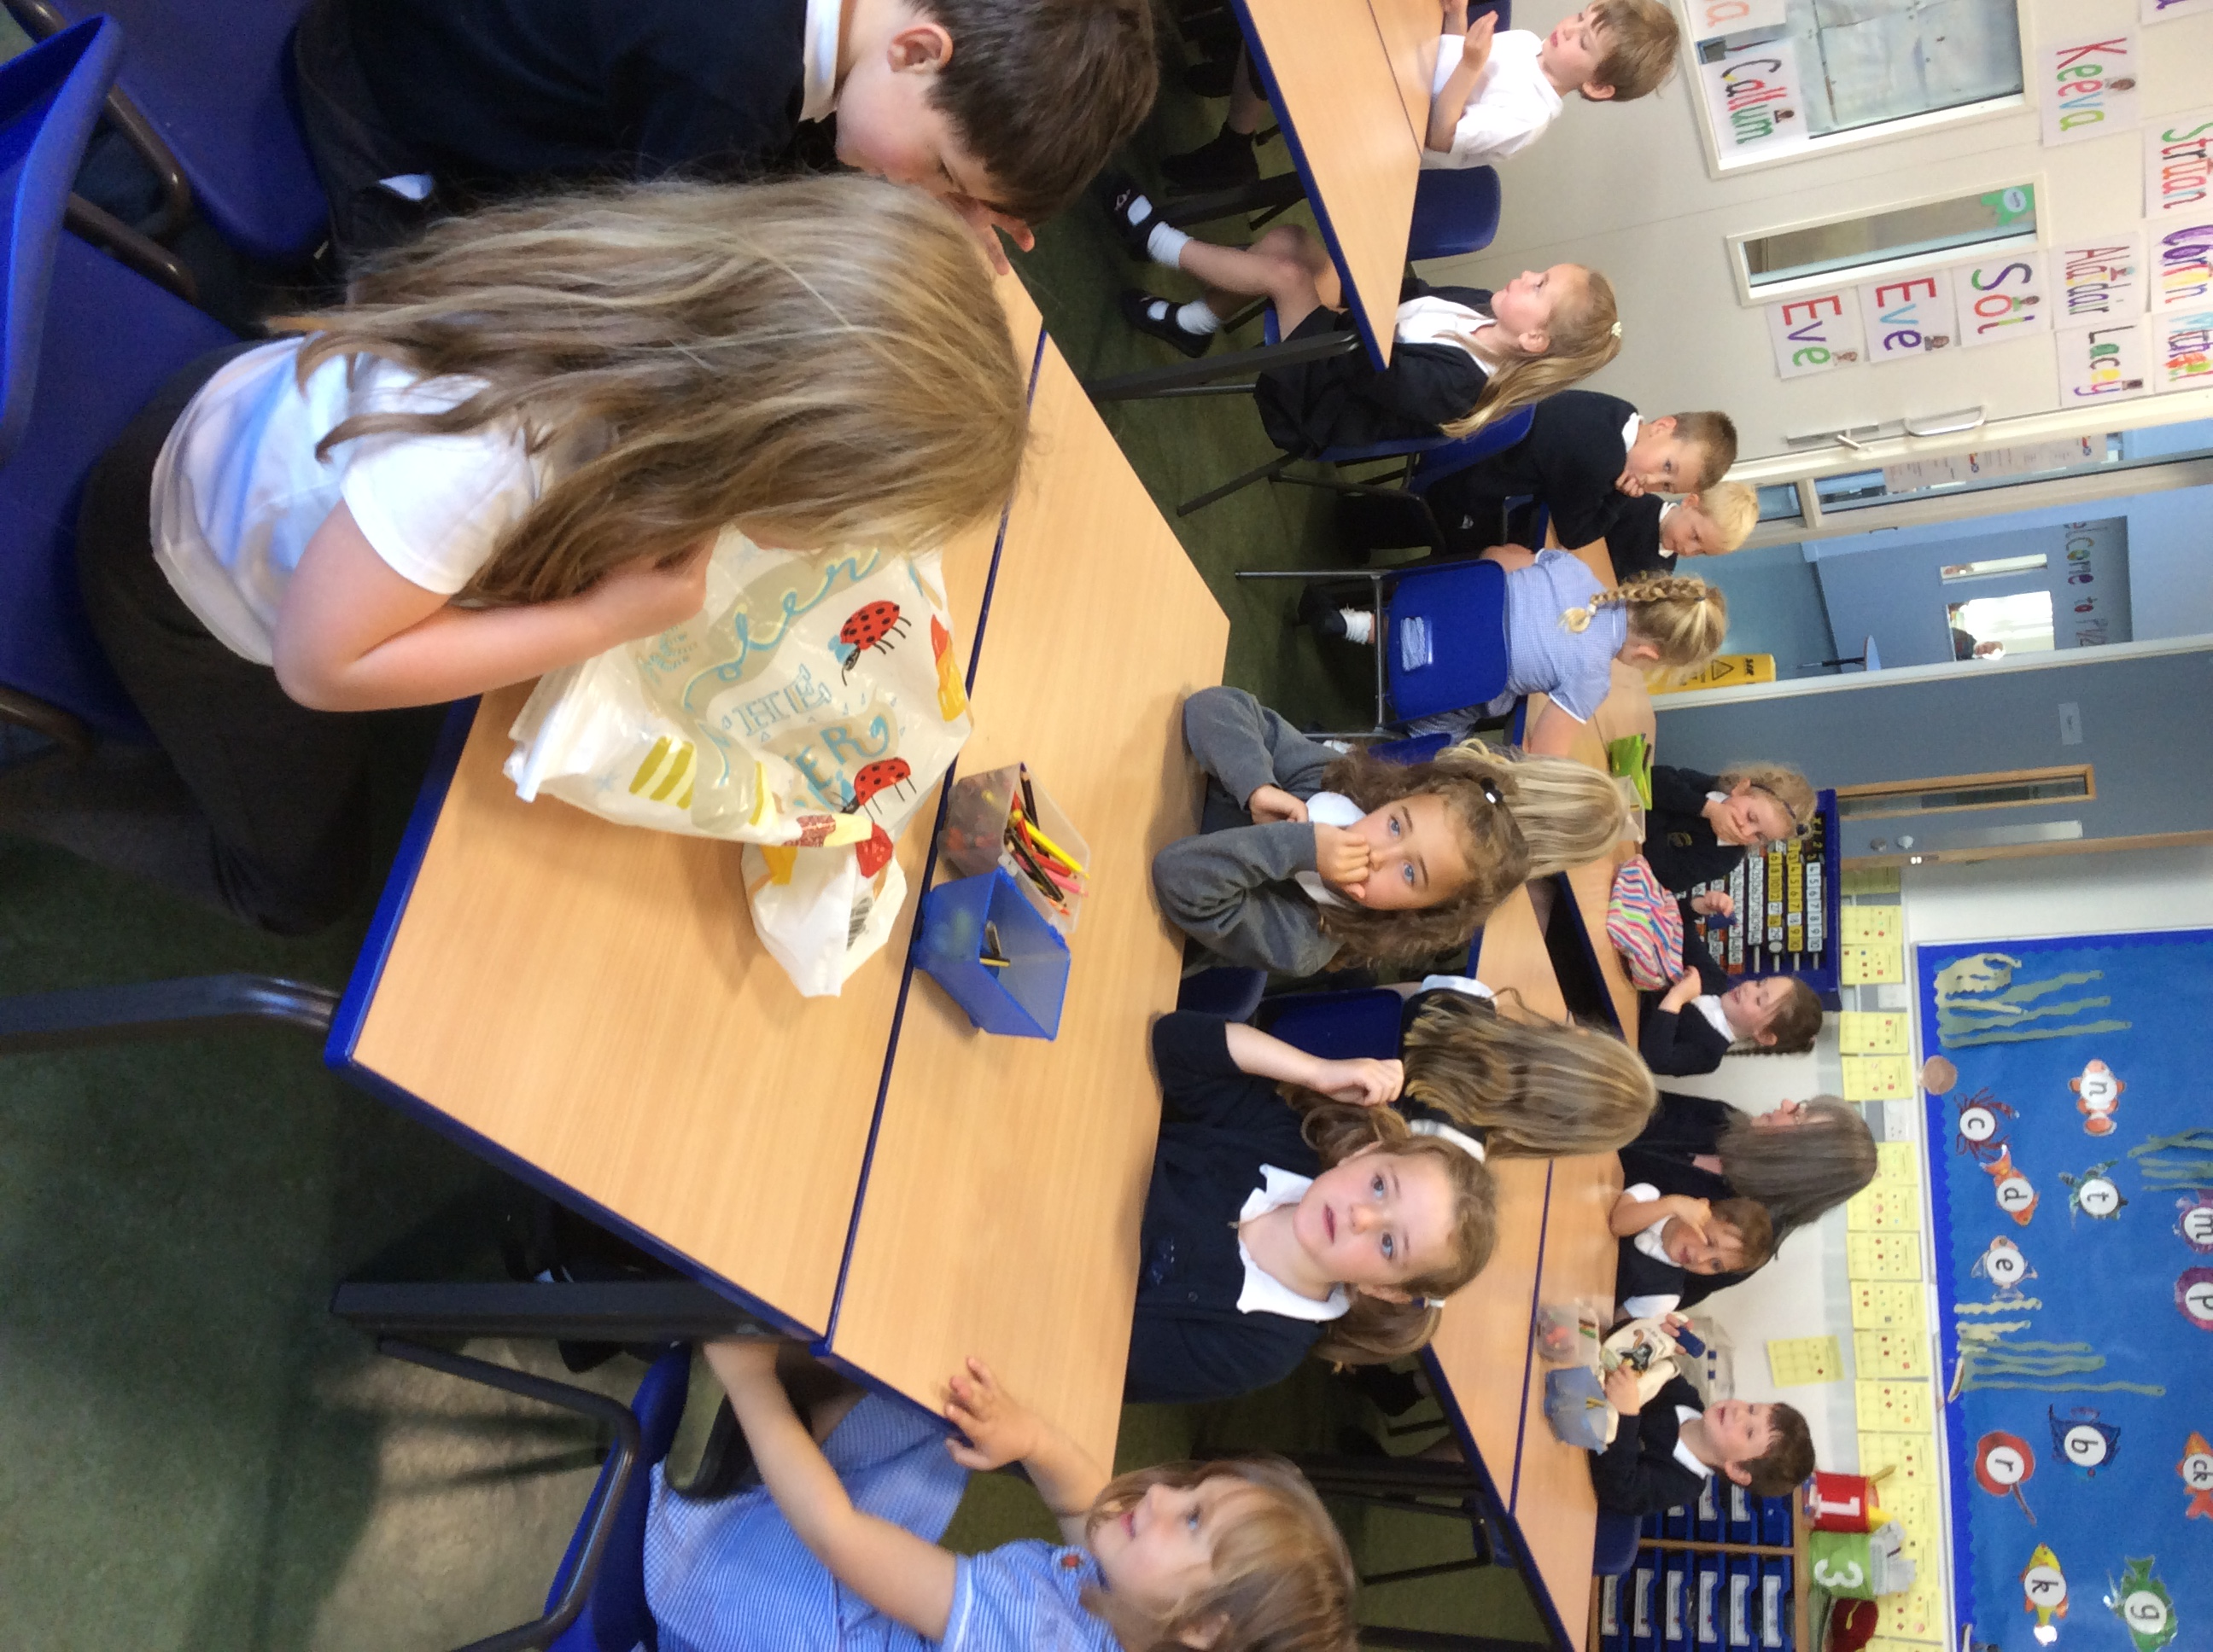 |  | We have been learning to play the cajon drum. We can play lots of different rhythms and we can use the drum to count out syllables in our name. We are now learning to play the drum as well as other instruments including a caxixi and claves as part of a story.
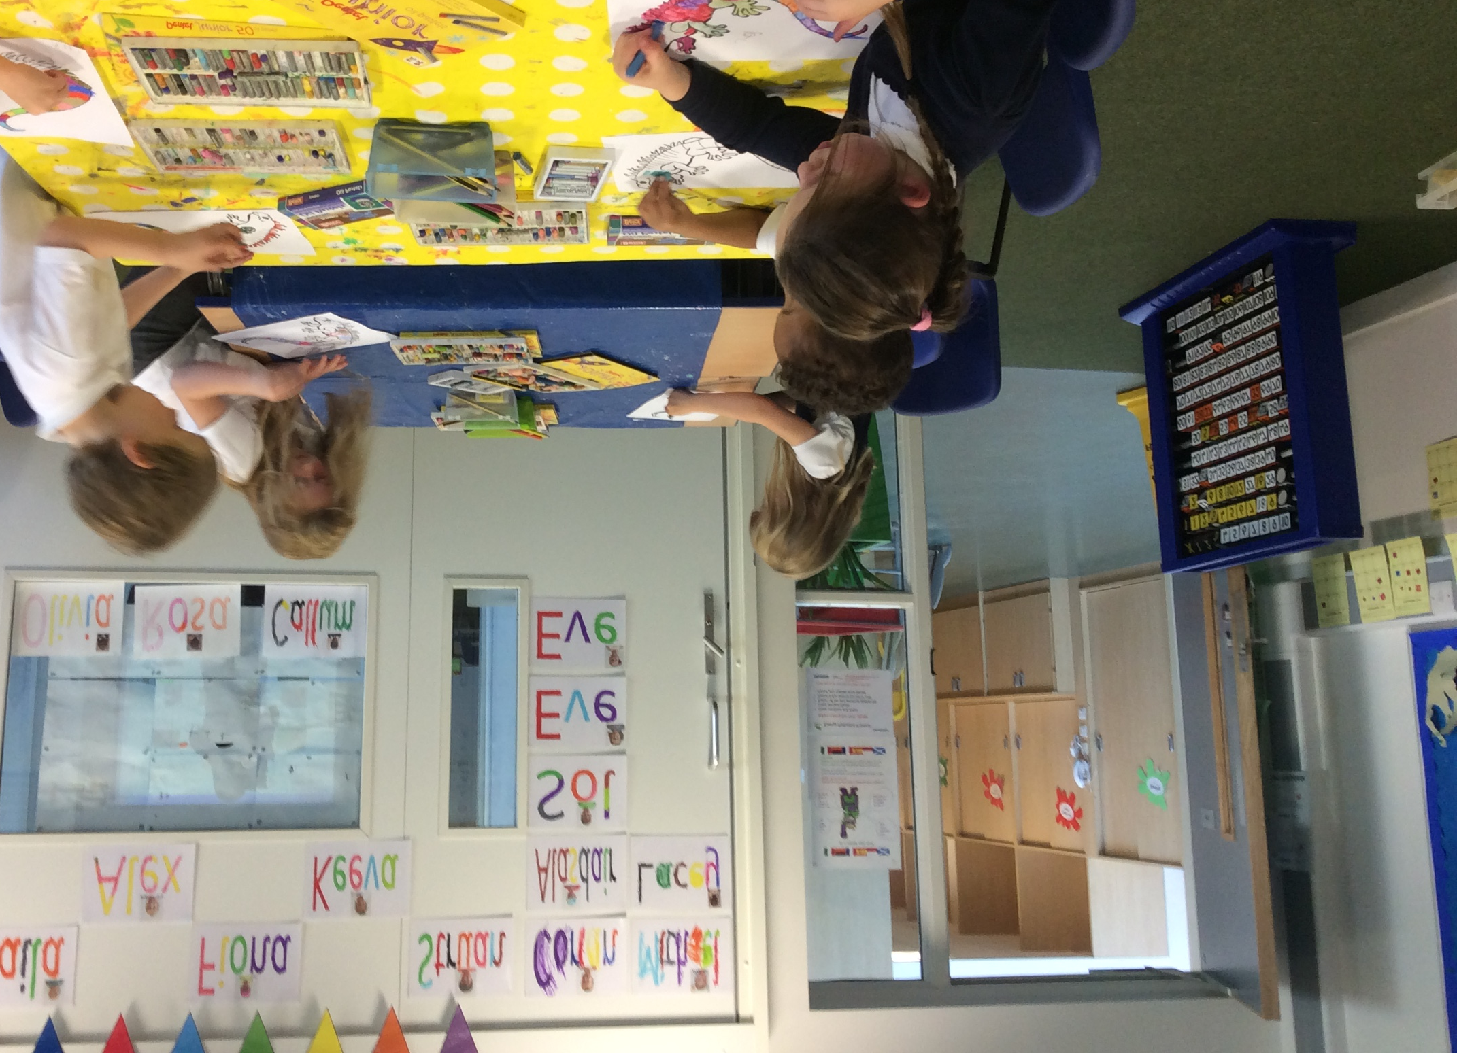 |  | We also played a guess the shape game where we described the shapes in the bag and the rest of the group had to guess the shape. We gave them hints by telling them how many sides and edges the shape had. |  | 

