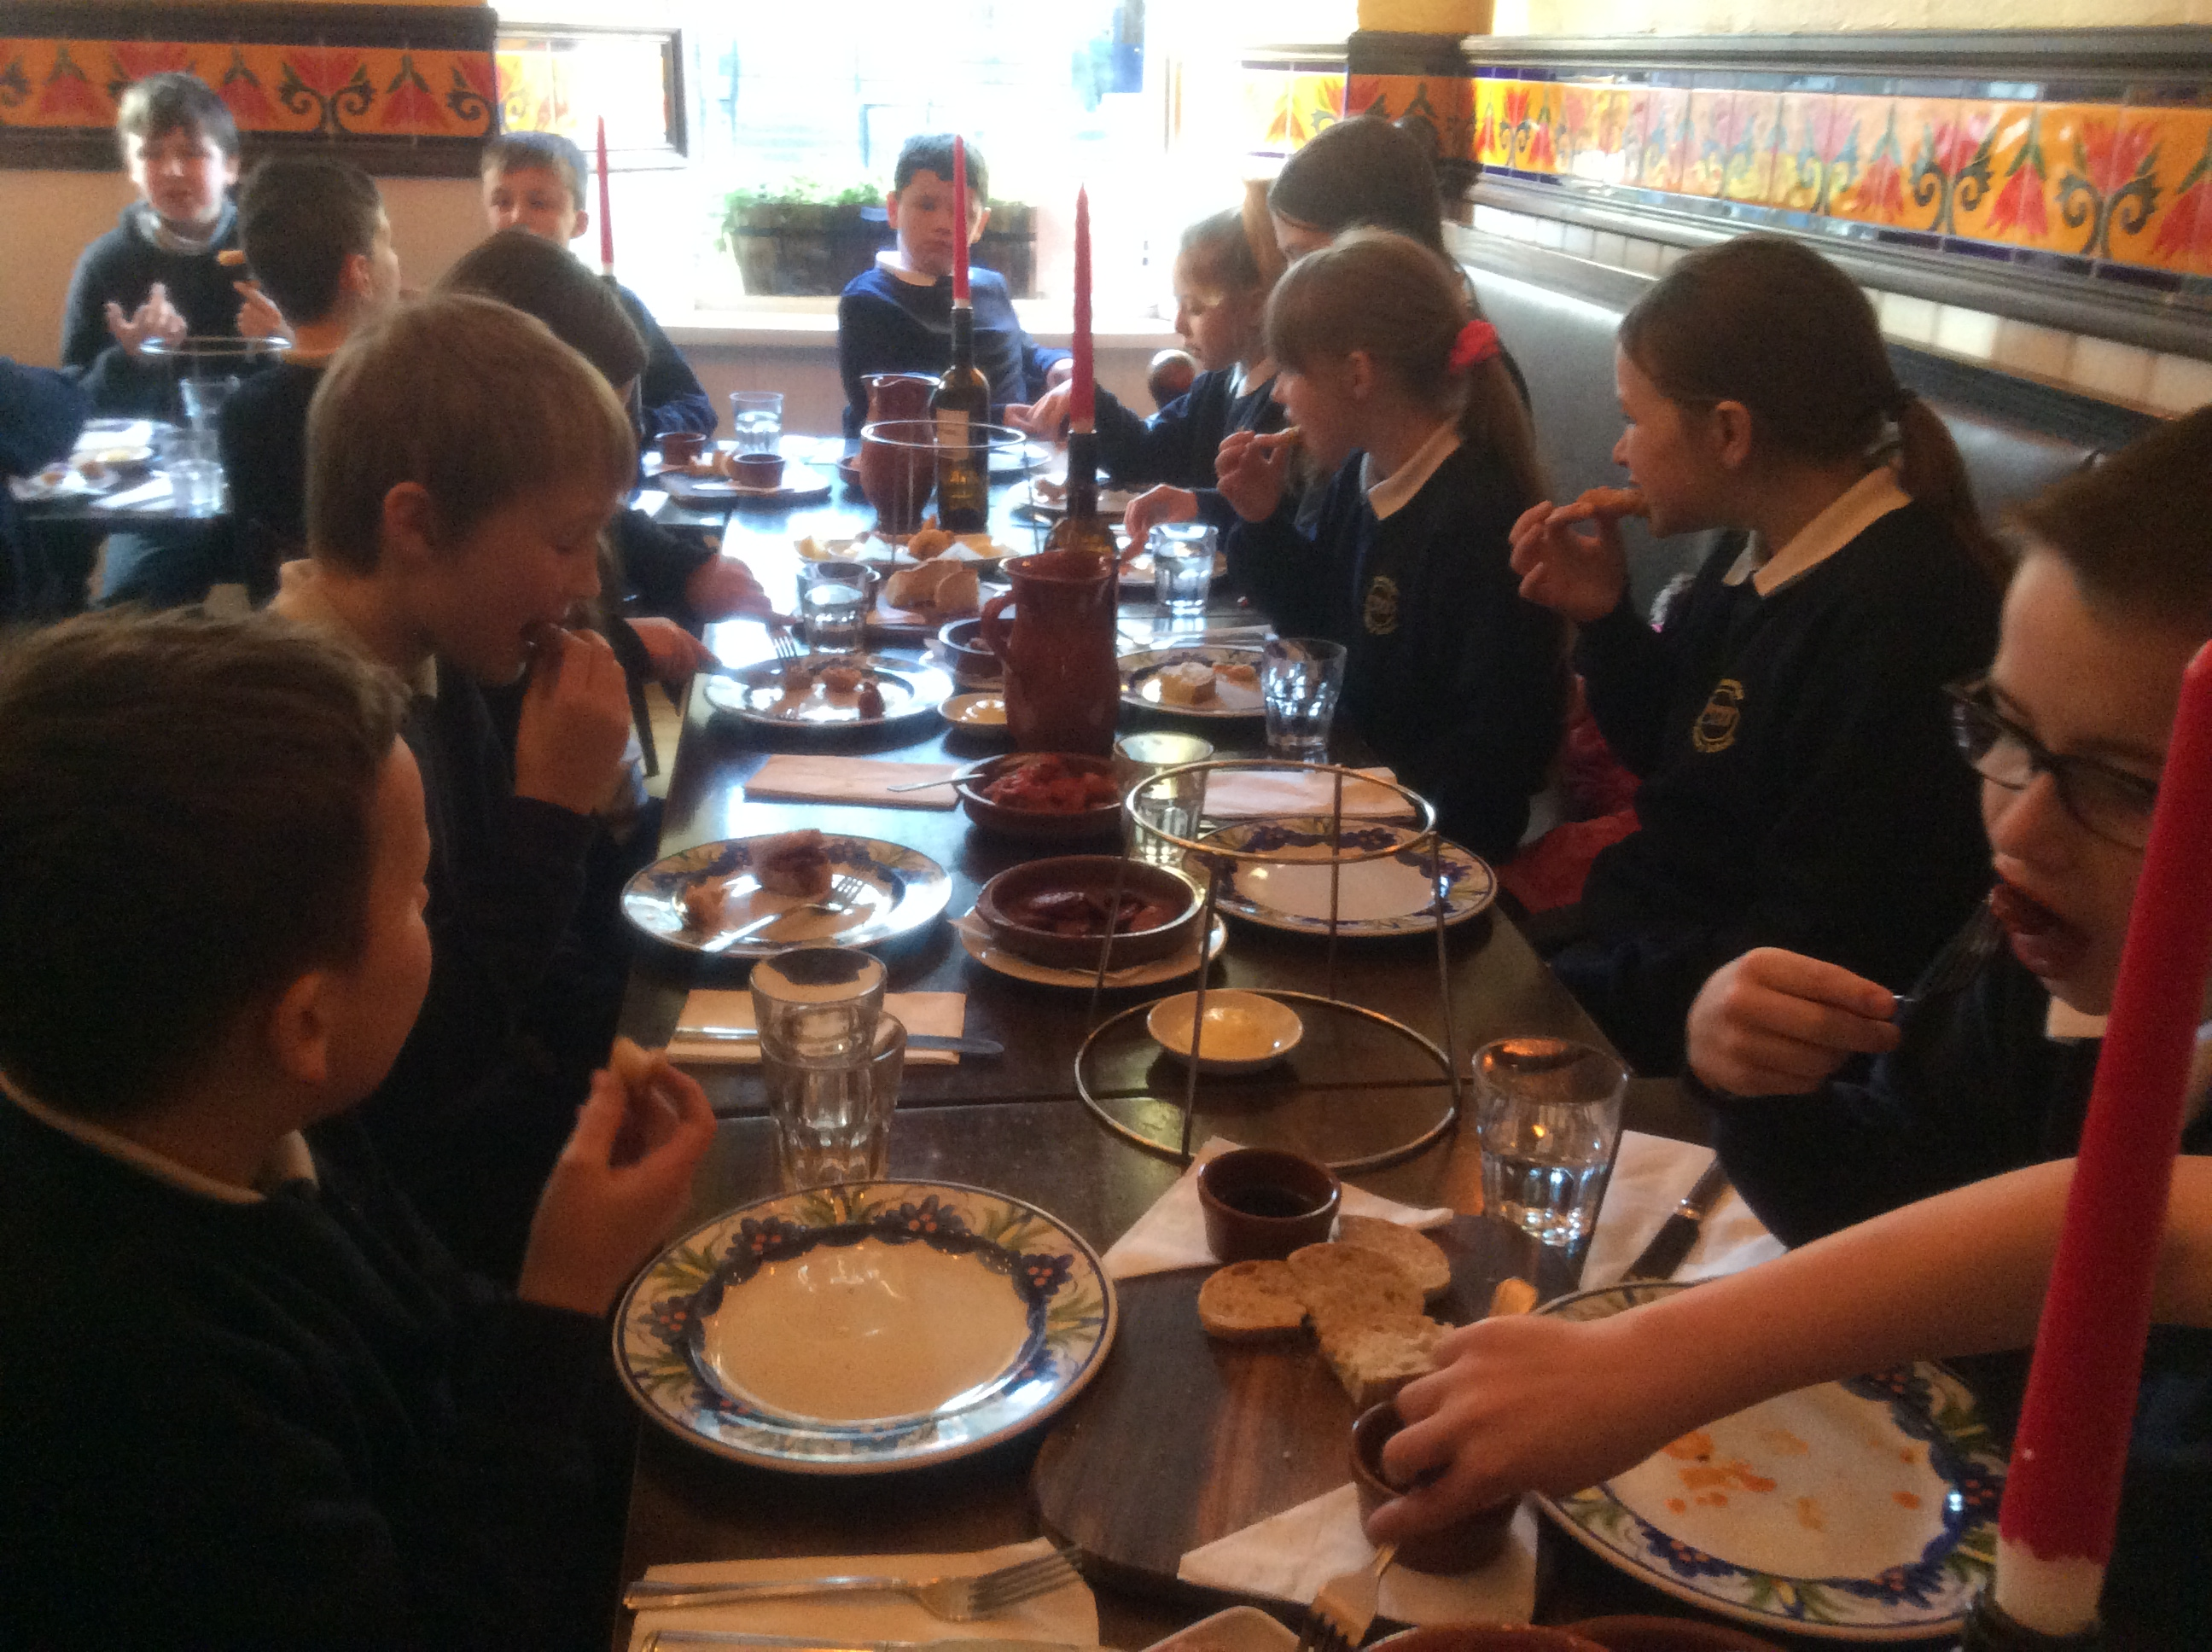 |  | 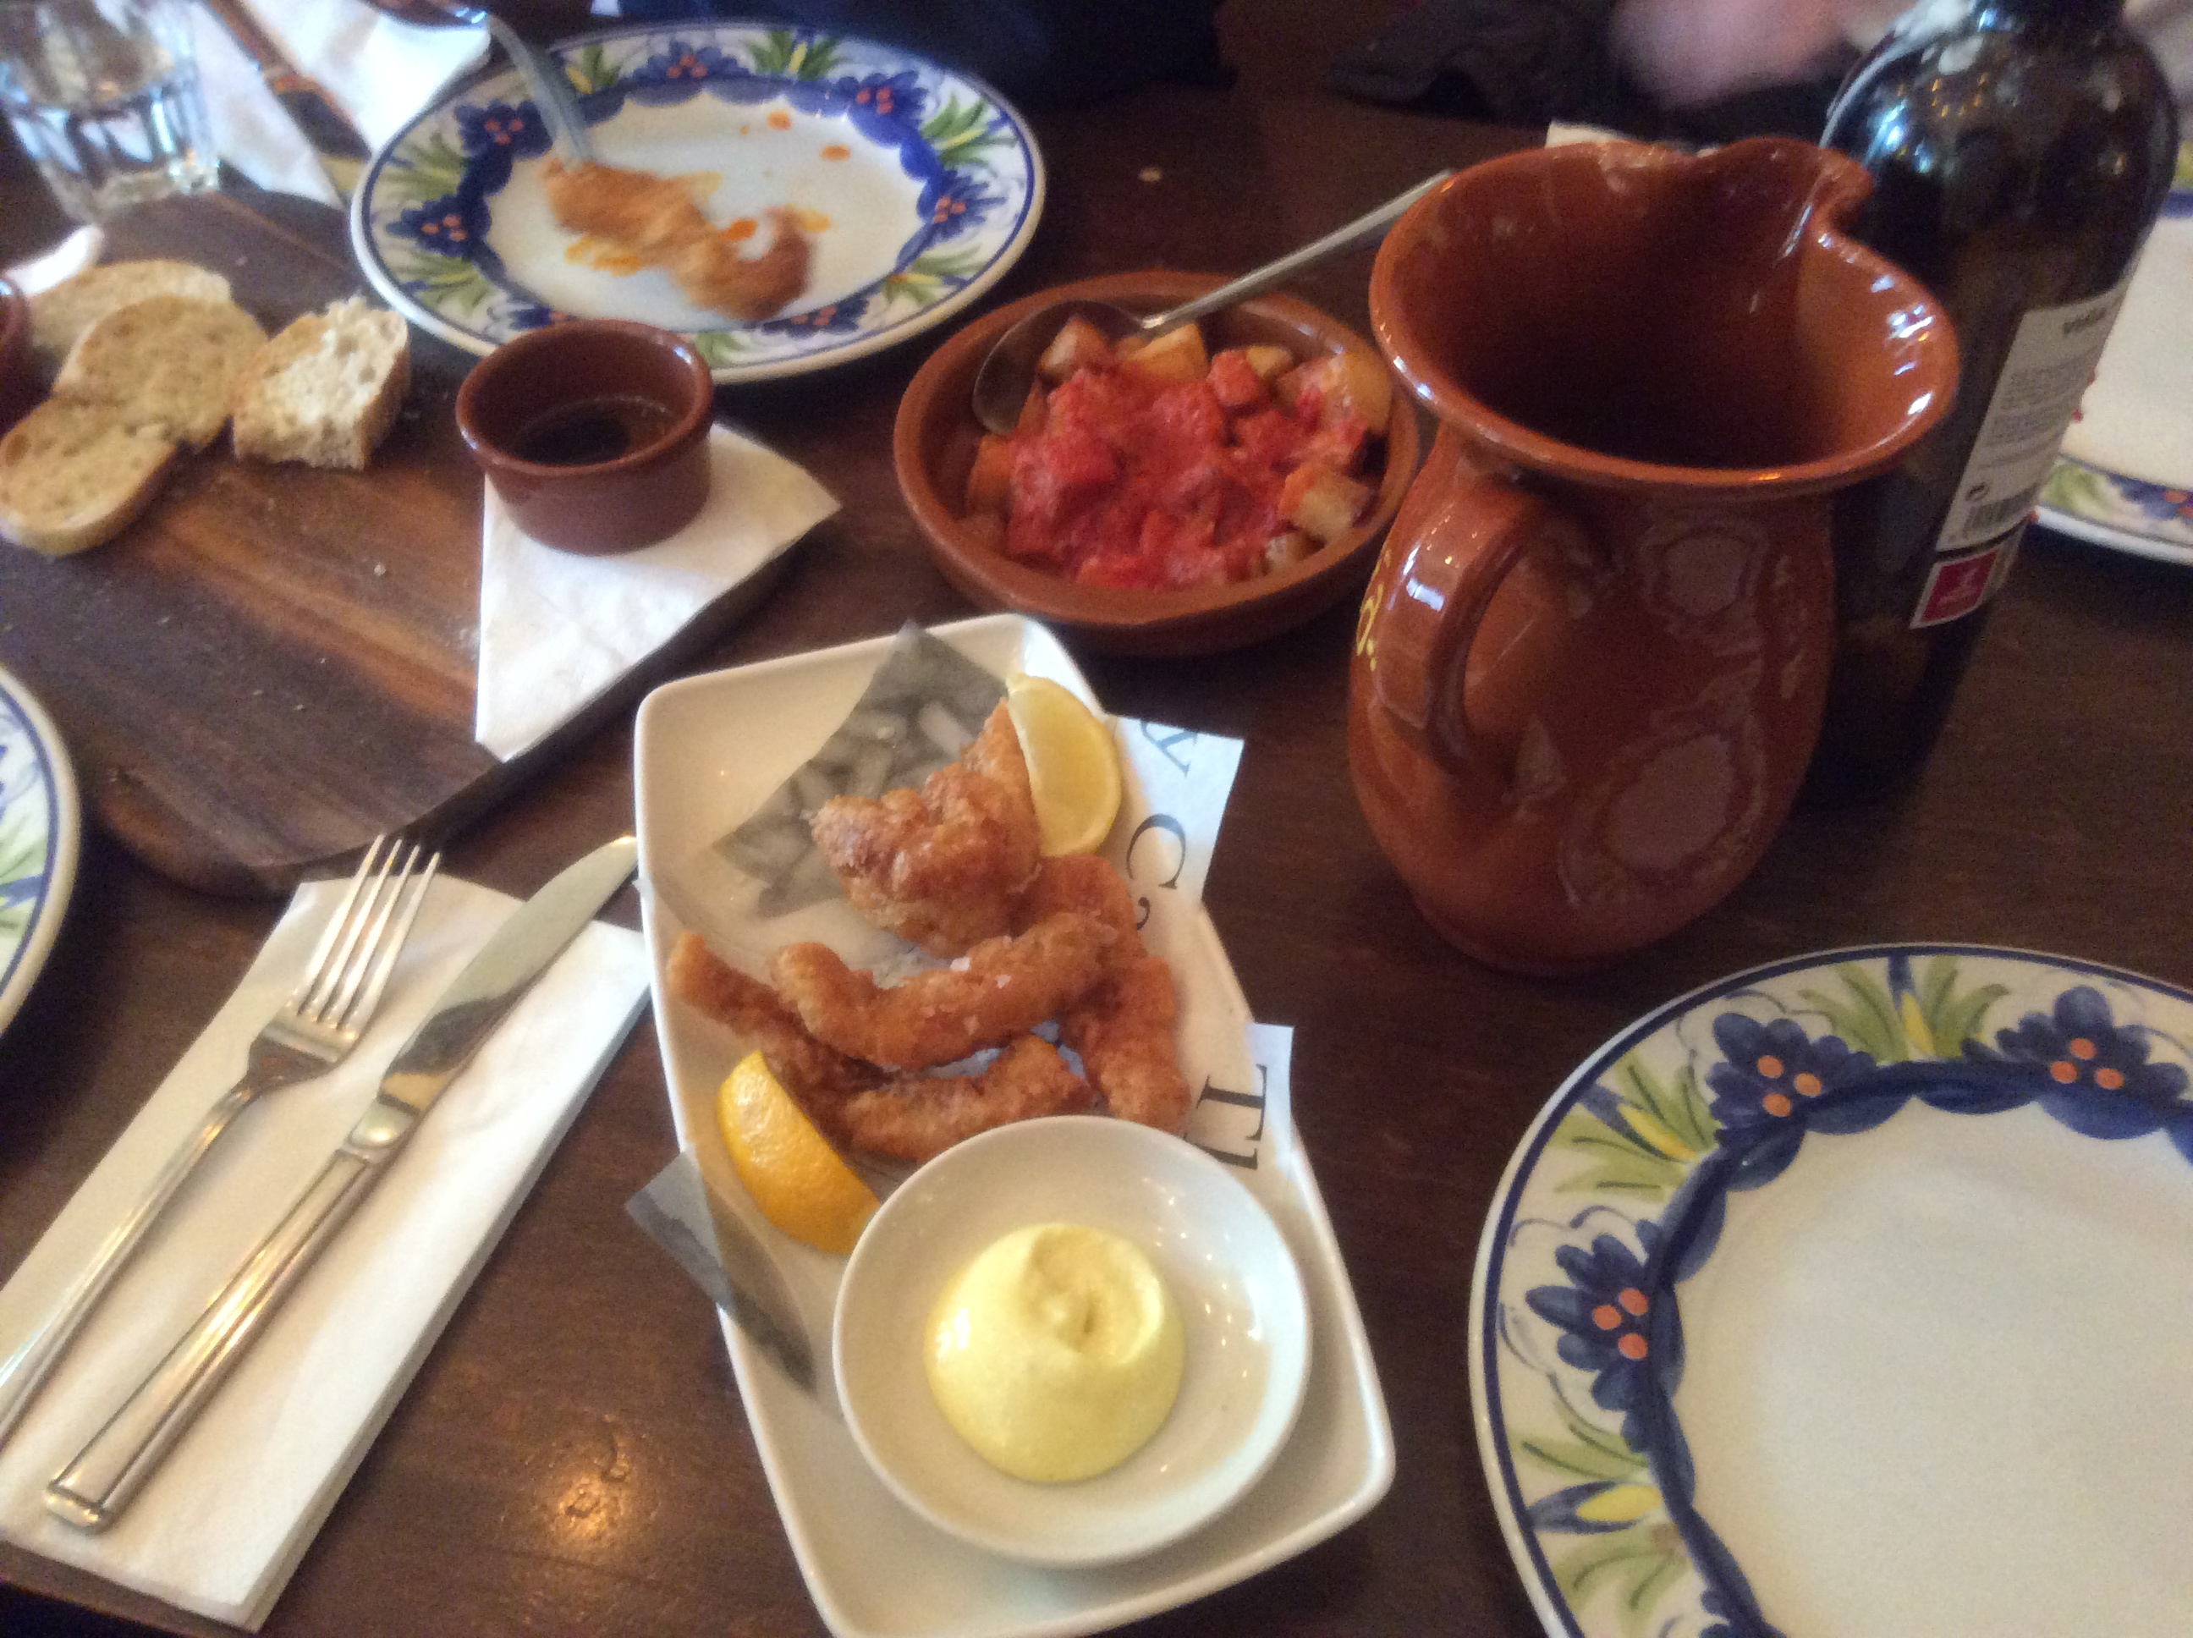 |  | Skiing  P6/7 went skiing at Hillend and we learnt how to ski and how to use at tow slope. The p7 learnt how to do a snowplough turn. While the p6 learnt how to do snowplough. All of us thought it was great. By Scott
P6 - Viva Espana!  P6 had a Spanish topic and a few weeks into the topic they went to La Tasca, a Spanish restaurant in Edinburgh. Spanish food include a famous feast called tapas which is a whole lot of Spanish food like chorizos, paella, fish, chicken wings but also Spanish tortilla omelette and for starters bread and oil.  All the p6s loved it! The staff were really happy to hear that we enjoyed it so much.  By Olav |  | As part of our Spanish topic we held an anti-bull fighting march and made 3D relief maps of Spain.  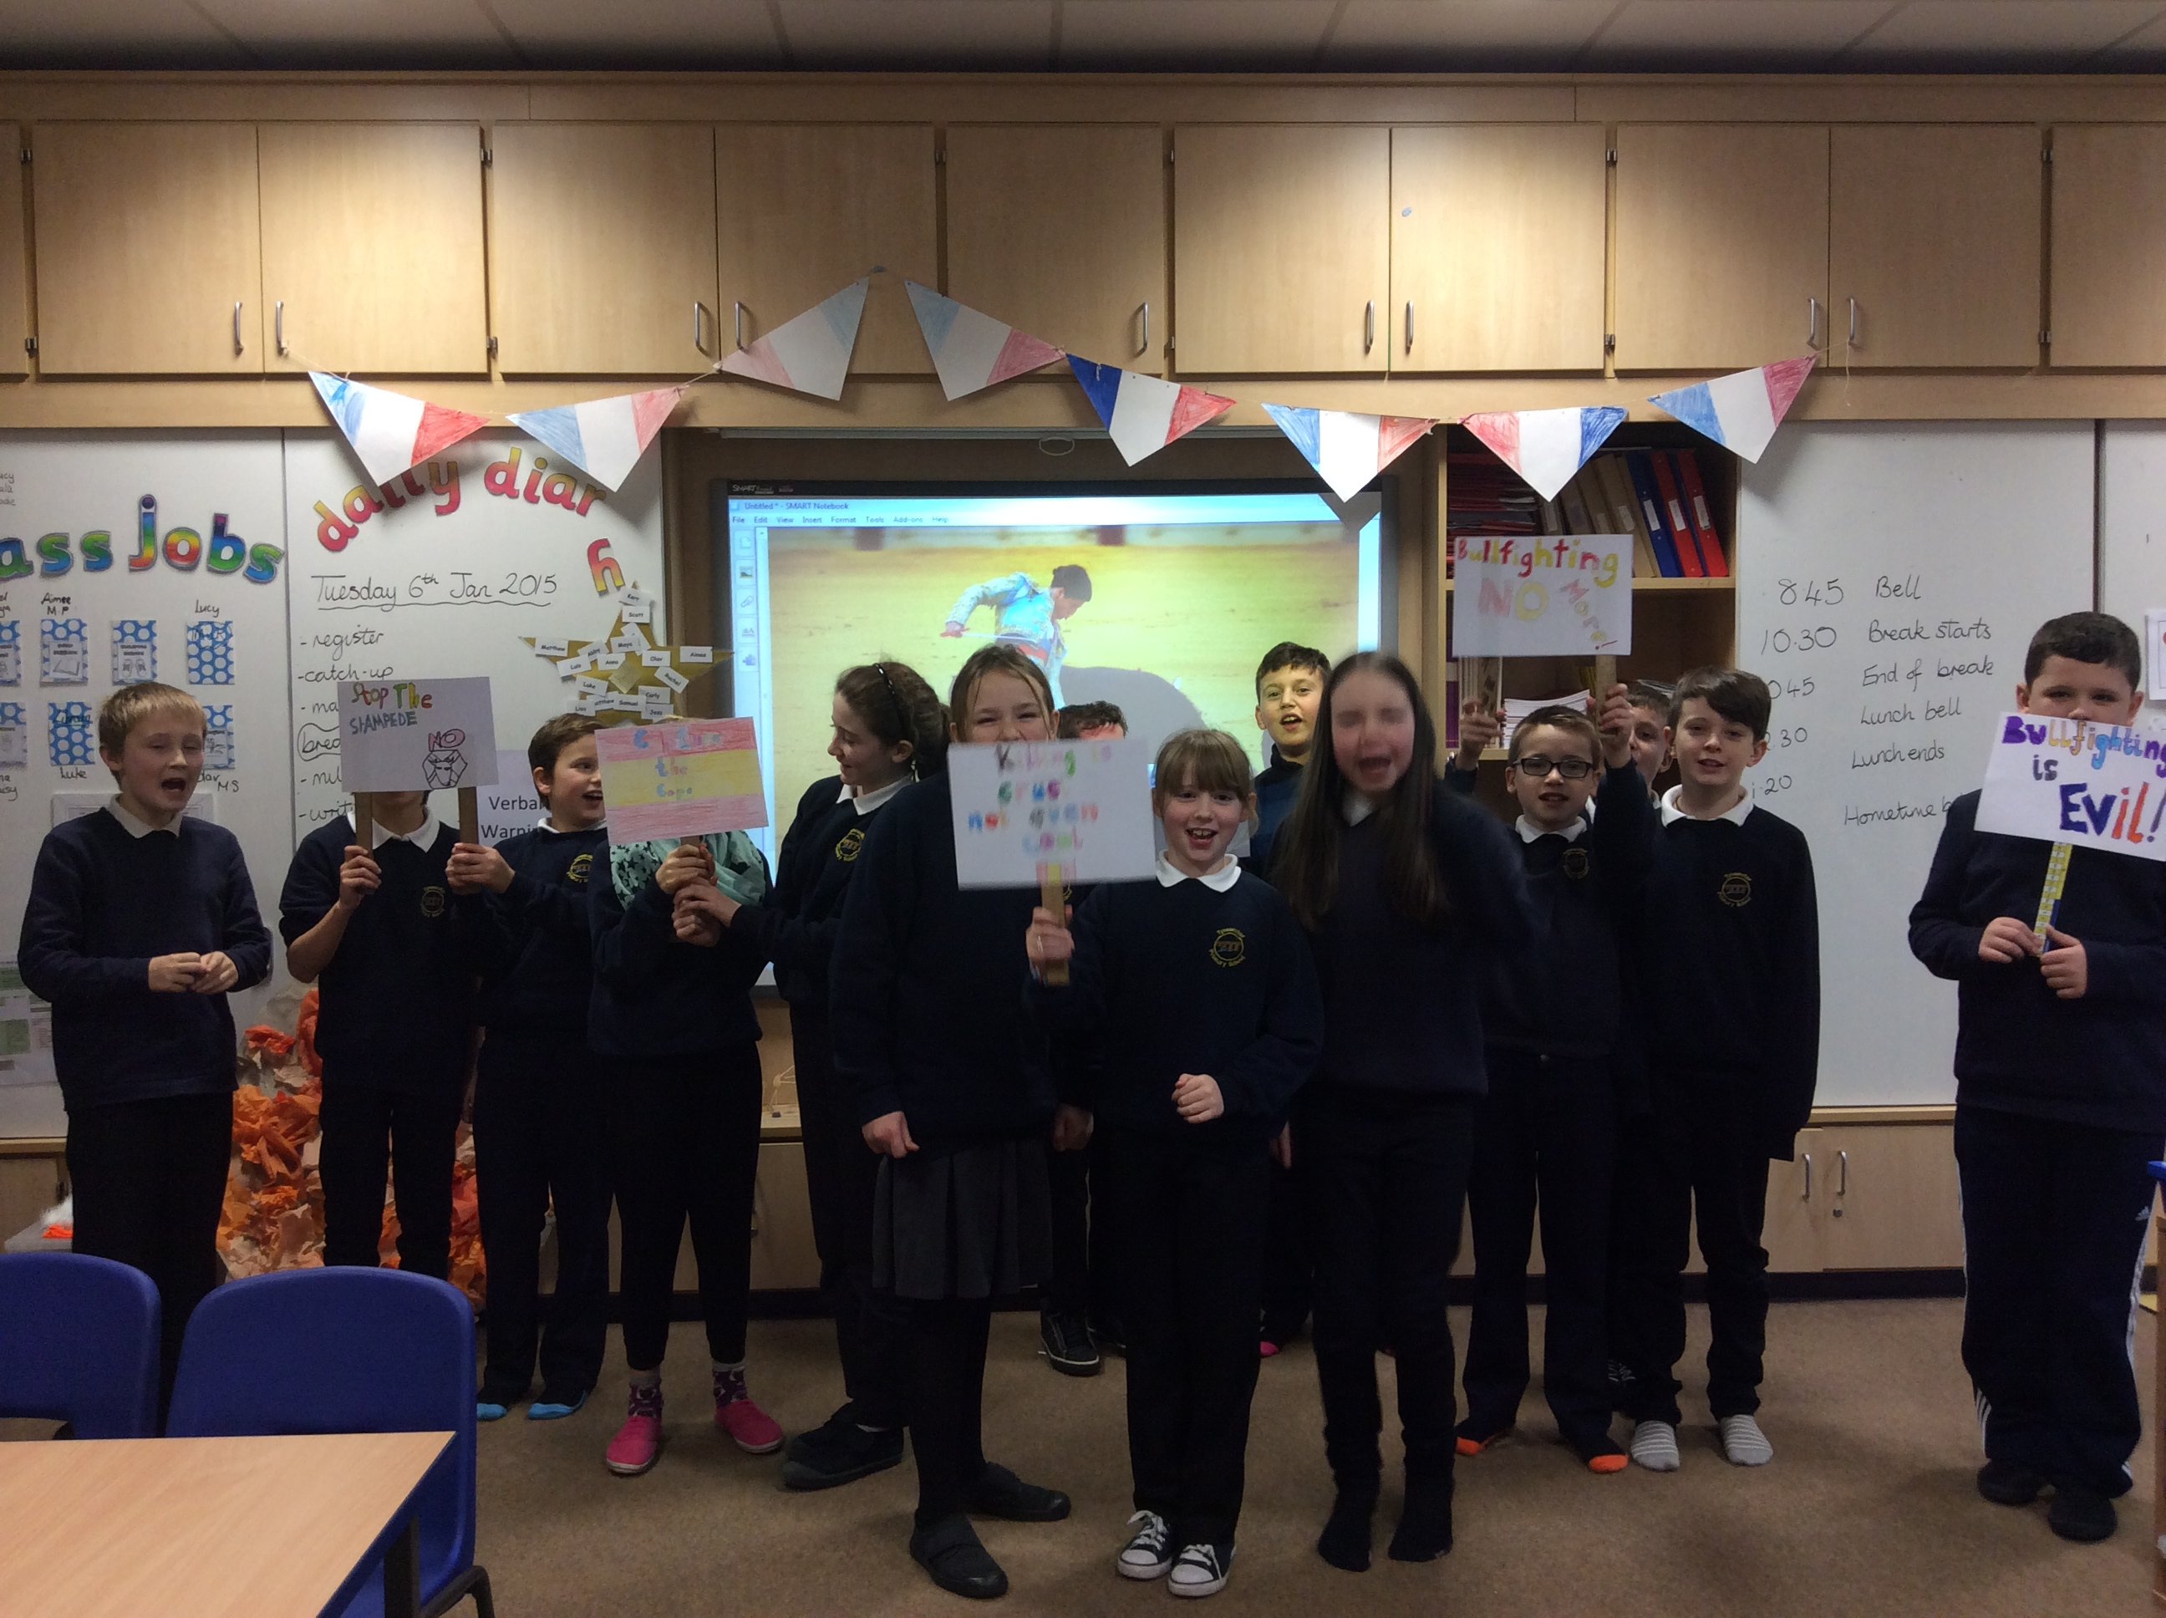  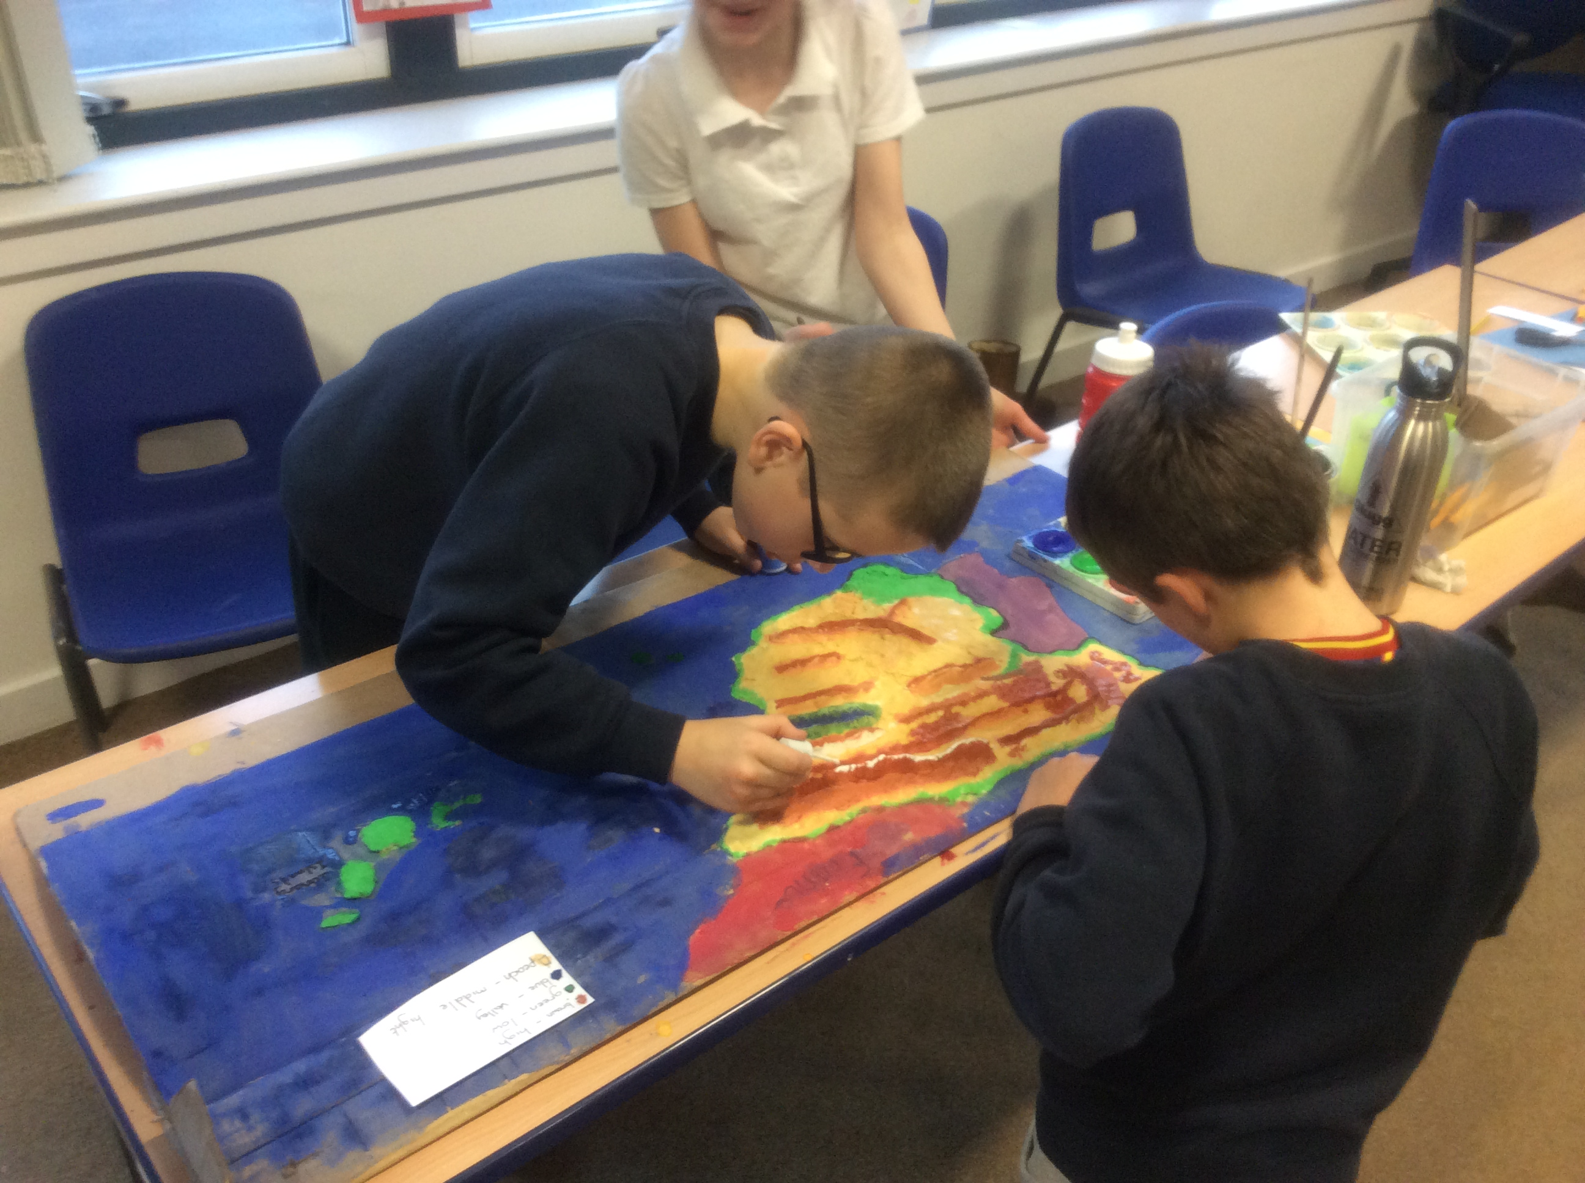 |  | P7 – Japan Topic  The p7s have entered a competition called Midvision where you have to make a documentary about a country and a song to do with that country. The p7s have Japan, which is a very interesting country. We have already recorded our song and have nearly finished our documentary. On the 29th of April the p7s found out that they had got through to the next round for our song. They are all very happy and can’t wait to hear about their documentary.
P7 Jumpers  On Monday 23rd of march Primary 7 got their new school jumpers. They are a lovely blue with the Tynewater badge on the front and on the back they have “P7 2015”. |  |     Update #1... |  | School Disco  On Thursday 26th march Tynewater had a disco. First the P1-3 had a disco and then p4-7. It was really fun.  By Katie
I think primary 7 are really going to enjoy them and get the wear out of them forever!  By Jess Lothian |  | Jess, Beth, Carly, Matthew.P, Matthew.S, Rachel, Jon, Scott, Olav and Jade were all awarded distinction grades for their competition entries and went onto the second round of the competition. The rest of the class were awarded merit certificates. The judges said, “The judges would like to congratulate all of your talented students.”  Update #2 – we just found out that Matthew S, Matthew P, Beth and Olav have gone through to round 3. Watch this space! |  | 500 Words – BBC radio 2  On the 30th of February 2015 p6/7 did the 500 word compo for Radio 2. The whole class had to write 500 words or under. A lot of people got bang on 500. By Luke.
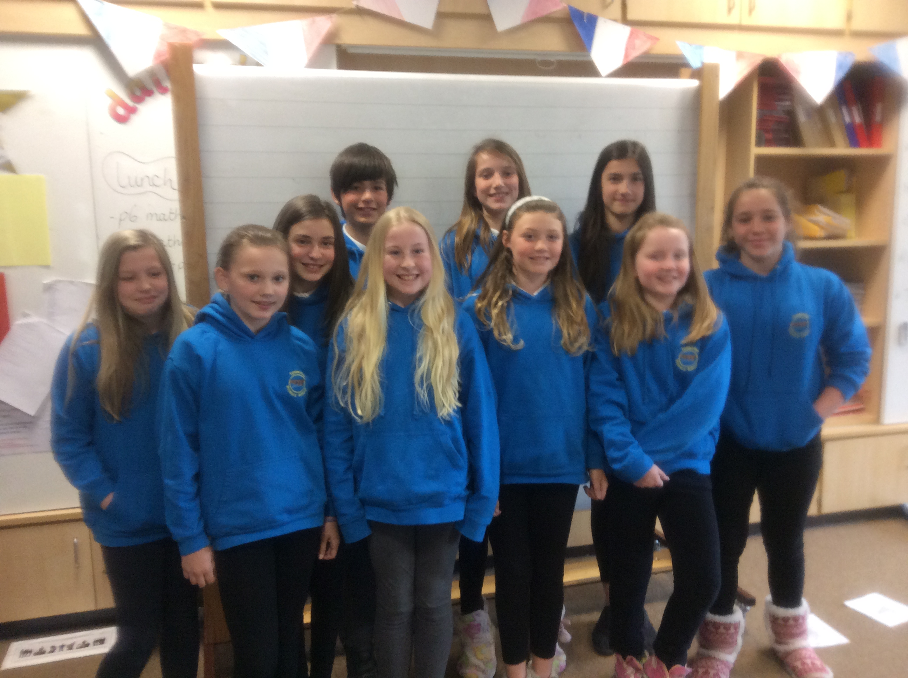 |  |  |  | 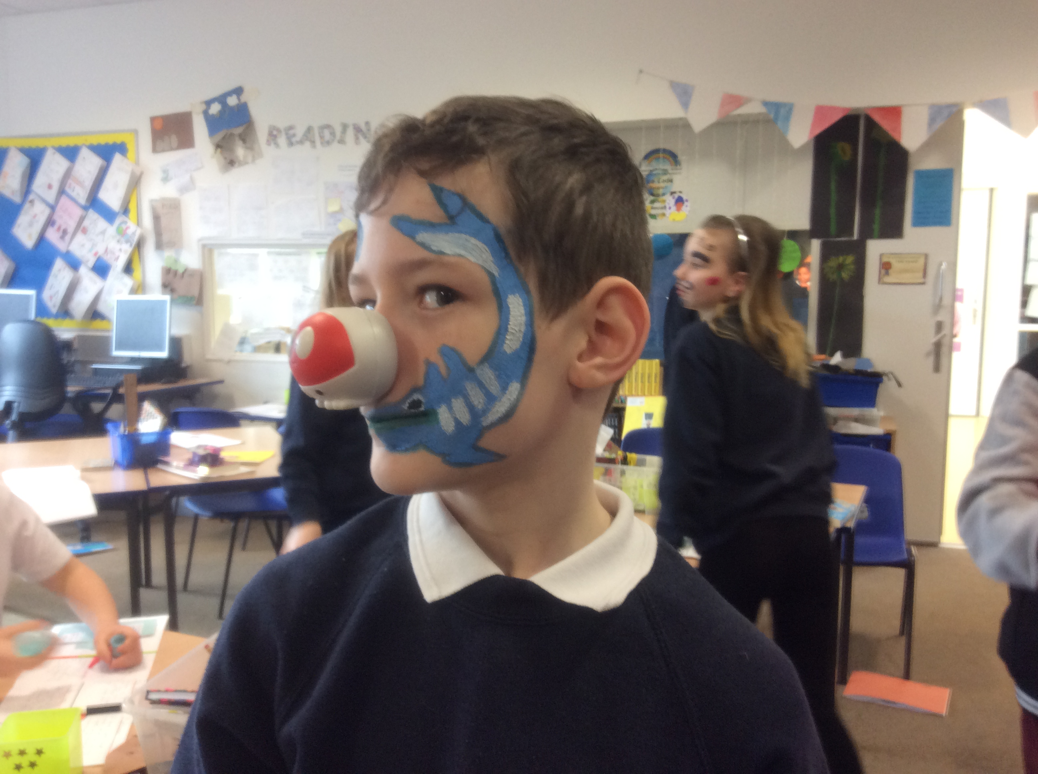  We all had fun on Red Nose Day making our faces funny!

