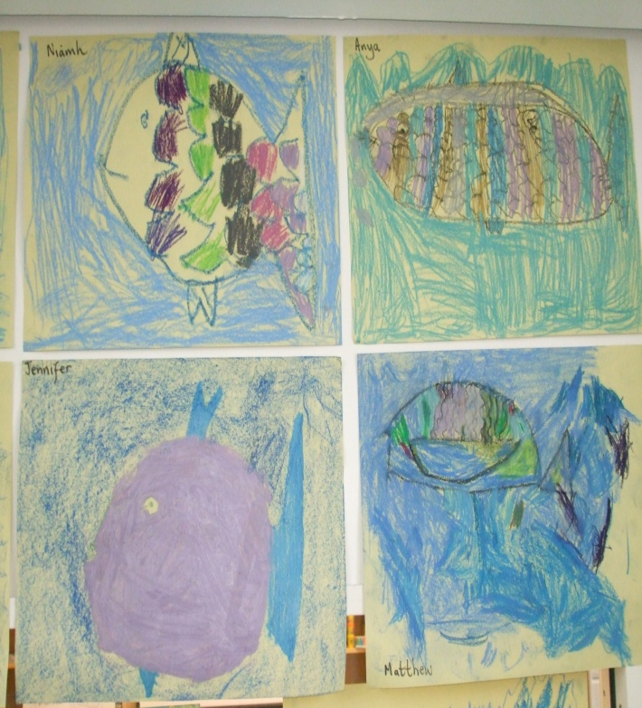  In art we have been learning about cold colours. We drew fantastic pictures of fish! |  | .  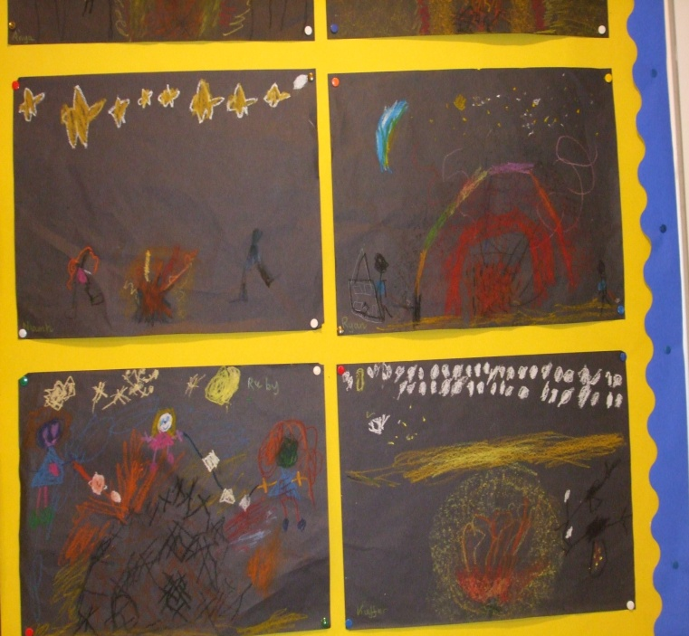  We also learned about hot colours and drew a bonfire scene which we read about in one of the Katie Morag stories. |  | 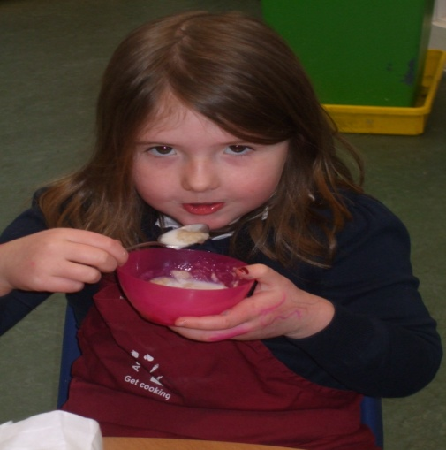  We made porridge and got to taste it. Some liked it, some didn’t  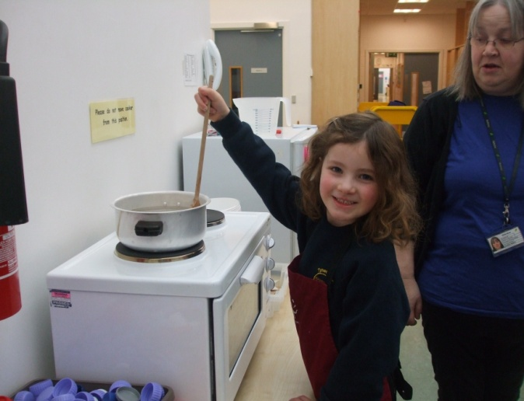
BIG EVENTS!  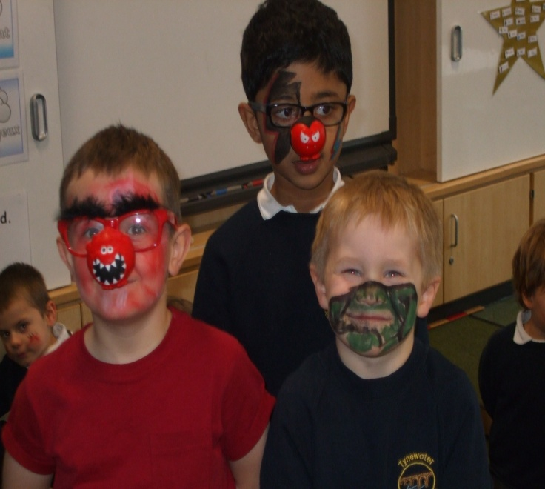  Children in Need Day.  We all enjoyed having our faces painted. |  | 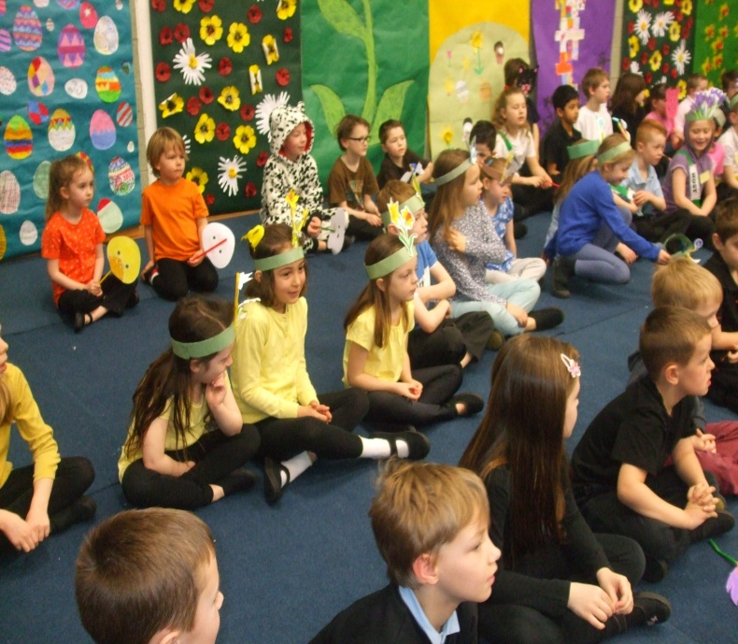  Spring Fling.  We worked hard on our Spring Fling Show, but thoroughly enjoyed it. We made lots of money for our Enterprise project. Well done Primary 1, 2 and 3! |  | 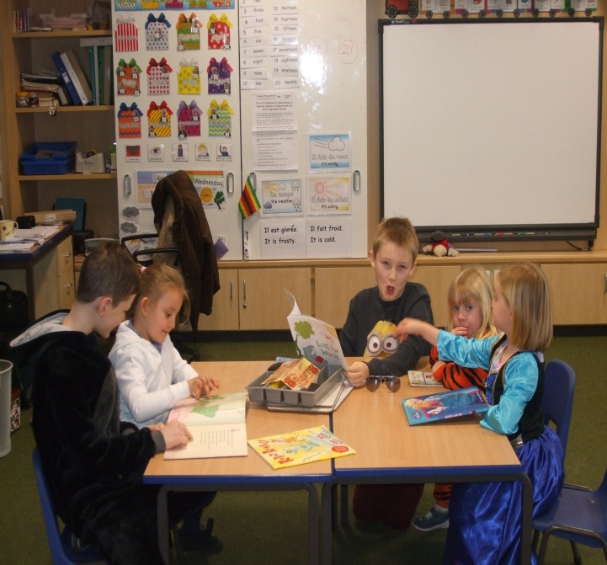  Sharing World Book Day with the older pupils.  We love it when we work with the older boys and girls. They came to our classroom and shared books with us.

