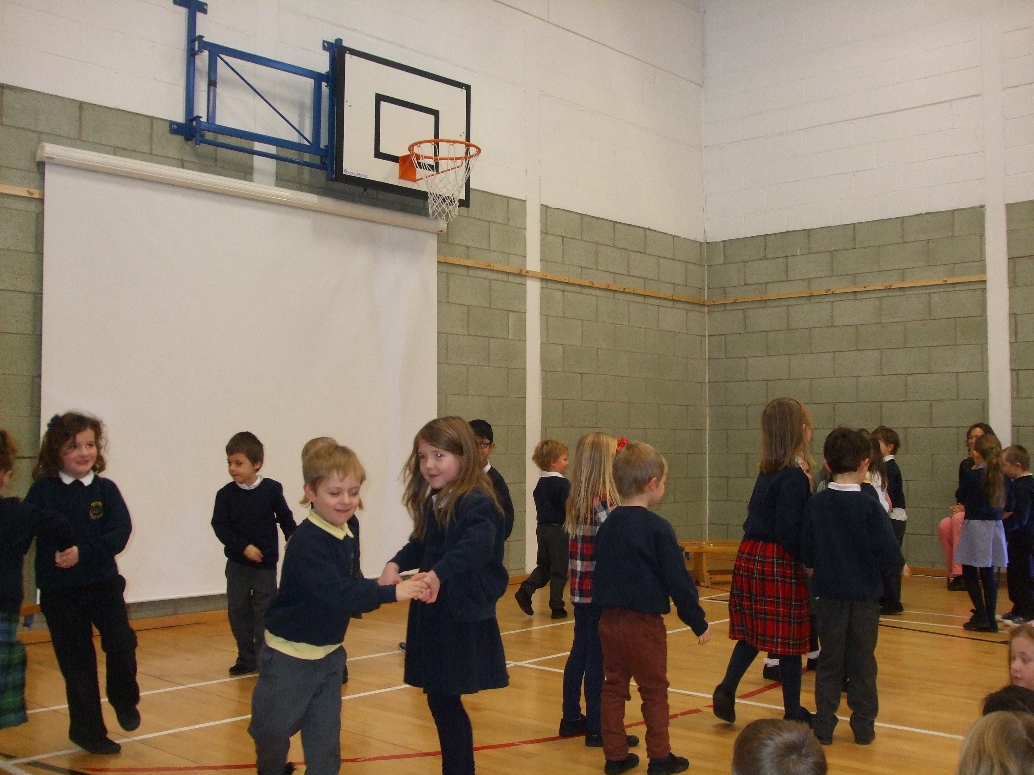 |  | During P.E. lessons, we learned some Scottish Country Dances. We performed a Canadian Barn Dance for our St Andrew’s Assembly. We enjoyed showing off our moves! |  | 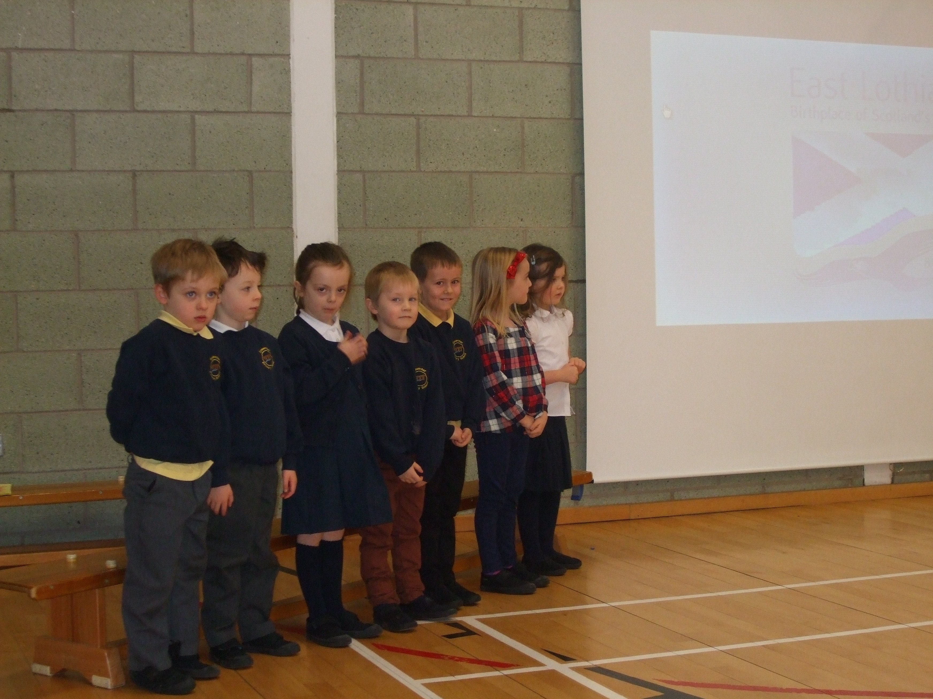
We learned about the story of St Andrew, the Patron Saint of Scotland. We drew the Saltire flag. |  | 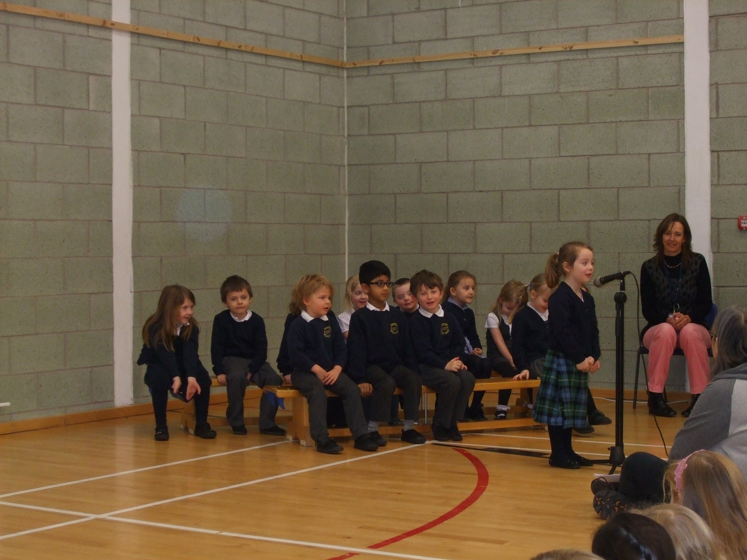 |  | We also sang ‘The Soltire Song. It was tricky to learn all the words but we worked hard and did really well.
One of the topics we studied was Katie Morag. We read lots of stories about life on Katie Morag’s island. We designed our own island and stuck it to the floor. We used it to learn about coordinates.  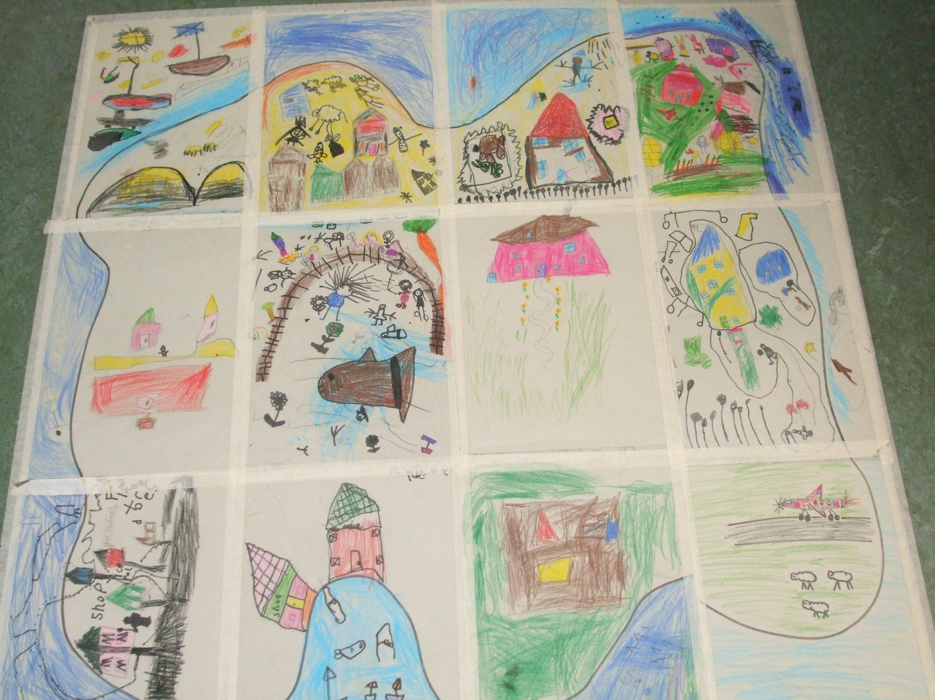 |  | 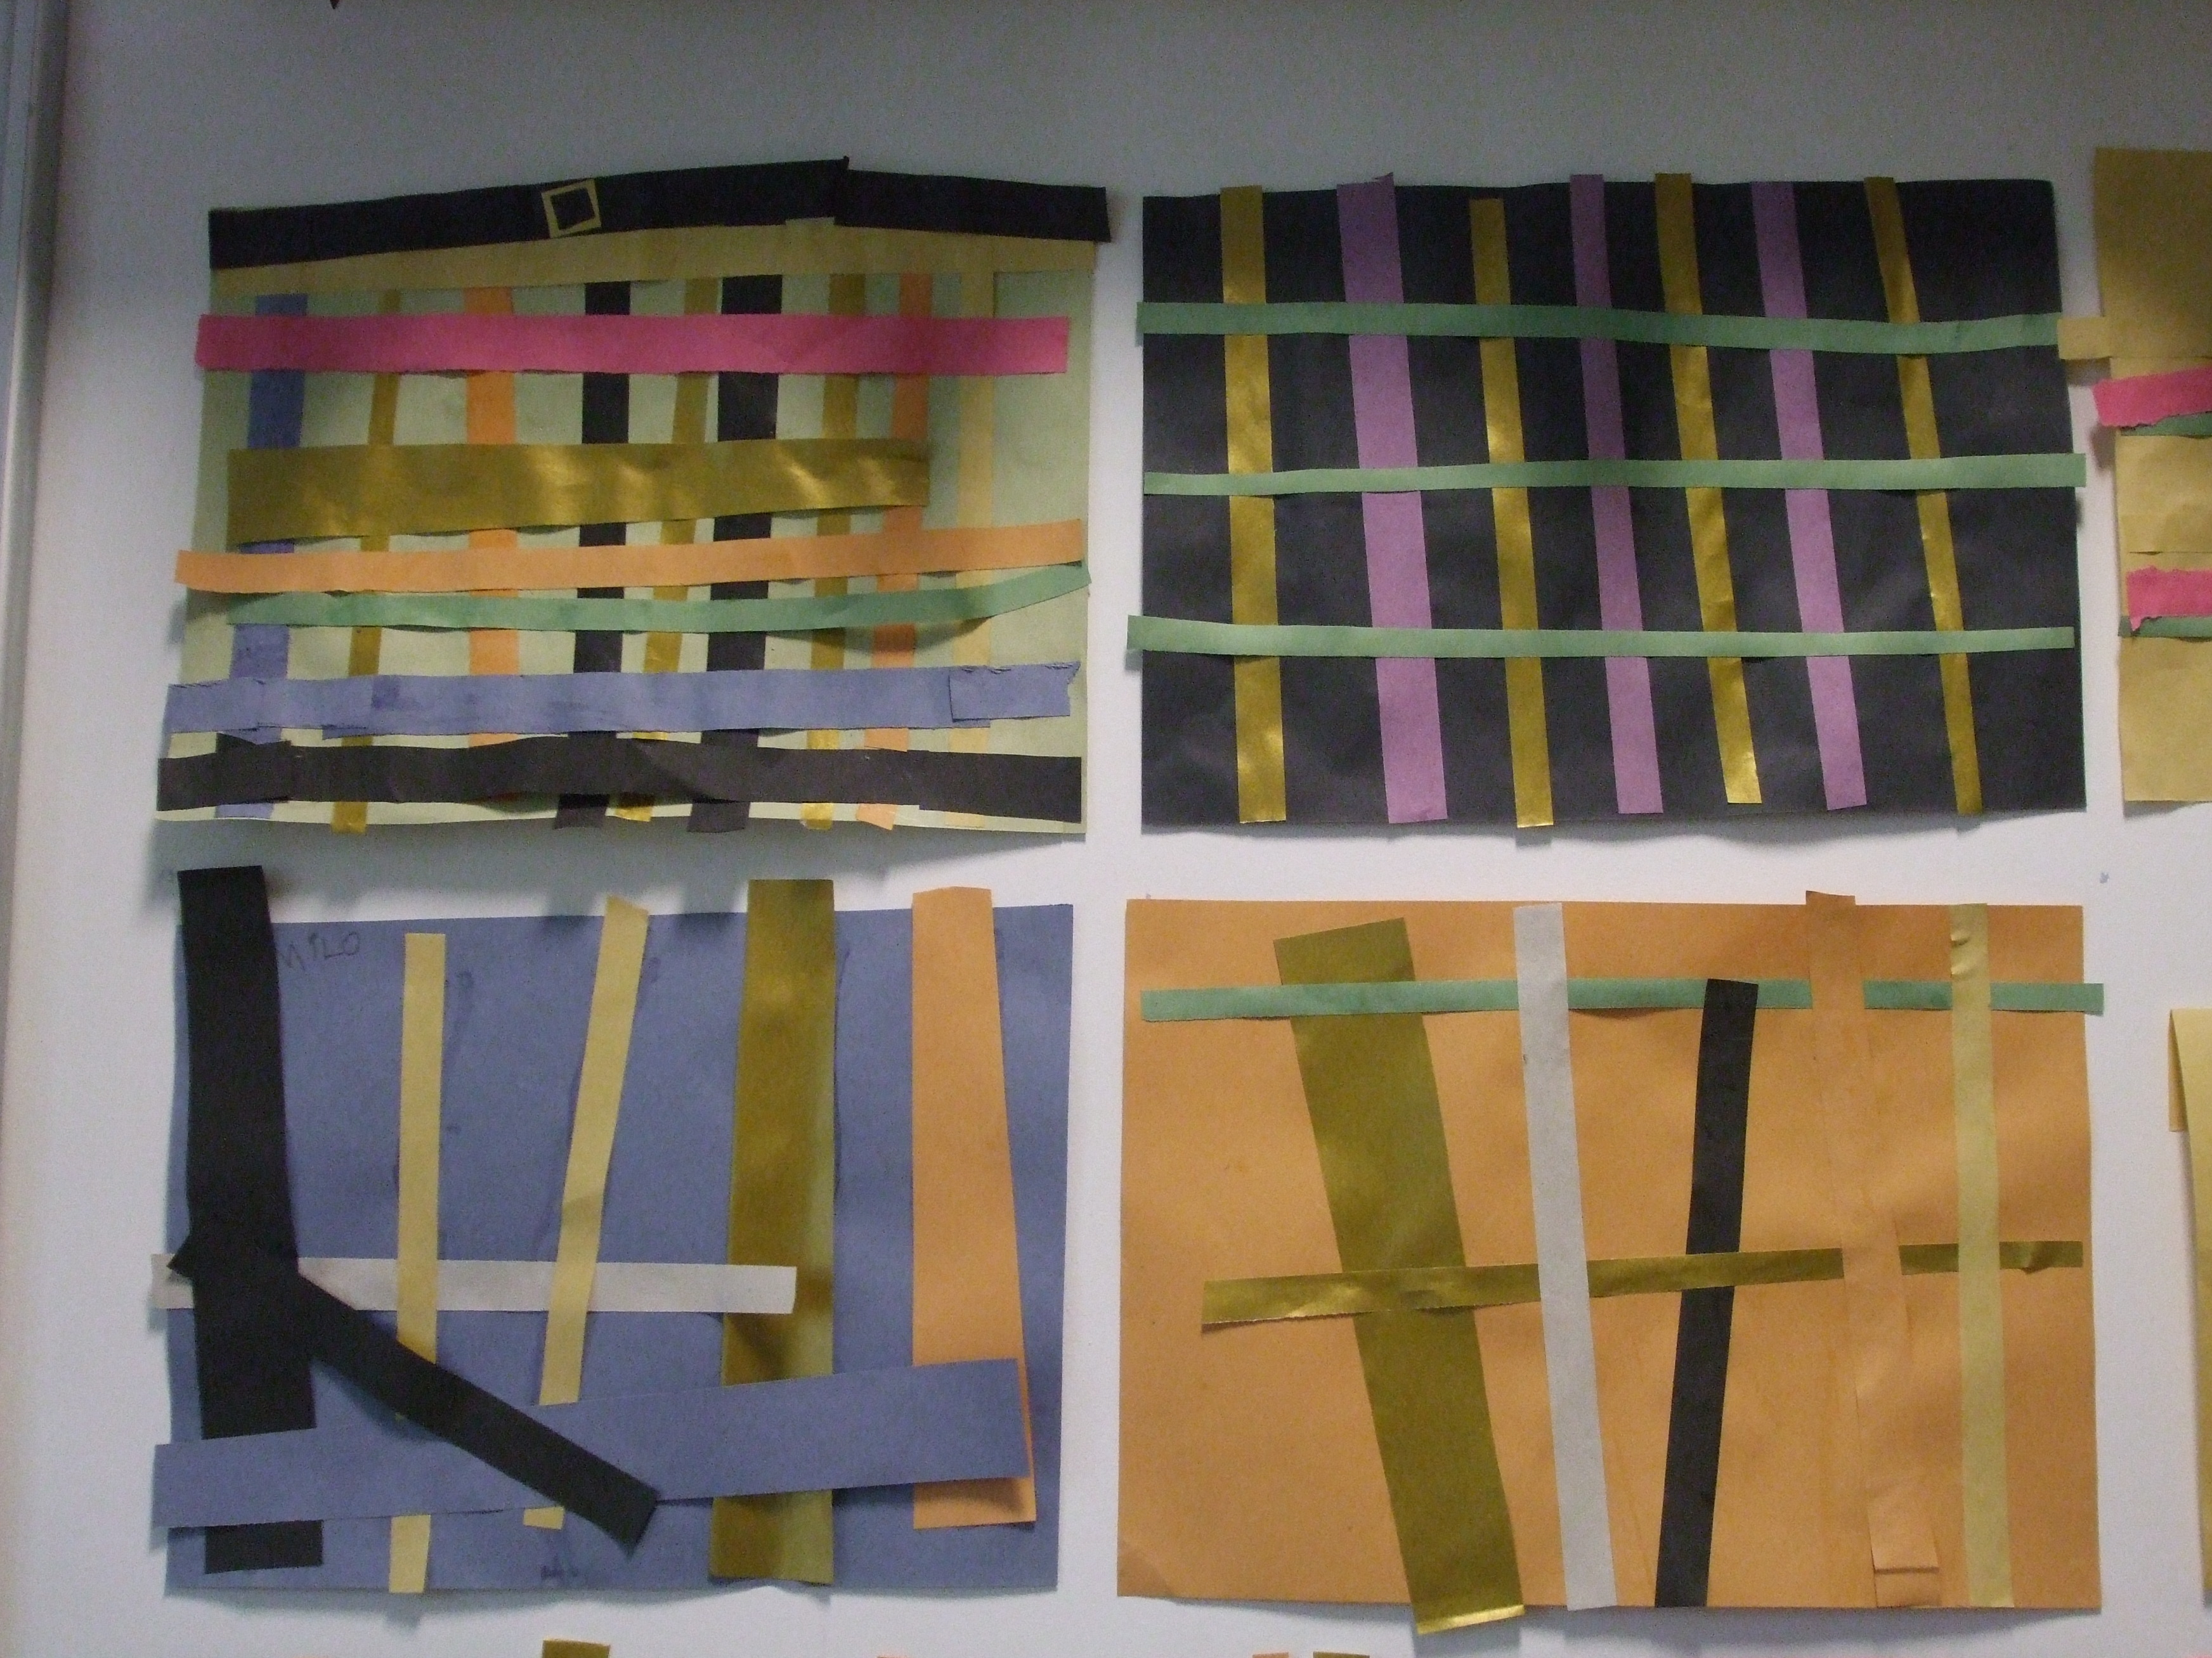  We designed our own tartans. |  | Another topic we learned about was ’The Body’. We learned to name some of the parts of our bodies. We also learned to say some of the different parts of the body in French.  We studied each other’s faces and drew them. Mrs Allan was very impressed with the details we included.  

