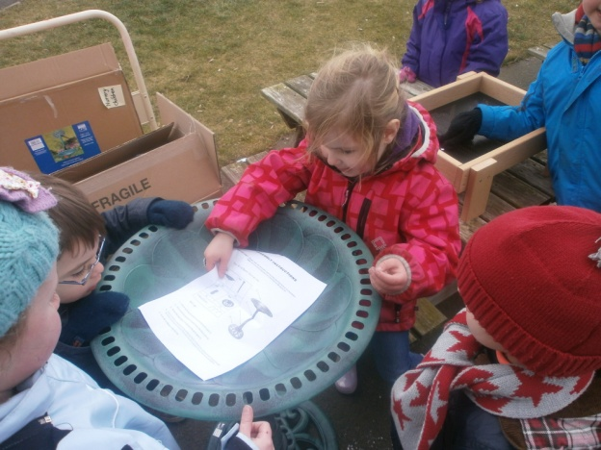 |  | Pancake Day!  We celebrated pancake day or shrove Tuesday a little bit early in Nursery. We had a pancake cafe, painted pancakes to eat for snack and sang songs and rhymes. We also shared our favourite toppings! |  | 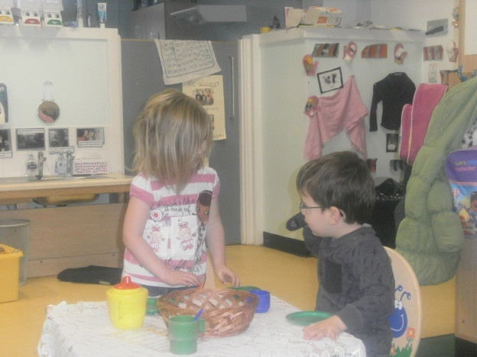
Birds  At the beginning of this term we learned how important it is to look after the bids in our garden, especially over winter. We fed them lots, even making our own food and asked Mr Lawson to buy them a bird bath for the garden. |  | 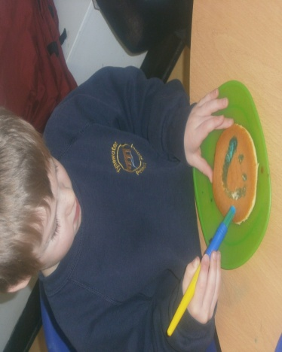 |  | 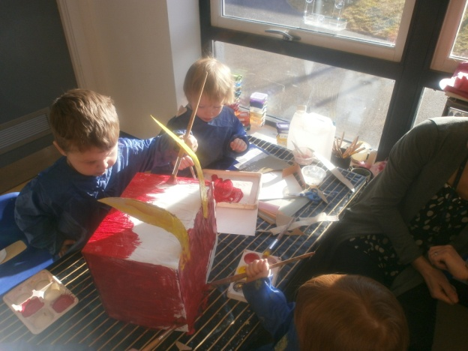
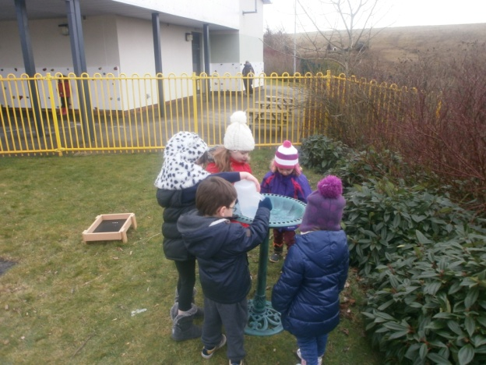 |  | Chinese New Year  To celebrate Chinese New Year we made lots of art such as dragons and Chinese drums and lanterns. We tasted lots of yummy food for snack too like spring rolls and rice. We also had lots of fun at our Chinese Restaurant. |  | 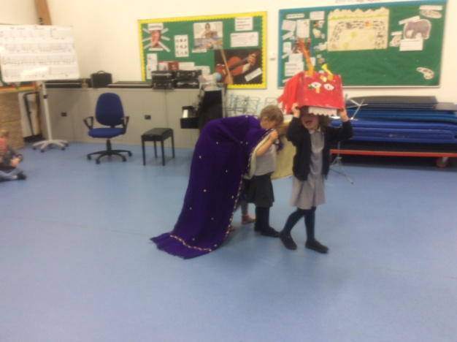
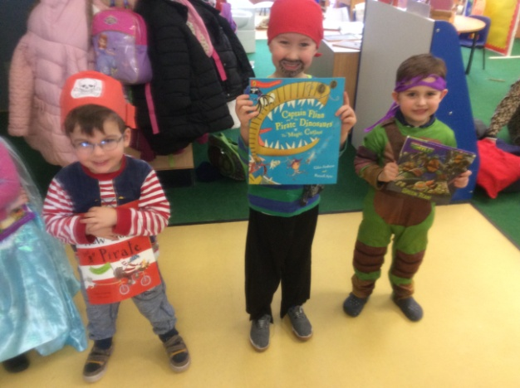 |  | 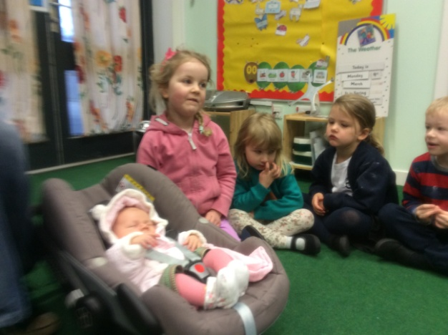 |  | 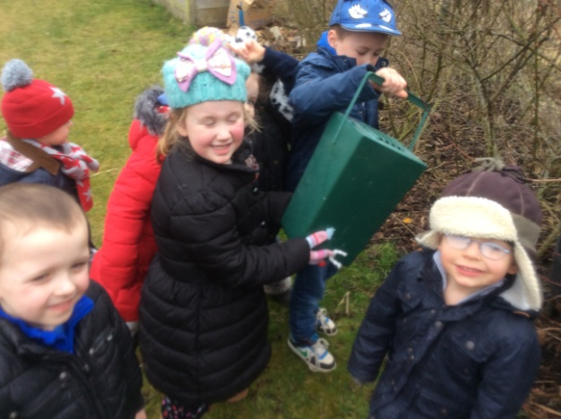
World Book Day  We had a great time dressing up for World Book Day and really enjoyed sharing a book with the P7 children in their classroom. It has definitely encouraged us to be authors and write our own books and stories! |  | Babies  We have had a few younger brothers and sisters arrive recently and so we have been learning about how to look after babies. Eve brought her little sister Emily in to teach us all she knows about looking after babies |  | Spring  With the better weather we have definitely enjoyed being able to get outside a little more. We have begun getting our garden ready and even enjoyed a rather soggy walk to Dreepie Burn!
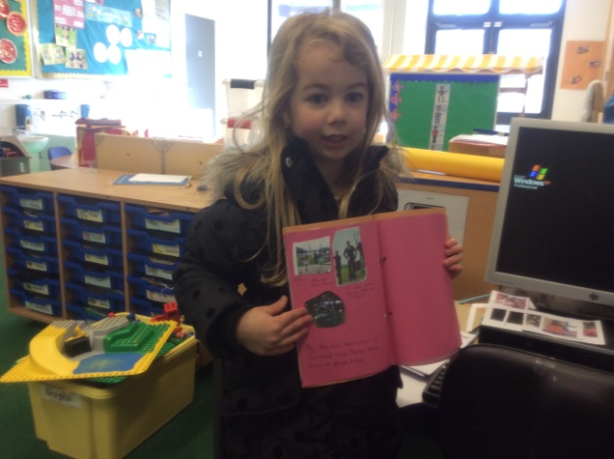 |  | 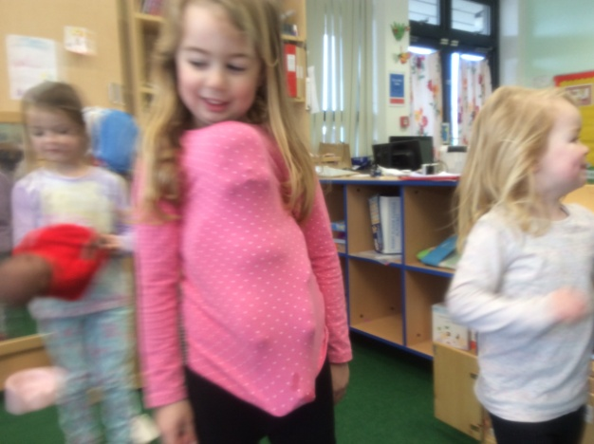 |  | 