Please find some activities below which you can do at home in case of bad weather.
Spelling
*Choose 10 words which you find difficult to spell. Create a mnemonic for each one.
E.g NECESSARY = Never Eat Cheese Eat Sausage Sandwiches And Remain Young.
*Spelling games
http://resources.woodlands-junior.kent.sch.uk/interactive/literacy.html#7

Maths
*Gingerbread House Coordinates – Follow the instructions to colour individual squares in the colours given (sheets below)
*Operation Snowman
http://www.harcourtschool.com/activity/operation_snowman/
*Maths games – choose an area of maths which you would like to practise and click on the link
http://resources.woodlands-junior.kent.sch.uk/maths/

Language
*Complete a Book Review on a book you have recently finished (sheet below)
*Improve the sentences (sheet below)
*Add adverbs to sentences (sheet below)
*Write a set of detailed instructions for how to build a snowman (sheet below)
*Write an imaginative story about a winter adventure (success criteria below)

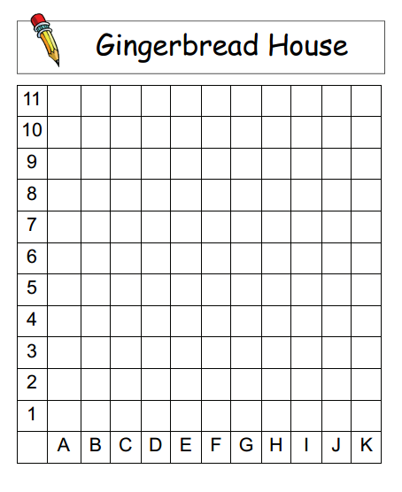

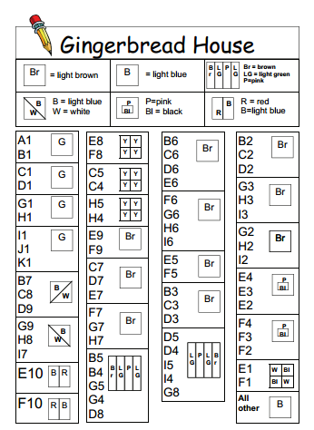

What is the book about?
Who would this book be suitable for? Age/interests

Book Illustration
Book review by: ___________________________________________

Title: _______________________________________________________

Author: ____________________________________________________

Non fiction Fiction
Book Review
Would you/would you not recommend the book? Why?

Rating:

Improving Sentences

These sentences are really boring and need to be made more interesting!
Rewrite each one neatly in your homework book.
Think about all the ways we have been learning to improve our sentences in class:

- use powerful verbs
- use adjectives (but not too many!) to describe the noun
- add adverbs to tell the reader about the verb
- extend your sentence by using connectives
- add a super sentences starter – time, place and character
- don’t forget PUNCTUATION!

- The band played.
- The police searched the park.
- The witch climbed onto her broom.
- The footballer kicked the ball.
- The man walked up the hill.
- The cat walked along the wall.
- The boy talked to his friend.
- Jane ate an apple.
- The school was on fire.
- The girls played football.

Adverbs

Adverbs describe verbs and they tell us more about how the verb was performed (done). They also make your writing more interesting.
Where to use an adverb...
An adverb can be used next to the verb;
(verb) (Adverb)
Simon ran quickly to Peter’s house.
Or somewhere else in the sentence;
(Adverb) (Verb)
Gently the mum rocked her baby back to sleep.
Word Bank of Adverbs
quickly quietly slowly gently angrily loudly greedily sadly sweetly anxiously accurately noisily firmly badly happily carefully tiredly nastily tightly furiously aggressively delicately pointlessly

Copy out these sentences adding in an adverb to describe the verb, underline the verb in red and the adverb in blue.
- Dave kicked the ball.
- Susan was singing in the shower.
- Michelle waited outside the head teacher’s office.
- The choir sang in assembly.
- The rugby team ran into the changing rooms.
- The class smiled at their new teacher.
- The passengers fastened their seatbelts.
- Tom wrote the sentences in his book.
- Mrs Smith placed the book on the table.
10) Mr Filtch ate the entire cake.

How to build a Snowman
First…
Next…
Then…
Finally…

We are learning to write an imaginative story about a winter adventure. | Me | Miss McD
*I can write in first person.

*I can punctuate sentences accurately using capital letters and full stops, and question and exclamation marks where appropriate.
*I can use words and phrases to describe the character and setting.

*I can use my senses to describe thoughts and feelings from different points in the story.
Winter Adventure Story

